# Instructional Guide to Support 2023 Grade 4 Mathematics *Standards of Learning*



Copyright © 2025

by the

Virginia Department of Education

P.O. Box 2120

Richmond, Virginia 23218-2120

[http://www.doe.virginia.gov](http://doe.virginia.gov/)

All rights reserved. Reproduction of these materials for instructional purposes in public school classrooms in Virginia is permitted.

**Superintendent of Public Instruction**

Emily Anne Gullickson, M.Ed. J.D.

**Office of Math and Science**

Dr. Anne Petersen, Director of Math and Science

Dr. Angela Byrd-Wright, Director of Humanities (Former Mathematics Coordinator)

Ms. Victoria Bohidar, Mathematics Coordinator

Dr. Jessica Brown, Elementary Mathematics Specialist

Dr. Regina Mitchell, Mathematics and Special Education Specialist

Mrs. Donna Snyder, Mathematics Division Support Specialist

**NOTICE**

The Virginia Department of Education does not unlawfully discriminate on the basis of race, color, sex, national origin, age, or disability in employment or in its educational programs or services.

Table of Contents

Introduction 3

Understanding the Standard 3

Skills in Practice 3

Concepts and Connections 3

Number and Number Sense 4

4.NS.1 4

4.NS.2 8

4.NS.3 11

4.NS.4 20

4.NS.5 25

Computation and Estimation 28

4.CE.1 28

4.CE.2 36

4.CE.3 51

4.CE.4 62

Measurement and Geometry 68

4.MG.1 68

4.MG.2 74

4.MG.3 79

4.MG.4 86

4.MG.5 91

4.MG.6 97

Probability and Statistics 100

4.PS.1 100

4.PS.2 109

Patterns, Functions, and Algebra 114

4.PFA.1 114

## Introduction

The Mathematics Instructional Guide, a companion document to the 2023 Mathematics *Standards of Learning*, amplifies the Standards of Learning by defining the core knowledge and skills in practice, supporting teachers and their instruction, and serving to transition classroom instruction from the 2016 *Mathematics Standards of Learning* to the newly adopted 2023 Mathematics *Standards of Learning.* Instructional supports are accessible in #GoOpenVA and support the decisions local school divisions must make concerning local curriculum development and how best to help students meet the goals of the standards. The local curriculum should include a variety of information sources, readings, learning experiences, and forms of assessment selected at the local level to create a rigorous instructional program.

For a complete list of the changes by standard, the [2023 Virginia Mathematics *Standards of Learning – Overview of Revisions*](https://www.doe.virginia.gov/home/showpublisheddocument/49329/638325360068970000) is available and delineates in greater specificity the changes for each grade level and course.

The Instructional Guide is divided into three sections: Understanding the Standard, Skills in Practice, and Concepts and Connections aligned to the Standard. The purpose of each is explained below.

### Understanding the Standard

This section includes mathematics understandings and key concepts that assist teachers in planning standards-focused instruction. The statements may provide definitions, explanations, or examples regarding information sources that support the content. They describe what students should know (core knowledge) as a result of the instruction specific to the course/grade level and include evidence-based practices to approaching the Standard. There are also possible misconceptions and common student errors for each standard to help teachers plan their instruction.

### Skills in Practice

This section outlines supporting questions and skills that are specifically linked to the standard. They frame student inquiry, promote critical thinking, and assist in learning transfer. Curriculum writers and teachers should use them to plan instruction to deepen understanding of the broader unit and course objectives. This is not meant to be an exhaustive list of student expectations.

### Concepts and Connections

This section outlines concepts that transcend grade levels and thread through the K through 12 mathematicsprogram as appropriate at each level. Concept connections reflect connections to prior grade-level concepts as content and practices build within the discipline as well as potential connections across disciplines.

# Grade 4

## Number and Number Sense

In K-12 mathematics, numbers and number sense form the foundation building blocks for mathematics understanding. Students develop a foundational understanding of numbers, their properties, and the relationships between them as they learn to compare and order numbers, understand place value, and perform numerical operations. Number sense includes an understanding of patterns and the relationships between numbers and being able to apply this knowledge to real world problems. Throughout K-12, students build on their number sense to develop a deeper understanding of mathematical concepts and reasoning.

In Grade 4, students will explore relationships between whole numbers, fractions, and decimals, and they will understand that these representations provide meaning and structure that allow students to quantify, measure, and make decisions in life. At this grade level, students will read, write, and identify the place and value of each digit in a nine-digit whole number; compare and order numbers up to seven digits; represent, compare, and order fractions (proper, improper, or mixed numbers with denominators 12 or less); represent, compare, and order decimals through thousandths; and identify and represent fraction and decimal equivalencies (limited to halves, fourths, fifths, tenths, and hundredths).

### 4.NS.1

##### The student will use place value understanding to read, write, and identify the place and value of each digit in a nine-digit whole number.

1. Students will demonstrate the following Knowledge and Skills:
2. Read nine-digit whole numbers, presented in standard form, and represent the same number in written form.
3. Write nine-digit whole numbers in standard form when the numbers are presented orally or in written form.
4. Apply patterns within the base 10 system to determine and communicate, orally and in written form, the place and value of each digit in a nine-digit whole number (e.g., in 568,165,724, the 8 represents 8 millions and its value is 8,000,000).

###### Understanding the Standard

* Reading and writing large numbers should be meaningful for students. Experiences can be provided that relate practical situations in students’ environments (e.g., the population of the school versus a school division, seats in an auditorium versus a stadium, number of letters in a word versus on a page).
* The structure of the base 10 number system is based upon a simple pattern of tens, where each place is ten times the value of the place to its right. This structure, known as a ten-to-one place value relationship, is helpful in comparing and ordering numbers.
* Place value refers to the value of each digit and depends upon the position of the digit in the number. For example, in the number 7,864,352, the 8 is in the hundred thousands place, and the value of the 8 is eight hundred thousand or 800,000.
* Numbers are arranged into groups of three places called *periods* (ones, thousands, millions, etc.). The value of the places within the periods repeat (hundreds, tens, ones). Commas are used to separate the periods. Knowing the value of the place and period of a number helps students determine values of digits in any number as well as read and write numbers.
* Whole numbers may be written in a variety of forms:
  + standard: 1,234,567;
  + written: one million, two hundred thirty-four thousand, five hundred sixty-seven;
  + expanded: (1,000,000 + 200,000 + 30,000 + 4,000 + 500 + 60 + 7); or
  + expanded: (1×1,000,000) + (2 × 100,000) + (3 × 10,000) + (4 × 1,000) + (5 × 100) + (6 × 10) + (7 × 1)
* Concrete materials such as base 10 blocks or bundles of sticks may be used to represent whole numbers through thousands. Larger numbers may be represented by digit cards, place value charts, or on number lines.

###### Skills in Practice

While the five process goals are expected to be embedded in each standard, the Skills in Practice highlight the most prevalent process goals in relation to the content presented.

**Mathematical Connections:** Students may have difficulty translating a number from one form to another. Translating a number in word form to standard form, especially when zero is in one or more place value positions in the number (e.g., three hundred sixty million, one hundred seven thousand, nineteen), can present a challenge for some students. Students would benefit from explicit instruction connecting the conventions used in word form (e.g., commas separating the periods) to the attributes of a number in standard form (e.g., three digits in each period, commas separating the periods). Understanding these connections may help students break the word form of a number into meaningful “chunks” as they translate it into standard form, as shown in the image below.

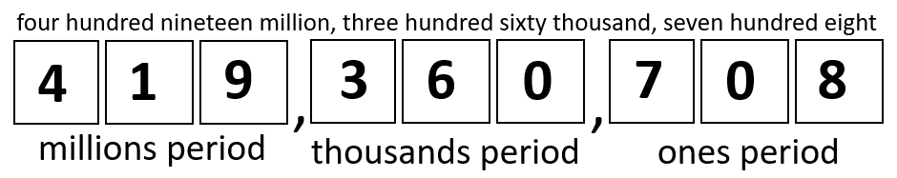

**Mathematical Reasoning:** Students may have difficulty identifying the place and value of a digit in a large number. For example, given the number 16,184,725 and asked to determine the value of the digit in the ten millions place, students may provide an incorrect response (e.g., stating 1 instead of 10,000,000 or stating the value of a digit in another place value) that reveals foundational place value misconceptions. Providing students with a place value chart up to the hundred millions place, and providing additional opportunities to practice writing numbers in the chart and identifying the values of the digits in the numbers would be helpful to support students’ place value understanding.

###### Concepts and Connections

Concepts

Flexibility with composing and decomposing base 10 numbers and understanding the structure to build relationships among numbers allows us to quantify, measure, and make decisions in life.

Connections

* *Within the grade level/course*:
  + 4.NS.2 – The student will demonstrate an understanding of the base 10 system to compare and order whole numbers up to seven digits.
* *Vertical Progression*:
  + 3.NS.1 – The student will use place value understanding to read, write, and determine the place and value of each digit in a whole number, up to six digits, with and without models.
  + There are no formal subsequent place value standards. In later grades, students explore the characteristics of prime and composite numbers (5.NS.2) and begin learning about integers (6.NS.2).

Across Content Areas [Theme – Numbers, Number Sense, and Patterns]:

* *Science:* 
  + 4.4a – The student will use weather instruments (thermometer, barometer, rain gauge, anemometer) and observations of sky conditions to collect, record, and graph weather data over time; analyze results and determine patterns that may be used to make weather predictions.
* *Computer Science*:
* 4.AP.1 – The student will apply computational thinking to identify patterns and design algorithms to compare and contrast multiple algorithms used for the same task (a) decompose an algorithm, process, or problem into a subset of smaller problems; (b) identify multiple algorithms for the same task; and (c) describe patterns within multiple algorithms.

###### Resources to Support Local Curriculum

* A list of approved textbooks and instructional materials is posted on the VDOE [website](https://www.doe.virginia.gov/teaching-learning-assessment/k-12-standards-instruction/mathematics/2024-mathematics-textbooks).

### 4.NS.2

##### The student will demonstrate an understanding of the base 10 system to compare and order whole numbers up to seven digits.

1. Students will demonstrate the following Knowledge and Skills:
2. Compare two whole numbers up to seven digits each, using words (*greater than, less than, equal to, not equal to*) and/orusing symbols (>, <, =, ≠).
3. Order up to four whole numbers up to seven digits each, from least to greatest or greatest to least.

###### Understanding the Standard

* Numbers written in standard form are often more easily compared. Students are then able to use the number of digits in a whole number, and the place and value of those digits, to compare and order numbers.
* Numbers written in expanded form are also easy to compare, as the value of each digit in each place value is written out, making them easier to compare.
* A number line is one model that can be utilized when comparing and ordering numbers.
* Mathematical symbols (>, <) used to compare two unequal numbers are called inequality symbols.

###### Skills in Practice

While the five process goals are expected to be embedded in each standard, the Skills in Practice highlight the most prevalent process goals in relation to the content presented.

**Mathematical Problem Solving:** The most common error made by students when ordering a set of numbers from least to greatest is putting the numbers in order from greatest to least. These students may demonstrate an understanding of ordering numbers but would benefit from strategies that focus attention on the type of ordering required.

**Mathematical Reasoning:** Students may have difficulty comparing larger numbers that have a different number of digits. For example, given the numbers 998,969 and 1,102,121, students may state that 998,969 is larger than 1,102,121. These students incorrectly reason that if the digit 9 is in the highest place value of a number (the 9 in the hundred thousands place), it automatically makes the number greater than another number that has a higher place value (the 1 in the millions place). Using manipulatives such as place value blocks to demonstrate this concept using smaller numbers (e.g., 1,021 is greater than 997) may help students strengthen their place value understanding. The use of a place value chart may also provide a helpful visual aid for comparing the individual digits between two numbers, as shown in the image below.

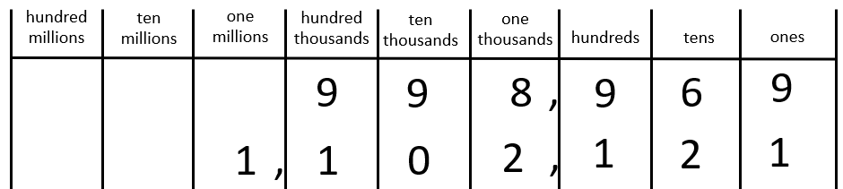

**Mathematical Representations:** Some students will likely confuse the < and > symbols and use them incorrectly when comparing numbers. Often, these students are able to determine which number is greater and which number is less, but they are unsure of which symbol should be used to make the number sentence correct. Students benefit from practice reading these comparisons aloud to make sure the correct vocabulary is used with the correct symbol.

###### Concepts and Connections

Concepts

Flexibility with composing and decomposing base 10 numbers and understanding the structure to build relationships among numbers allows us to quantify, measure, and make decisions in life.

Connections

* *Within the grade level/course*:
  + 4.NS.1 – The student will use place value understanding to read, write, and identify the place and value of each digit in a nine-digit whole number.
* *Vertical Progression*:
  + 3.NS.2 – The student will demonstrate an understanding of the base 10 system to compare and order whole numbers up to 9,999.
  + While there are no formal standards involving comparing whole numbers in subsequent grade levels, Grade 5 students will compare and order sets of fractions and decimals (5.NS.1), and Grade 6 students will compare and order integers (6.NS.2).

Across Content Areas

Reference 4.NS.1

###### Resources to Support Local Curriculum

* A list of approved textbooks and instructional materials is posted on the VDOE [website](https://www.doe.virginia.gov/teaching-learning-assessment/k-12-standards-instruction/mathematics/2024-mathematics-textbooks).

### 4.NS.3

##### The student will use mathematical reasoning and justification to represent, compare, and order fractions (proper, improper, and mixed numbers with denominators 12 or less), with and without models.

1. Students will demonstrate the following Knowledge and Skills:
2. Compare and order no more than four fractions (proper or improper), and/or mixed numbers, with like denominators by comparing the number of parts (numerators) using fractions with denominators of 12 or less (e.g., < ). Justify comparisons orally, in writing, or with a model.*
3. Compare and order no more than four fractions (proper or improper), and/or mixed numbers, with like numerators and unlike denominators by comparing the size of the parts using fractions with denominators of 12 or less (e.g., < ). Justify comparisons orally, in writing, or with a model.*
4. Use benchmarks (e.g., 0, , or 1) to compare and order no more than four fractions (proper or improper), and/or mixed numbers, with like and unlike denominators of 12 or less. Justify comparisons orally, in writing, or with a model.*
5. Compare two fractions (proper or improper) and/or mixed numbers using fractions with denominators of 12 or less, using the symbols >, <, and = (e.g., > ). Justify comparisons orally, in writing, or with a model.*
6. Represent equivalent fractions with denominators of 12 or less, with and without models.*
7. Compose and decompose fractions (proper and improper) and/or mixed numbers with denominators of 12 or less, in multiple ways, with and without models.*
8. Represent the division of two whole numbers as a fraction given a contextual situation and a model (e.g., means the same as 3 divided by 5 or represents the amount of muffin each of five children will receive when sharing three muffins equally).

* On the state assessment, items measuring this objective are assessed without the use of a calculator.

###### Understanding the Standard

* A fraction is a numerical way of representing part of a whole. Fractions can have different meanings: part-whole, measurement, division, ratio, and operator. When working with fractions, the whole must be defined. In Grade 4, fractions most commonly represent part-whole, measurement, or division situations.
* The value of a fraction is dependent on both *b,* the number of equivalent parts in a whole (denominator), and *a,* the number of those parts being considered (numerator).
* Fractions with a numerator of one are called unit fractions (e.g., ).
* Proper fractions, improper fractions, and mixed numbers are terms often used to describe fractions. A proper fraction is a fraction whose numerator is less than the denominator. An improper fraction is a fraction that is greater than or equal to one whole (i.e., whose numerator is greater than or equal to the denominator (e.g., ). An improper fraction may also be expressed as a mixed number. A mixed number is written with two parts: a whole number and a proper fraction (e.g., 3). The value of a mixed number is the sum of its two parts.
* At this grade level, models can provide considerable support for developing student understanding of the different fraction concepts and for justifying solutions when problem solving.
* Representations that students use in fraction explorations, activities, and during problem solving should be based on the concept being developed. At this grade level, the three representations most commonly used are region/area models, set models, or length/measurement models.
* 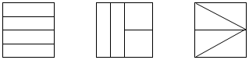In a region/area model (e.g., fraction circles, pattern blocks, geoboards, grid paper, color tiles), the whole is continuous and divided or partitioned into parts with areas of equivalent value. The fractional parts may or may not be congruent and could have a different shape as shown in the middle example below. This model is helpful when developing the part-whole concept.
* In a set model (e.g., chips, counters, cubes), the whole is made up of discrete members of the set, where each member is an equivalent part of the set. In set models, the whole needs to be defined, but members of the set may have different sizes and shapes. For example, if a whole is defined as a set of 10 shapes, the shapes within the set may be different. In the example below, students should identify hearts as representing (or one-half) of the shapes in the set shown:

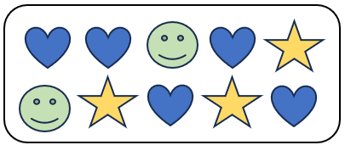

* In a length/measurement model (e.g., fraction strips, rods, number lines, rulers), each length represents an equal part of the whole. For example, given a strip of paper, students could fold the narrow strip into four equal parts, with each part representing one-fourth. Students will notice that there are four one-fourths in the entire length of the strip of paper. A concrete model connects to a representation of a number line to make sense of the spaces that show the value of the fraction.

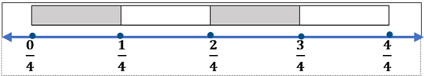

* A ruler is an important representation of the length model of fractions. When using rulers to measure length, opportunities should be provided for students to identify the points of the ruler that represent the lengths of halves, fourths, and eighths, and students should be encouraged to make connections to fractions and mixed numbers.
* A fraction can represent the result obtained when two numbers are divided.
  + The number of gumdrops each child receives when 40 gumdrops are shared equally among 5 children can be expressed as or 8.
* When presented with a fraction representing division, the division expression representing the fraction is written as 3 ÷ 5.
  + When 3 cakes are divided equally among 4 people, the fraction may be interpreted as the amount of cake each person will receive.
* Equivalent fractions name the same amount. Students should have multiple opportunities to explore and use a variety of representations including visual fraction models and folding paper to represent, explore, and explain why two fractions are equivalent. For example, is equivalent to because the fractions themselves represent the same value, even though the number and size of the parts differ.

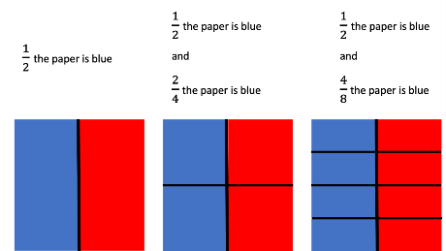

* Concrete and pictorial models, benchmarks (e.g., 0, , 1), and equivalent forms are helpful in judging the size of fractions.
* Composing and decomposing fractions develops a deeper understanding of fractional concepts including the use of models, benchmarks, and equivalent forms to compare and order fractions as well as estimating size.
* Decomposing a fraction is breaking it into parts. Fractions can be decomposed in a variety of ways.

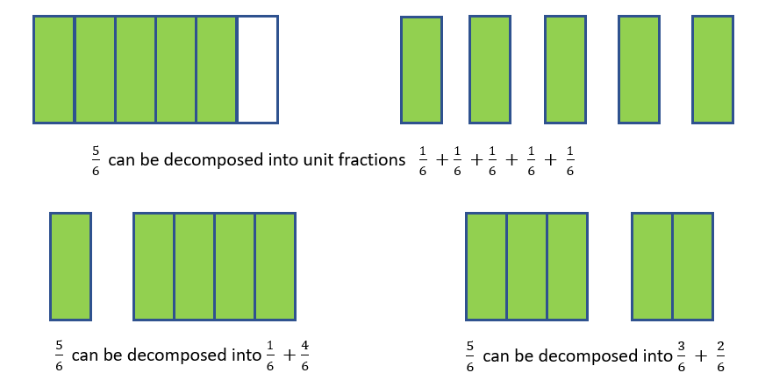

* When fractions have the same denominator, they are said to have “common denominators” or “like denominators.”
* Strategies used for comparing and ordering fractions (proper and improper) and mixed numbers may include:
  + more than 1 whole;
  + less than 1 whole;
  + comparing fractions to familiar benchmarks (e.g., 0, , 1);
  + distance from or to 0, , 1;
  + determining equivalent fractions;
  + using like denominators; or
  + using like numerators.
* Comparing fractions with like denominators involves comparing only the numerators or the number of pieces.
* Comparing fractions with like numerators involves thinking about the size of the fractional parts. The more parts the whole is divided into, the smaller each part will be (e.g., < ).
* Strategies for comparing fractions with unlike denominators may include:
  + comparing fractions to familiar benchmarks (e.g., 0, , 1); and
  + determining equivalent fractions using models such as fraction strips, number lines, fraction circles, rods, pattern blocks, cubes, base 10 blocks, tangrams, graph paper, or patterns in a multiplication chart.
* The use of benchmarks can aid in comparing and ordering fractions and solving problems involving addition and subtraction of fractions.

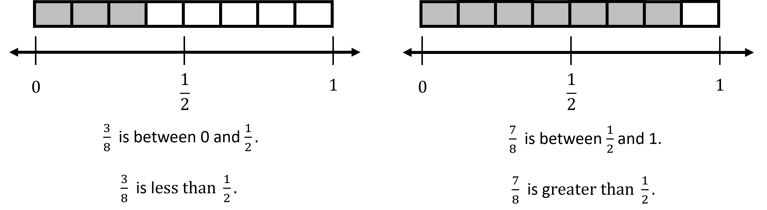

* The examples below compare fractions with unlike denominators using the strategies of decomposing and benchmark fractions:

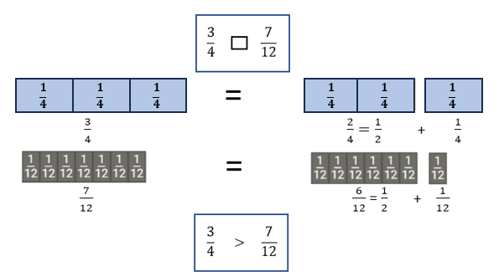 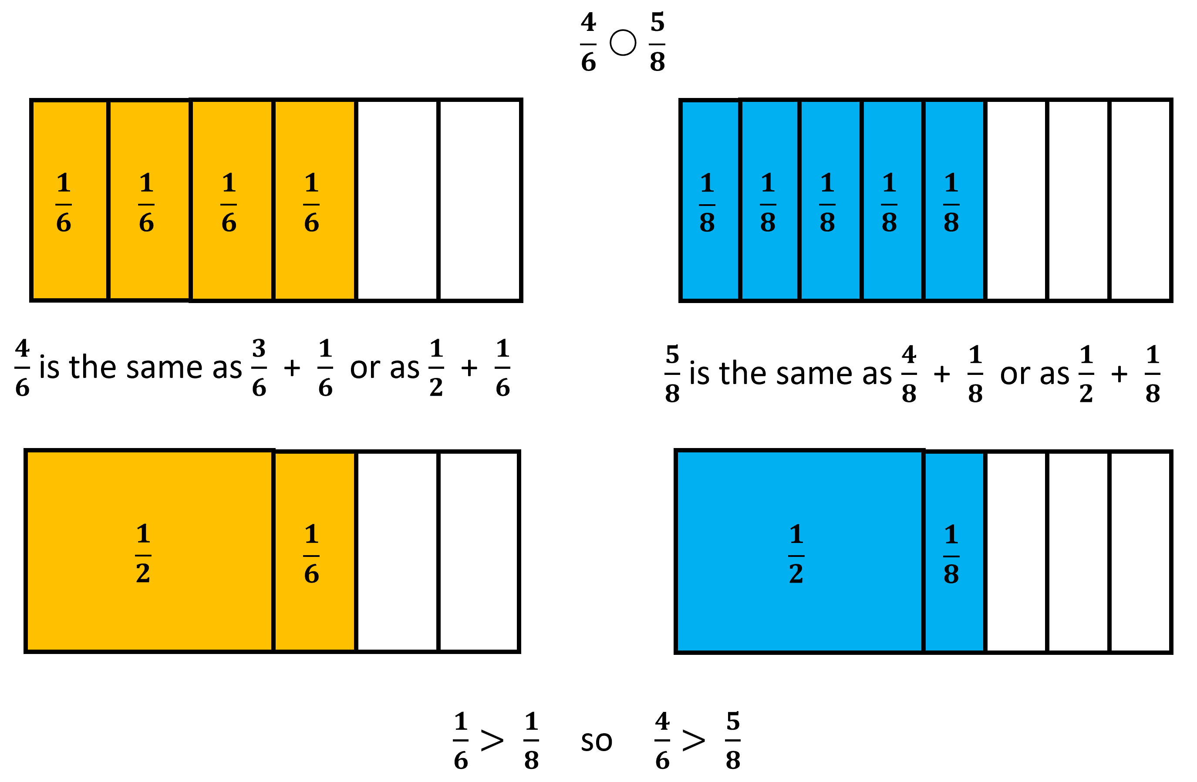

###### Skills in Practice

While the five process goals are expected to be embedded in each standard, the Skills in Practice highlight the most prevalent process goals in relation to the content presented.

**Mathematical Reasoning:** Students may struggle to compare fractions accurately. Students who demonstrate the common misconceptions and errors below would benefit from continued experiences using concrete fraction manipulatives to deepen their conceptual understanding of fractions. Additionally, the use of benchmarks (e.g., 0, , 1) may help students determine the size of fractions.

* When comparing or ordering fractions with like denominators (e.g., and , or and ), students may try to first simplify the fractions, rather than recognizing that they have like denominators. Another common error occurs when students apply the idea of “the larger the denominator, the smaller the pieces” to numerators. Students making this error will look at numerators and determine that fractions with larger numerators are smaller fractions.
* When comparing or ordering fractions with like numerators (e.g., and , or and ), students often do not notice that the fractions have the same numerator and thus, they do not realize that they can focus on the size of the denominators to compare the fractions. Another common error occurs when students apply whole number reasoning to compare denominators rather than understanding that fractional pieces get smaller as the denominator gets larger.
* When comparing or ordering mixed numbers and/or improper fractions, a common error is for students to focus on the fractional part and ignore the whole number. Students would benefit from modeling the number using concrete materials. Similarly, having students sort fractions into categories such as “less than one whole” and “more than one whole” can help students when comparing and ordering fractions.

**Mathematical Representations:**

* Students may have difficulty comparing two mixed numbers. Given Model A and Model B below, a common error is for students to think that the model that has a whole completely shaded (Model B) is automatically greater than a model that has two partial wholes shaded (Model A). Students who demonstrate this misconception would benefit from opportunities to use models similar to the ones shown below. Additional practice where students must model a fraction or mixed number in multiple ways would also help students deepen their fraction understanding.

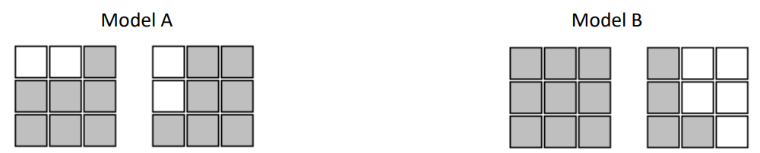

* Students may have difficulty when composing a fraction or mixed number, when given a piece of the fraction, as demonstrated in the example below. In Grade 2, students were expected to compose the whole for a given fractional part and its value (2.NS.3c). Students should build on this knowledge and create models to represent the composed fraction or mixed number.

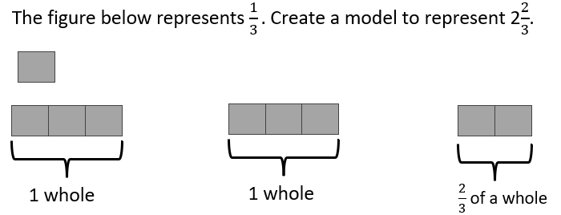

**Mathematical Connections:** Students sometimes struggle to see the connections between equivalent fractions. For example, students may believe that breaking fractional pieces into smaller pieces changes the value of the shaded portion (e.g., drawing a horizontal line through the image of one-third to create two-sixths changes it to a larger fraction the numerator and the denominator are larger). Exploring equivalent fractions using concrete materials can help students develop their understanding of equivalent fractions, as shown in the image below.

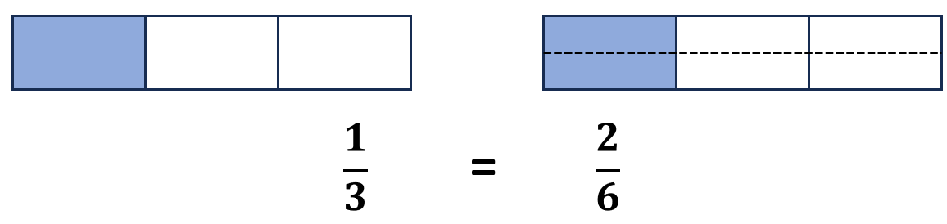

###### Concepts and Connections

Concepts

Flexibility with composing and decomposing base 10 numbers and understanding the structure to build relationships among numbers allows us to quantify, measure, and make decisions in life.

Connections

* *Within the grade level/course*:
  + 4.NS.5 – The student will reason about the relationship between fractions and decimals (limited to halves, fourths, fifths, tenths, and hundredths) to identify and represent equivalencies.
  + 4.CE.3 – The student will estimate, represent, solve, and justify solutions to single-step problems, including those in context, using addition and subtraction of fractions (proper, improper, and mixed numbers with like denominators of 2, 3, 4, 5, 6, 8, 10, and 12), with and without models; and solve single-step contextual problems involving multiplication of a whole number (12 or less) and a unit fraction, with models.
* *Vertical Progression*:
  + 3.NS.3 - The student will use mathematical reasoning and justification to represent and compare fractions (proper and improper) and mixed numbers with denominators of 2, 3, 4, 5, 6, 8, and 10), including those in context.
  + 5.NS.1 – The student will use reasoning and justification to identify and represent equivalency between fractions (with denominators that are thirds, eighths, and factors of 100) and decimals; and compare and order sets of fractions (proper, improper, and/or mixed numbers having denominators of 12 or less) and decimals (through thousandths).

Across Content Areas

Reference 4.NS.1.

###### Resources to Support Local Curriculum

* A list of approved textbooks and instructional materials is posted on the VDOE [website](https://www.doe.virginia.gov/teaching-learning-assessment/k-12-standards-instruction/mathematics/2024-mathematics-textbooks).

### 4.NS.4

##### The student will use mathematical reasoning and justification to represent, compare, and order decimals through thousandths, with and without models.

1. Students will demonstrate the following Knowledge and Skills:
2. Investigate and describe the ten-to-one place value relationship for decimals through thousandths, using concrete models (e.g., place value mats/charts, decimal squares, base 10 blocks).
3. Represent and identify decimals expressed through thousandths, using concrete, pictorial, and numerical representations.
4. Read and write decimals expressed through thousandths, using concrete, pictorial, and numerical representations.
5. Identify and communicate, both orally and in written form, the place and value of each digit in a decimal through thousandths (e.g., given 0.385, the 8 is in the hundredths place and has a value of 0.08).
6. Compare using symbols (<, >, =) and/or words (*greater than, less than, equal to*) and order (least to greatest and greatest to least), a set of no more than four decimals expressed through thousandths, using multiple strategies (e.g., benchmarks, place value, number lines). Justify comparisons with a model, orally, and in writing.

###### Understanding the Standard

* Decimal numbers expand the set of whole numbers and, like fractions, are a way of representing part of a whole.
* A decimal point (.) separates the whole number from the part of the decimal number that is less than one. A number containing a decimal point is called a *decimal number* or simply a *decimal*.
* The structure of the base 10 number system is based upon a simple pattern of tens, where each place is ten times the value of the place to its right. This is known as a ten-to-one place value relationship (e.g., in 2.35, 3 is in the tenths place since it takes ten one-tenths to make one whole). Concrete materials that clearly illustrate the relationships among ones, tenths, hundredths, and thousandths, and are physically proportional (e.g., the ones piece is ten times larger than the tenths piece) may be used to represent decimal numbers. Examples of proportional manipulatives include decimal squares, base 10 blocks, or meter sticks. In moving beyond the concrete, non-proportional manipulatives where the relationship is not visible in the material such as money or number disks (e.g., 1, 10, 100, 1000) can be helpful in developing place value understanding of decimal numbers.
* To read decimals,
  + read the whole number to the left of the decimal point;
  + read the decimal point as “*and*;”
  + read the digits to the right of the decimal point just as you would read a whole number; and say the name of the place value of the digit in the smallest place.
* Any decimal less than 1 will include a leading zero. For example, 0.125 can be read as “zero and one hundred twenty-five thousandths” or as “one hundred twenty-five thousandths.”
* Decimals may be written in a variety of forms:
  + standard: 26.537;
  + written: twenty-six and five hundred thirty-seven thousandths;
  + expanded: 20 + 6 + 0.5 + 0.03 + 0.007; or
  + expanded: (2 × 10) + (6 × 1) + (5 × 0.1) + (3 × 0.01) + (7 × 0.001)
* Number lines and beaded number lines serve as useful tools when using benchmarks (e.g., 0, 0.5, 1) to compare and order decimals. The terms *closer to, between*, and *a little more than* are often used when comparing and ordering decimals (e.g., 0.48 is a little less than 0.5; 0.75 is between 0.5 and 1; 0.98 is close to 1; see the examples below).

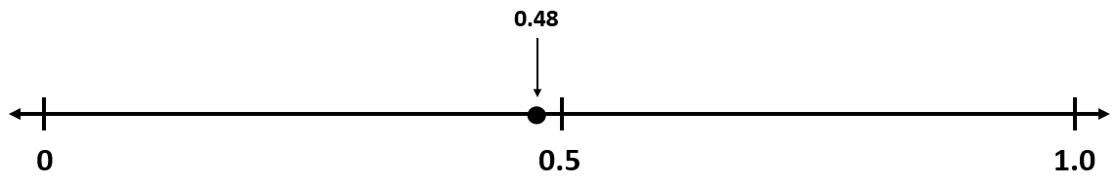

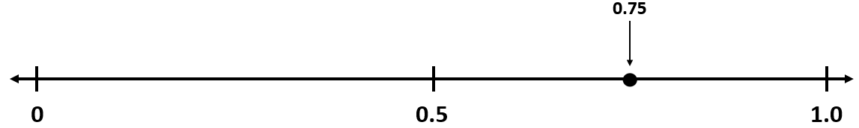

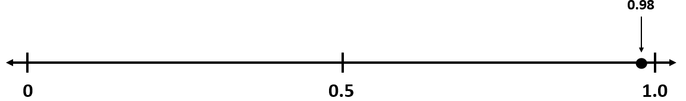

* Meter sticks are an important representation of decimals. When measuring length, students can identify the points of the meter stick that represent millimeters (thousandths), centimeters (hundredths), decimeters (tenths), and meters (whole).

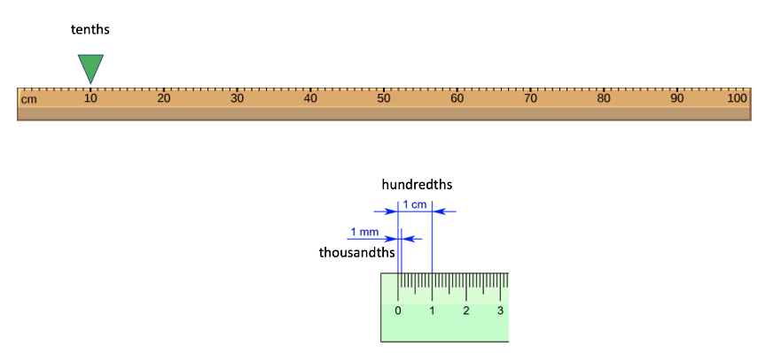

###### Skills in Practice

While the five process goals are expected to be embedded in each standard, the Skills in Practice highlight the most prevalent process goals in relation to the content presented.

**Mathematical Reasoning:** As students are formally introduced to decimal numbers, a common misconception is that a number with more digits is always greater than a number with fewer digits. For example, given the numbers 5.087 and 5.3, students may state that 5.087 is larger because it has “more numbers.” This indicates that students are applying whole number reasoning to decimal numbers. Students would benefit from opportunities to develop their conceptual understanding of decimal numbers through the use of base-10 blocks. Using concrete materials to construct models of decimal numbers and then comparing the models provides students with visual cues to understand the importance of the place of each digit in a decimal number. Additionally, the use of models and a decimal place value chart can help students see that a number such as 5.3 is equivalent to 5.300 and may aid in comparing and ordering numbers, as shown in the image below.

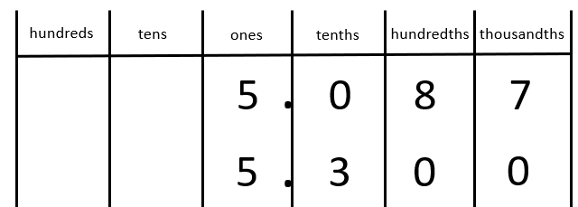

**Mathematical Representations:** A common concrete representation for decimals is the use of base-10 blocks, with a flat representing one whole, as indicated below.

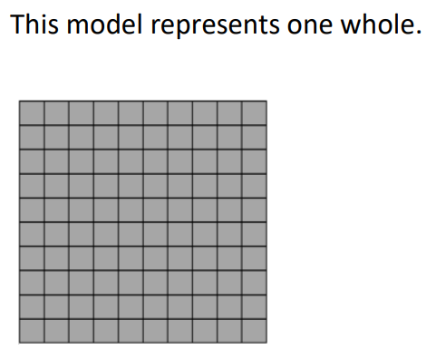

For the majority of students, their prior experiences with base-10 blocks included the use of a flat as 100, rather than one whole. This shift in the representation may cause confusion for some students. For example, given the model below, students may inaccurately state that the model represents 373 rather than 3.73. Similar confusion may occur when a rod is identified as one whole. Providing many opportunities for students to practice using flats, rods, and units to create decimals numbers would be helpful. In addition, the use of a place value chart and digit cards will help students label their representations with the standard form of the decimal number.

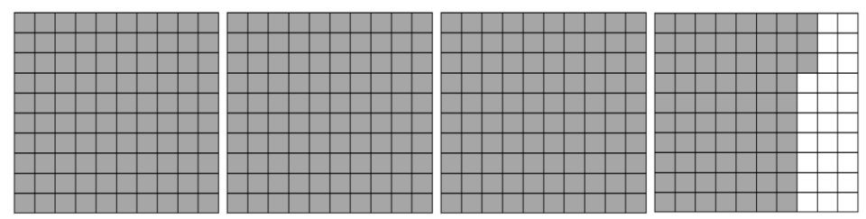

**Mathematical Communication:** Students may experience difficulty when reading and writing decimal numbers. For example, when asked to write the number “nine hundred eighty-one thousandths” in standard form, students may write 981 or 981,000. These errors indicate that students are using their knowledge of whole numbers to write decimal numbers. Students would benefit from the use of a place value chart that includes labels for each decimal place value and a clearly marked space in the chart for the decimal point, paired with a reference to the word “and” to facilitate the process of reading and writing decimal numbers in standard form.

###### Concepts and Connections

Concepts

Flexibility with composing and decomposing base 10 numbers and understanding the structure to build relationships among numbers allows us to quantify, measure, and make decisions in life.

Connections

* *Within the grade level/course*:
  + 4.NS.5 – The student will reason about the relationship between fractions and decimals (limited to halves, fourths, fifths, tenths, and hundredths) to identify and represent equivalencies.
  + 4.CE.4 – The student will estimate, represent, solve, and justify solutions to single-step and multistep problems, including those in context, using addition and subtraction of decimals through the thousandths, with and without models.
* *Vertical Progression*:
  + While there are no formal standards that address decimals in previous grade levels, students had experience with writing decimal notation in conjunction with money (2.NS.4 and 3.NS.4).
  + 5.NS.1 – The student will use reasoning and justification to identify and represent equivalency between fractions (with denominators that are thirds, eighths, and factors of 100) and decimals; and compare and order sets of fractions (proper, improper, and/or mixed numbers having denominators of 12 or less) and decimals (through thousandths).

Across Content Areas

Reference 4.NS.1.

###### Resources to Support Local Curriculum

* A list of approved textbooks and instructional materials is posted on the VDOE [website](https://www.doe.virginia.gov/teaching-learning-assessment/k-12-standards-instruction/mathematics/2024-mathematics-textbooks).

### 4.NS.5

##### The student will reason about the relationship between fractions and decimals (limited to halves, fourths, fifths, tenths, and hundredths) to identify and represent equivalencies.

1. Students will demonstrate the following Knowledge and Skills:
2. Represent fractions (proper or improper) and/or mixed numbers as decimals through hundredths, using multiple representations, limited to halves, fourths, fifths, tenths, and hundredths.*
3. Identify and model equivalent relationships between fractions (proper or improper) and/or mixed numbers and decimals, using halves, fourths, fifths, tenths, and hundredths.*
4. Write the decimal and fraction equivalent for a given model (e.g., = 0.25 or 0.25 = ; 1.25 = or 1; 1.02 = or 1).*

* On the state assessment, items measuring this objective are assessed without the use of a calculator.

###### Understanding the Standard

* Decimals and fractions represent the same relationship. They are both used when representing a number less than a whole (e.g., 0.5 is written as or ) and when representing wholes plus some part of a whole (e.g., 2.31 is written as 2 ).
* Decimal notation is used when writing a number with a decimal. Wholes are recorded to the left of the decimal point and the part of the whole is recorded to the right. Decimals are another way of writing fractions whose denominators are powers of ten (e.g., 10, 100, 1000). Just as the counting numbers are based on powers of ten, decimals are based on powers of ten. The table below shows the relationship between decimals and fractions.

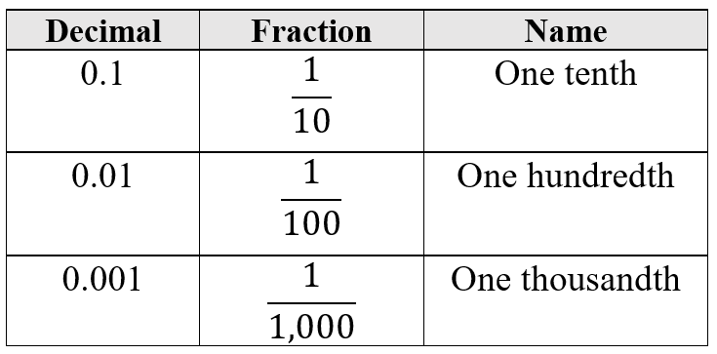

* Base 10 models can concretely model the relationship between fractions and decimals (e.g., 10-by-10 grids, meter sticks, number lines, decimal squares, decimal circles, money).

###### Skills in Practice

While the five process goals are expected to be embedded in each standard, the Skills in Practice highlight the most prevalent process goals in relation to the content presented.

**Mathematical Representations:** When given a model, students may struggle to write the fraction and decimal equivalents represented by the model. For example, given Model A below, most students will easily recognize that the model represents the fraction . However, they may incorrectly write the decimal equivalent as 0.45 or 4.5 or 0.4. These errors indicate that students lack an understanding of how to determine the decimal equivalent when given a fraction. Helping students see connections between decimal numbers (e.g., between fifths and tenths; between fourths and money [quarters]) may help students develop a deeper understanding of the relationships between fractions and decimals.

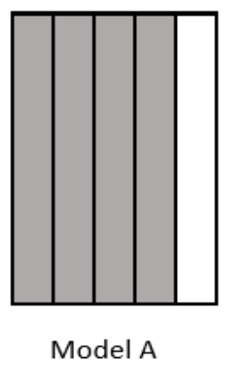

**Mathematical Connections:** Some students have difficulty seeing the connections between fractions and decimals. They see them as two separate types of numbers, rather than recognizing that decimals are another way to represent fractions, and fractions are another way to represent decimals. Students may struggle to relate fraction and decimal models, especially with different sized wholes, and would benefit from additional practice opportunities to match fraction and decimal models with different sized wholes that represent the same amounts. The use of fraction and decimal picture cards may help students develop their understanding of the relationships between fractions and decimals. For example, Square A and Square B below provide a visual representation of how fractions (fourths) are related to decimals.

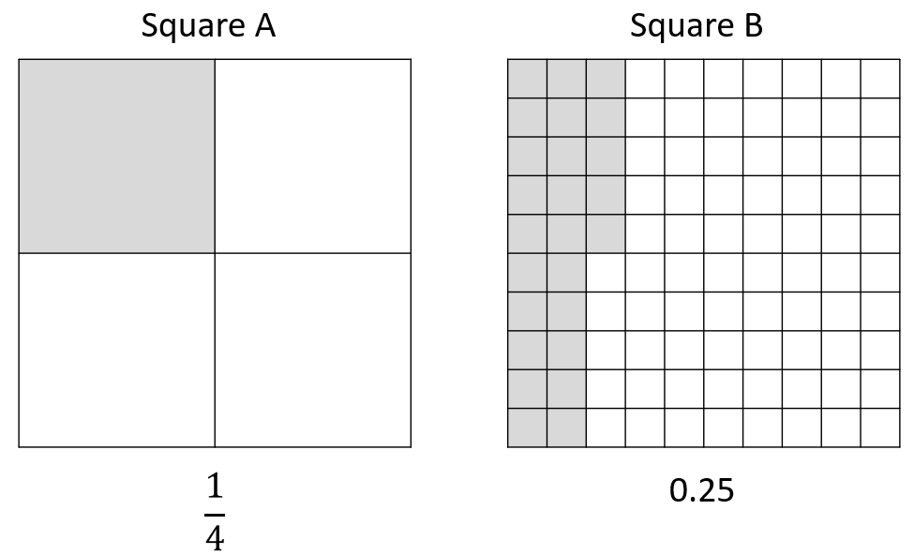

###### Concepts and Connections

Concepts

Flexibility with composing and decomposing base 10 numbers and understanding the structure to build relationships among numbers allows us to quantify, measure, and make decisions in life.

Connections

* *Within the grade level/course*:
  + 4.NS.3 – The student will use mathematical reasoning and justification to represent, compare, and order fractions (proper, improper, and mixed numbers with denominators 12 or less), with and without models.
  + 4.NS.4 – The student will use mathematical reasoning and justification to represent, compare, and order decimals through thousandths, with and without models.
* *Vertical Progression*:
  + 3.NS.3 – The student will use mathematical reasoning and justification to represent and compare fractions (proper and improper) and mixed numbers with denominators of 2, 3, 4, 5, 6, 8, and 10), including those in context.
  + 5.NS.1 – The student will use reasoning and justification to identify and represent equivalency between fractions (with denominators that are thirds, eighths, and factors of 100) and decimals; and compare and order sets of fractions (proper, improper, and/or mixed numbers having denominators of 12 or less) and decimals (through thousandths).

Across Content Areas

Reference 4.NS.1.

###### Resources to Support Local Curriculum

* A list of approved textbooks and instructional materials is posted on the VDOE [website](https://www.doe.virginia.gov/teaching-learning-assessment/k-12-standards-instruction/mathematics/2024-mathematics-textbooks).

## Computation and Estimation

In K-12 mathematics, computation and estimation are integral to developing mathematical proficiency. Computation refers to the process of performing numerical operations, such as addition, subtraction, multiplication, and division. It involves applying strategies and algorithms to solve arithmetic problems accurately and efficiently. Estimation is the process of obtaining a reasonable or close approximation of a result without performing an exact calculation. Estimation is particularly useful when an exact answer is not required, especially in real-world situations, and when assessing the reasonableness of an answer. Computation and estimation are used to support problem solving, critical thinking, and mathematical reasoning by providing students with a range of approaches to solve mathematics problems quickly and accurately.

In Grade 4, students understand that estimation, and the operations of addition, subtraction, multiplication, and division are used to model, represent, and solve different types of problems with whole numbers and positive rational numbers. At this grade level, students represent, solve, and justify solutions to single-step and multistep problems involving addition, subtraction, and multiplication with whole numbers, and single-step problems using division; recall with automaticity multiplication facts through 12 × 12 and the corresponding division facts; solve addition and subtraction problems involving fractions with like denominators; solve problems involving multiplication of a whole number and unit fraction; and solve addition and subtraction problems involving decimals. For building automaticity, the intentional use of timed exercises such as flashcards and/or supplemental handouts aligned to the rigor of the standard that require students to generate many correct responses are highly encouraged.

It is critical at this grade level that while students build their conceptual understanding through concrete and pictorial representations, that students also apply standard algorithms when performing operations as specified within the parameters of each standard of this strand. At this grade level, students become more efficient with problem solving strategies. Fluent use of standard algorithms not only depends on automatic retrieval (automaticity) but also reinforces them. Practice provides the foundation allowing students the ability to achieve mathematically accurate and systematic use of basic skills at a reasonably quick pace – freeing up working memory to solve complex problems in later grades. Automaticity further grounds students’ entry points and the structures needed to solve contextual problems and execute mathematical procedures.

### 4.CE.1

##### The student will estimate, represent, solve, and justify solutions to single-step and multistep problems, including those in context, using addition and subtraction with whole numbers.

1. Students will demonstrate the following Knowledge and Skills:
2. Determine and justify whether an estimate or an exact answer is appropriate when solving contextual problems involving addition and subtraction with whole numbers. Refine estimates by adjusting the final amount, using terms such as *closer to*, *between*, and *a little more than*.
3. Apply strategies (e.g., rounding to the nearest 100 or 1,000, using compatible numbers, other number relationships) to estimate a solution for single-step or multistep addition or subtraction problems with whole numbers, where addends or minuends do not exceed 10,000.*
4. Apply strategies (e.g., place value, properties of addition, other number relationships) and algorithms, including the standard algorithm, to determine the sum or difference of two whole numbers, where addends and minuends do not exceed 10,000.*
5. Estimate, represent, solve, and justify solutions to single-step and multistep contextual problems involving addition and subtraction with whole numbers where addends and minuends do not exceed 1,000,000.

* On the state assessment, items measuring this objective are assessed without the use of a calculator.

###### Understanding the Standard

* Estimation skills are valuable, time-saving tools particularly in practical situations when exact answers are not required, and can be used in determining the reasonableness of the sum or difference when solving for the exact answer.
* An estimate is a number that lies within a range of the exact solution, and the estimation strategy used in a particular problem determines how close the estimate is to the exact solution. Estimates involve using friendlier numbers to mentally compute a reasonable answer before any exact computation is calculated.
* Students should explore reasons for estimation, using practical experiences, and use various estimation strategies to solve contextual problems. Estimation strategies include rounding, using compatible numbers, and front-end estimation.
* When estimating, students should consider whether it is important that the estimate is greater than or less than the exact answer. In the following examples using the same addends, each estimation strategy results in a different sum, so students should be encouraged to examine the context and the demand for precision when deciding which estimation strategy to use.
  + Rounding numbers is one estimation strategy and may be introduced through the use of a number line. When given a number to round, use multiples of ten, hundred, thousand, ten thousand, or hundred thousand as benchmarks and use the nearest benchmark value to represent the number. For example, using rounding to the nearest hundred to estimate the sum of 255 + 481 would result in 300 + 500 = 800.
  + Using compatible numbers is another estimation strategy. Compatible numbers are pairs of numbers that are easy to add and subtract mentally. For example, using compatible numbers to estimate the sum of 255 + 481 could result in 250 + 500 = 750.
  + Using front-end estimation is another estimation strategy. Front-end estimation involves truncating numbers to the highest place value to compute. For example, using front-end estimation to estimate the sum of 255 + 481 would result in 200 + 400 = 600.
* Students would benefit from hearing the estimation strategies of other classmates and from discussions about how different estimation strategies produce different answers (e.g., rounding numbers may produce an estimate closer to the actual answer than using front-end estimation).
* When an exact answer is required, opportunities to explore whether the answer can be determined mentally or must involve paper and pencil, or calculators help students select the most efficient approach.
* Number lines are useful tools when developing a conceptual understanding of rounding with whole numbers. When given a number to round, locate it on the number line. Next, determine the closest multiples of thousand, ten thousand, or hundred thousand it is between. Then, identify to which it is closer.
* Grade 4 students should explore and apply the properties of addition as strategies for solving addition and subtraction problems using a variety of representations (e.g., manipulatives, diagrams, and symbols).
* The properties of the operations are “rules” about how numbers work and how they relate to one another. Students at this level do not need to use the formal terms for these properties but should utilize these properties to further develop flexibility and fluency in solving problems. The following properties are most appropriate for exploration at this level:
  + The identity property of addition states that if zero is added to a given number, the sum is the same as the given number (e.g., 24 + 0 = 24);
  + The commutative property of addition states that changing the order of the addends does not affect the sum (e.g., 24 + 136 = 136 + 24);
  + The associative property of addition states that the sum stays the same when the grouping of addends is changed (e.g., 15 + (35 + 16) = (15 + 35) + 16).
* Computational fluency is the ability to think flexibly in order to choose appropriate strategies to solve problems accurately and efficiently. A certain amount of practice is necessary to develop fluency with computational strategies. The practice must be motivating and systematic if students are to develop fluency in computation.
* An expression is a representation of a quantity. It is made up of numbers, variables, and/or computational symbols. It does not have an equal symbol (e.g., 8, 15 × 12).
* Mathematical relationships can be expressed using equations. An equation represents the relationship between two expressions of equal value (e.g., 12 × 4 = 60 − 12).
* The equal symbol (=) means that the values on either side are equivalent (balanced).
* The not equal symbol (≠) means that the values on either side are not equivalent (not balanced).
* In problem solving, emphasis should be placed on thinking and reasoning rather than on key words. Focusing on key words such as *in all, altogether, difference,* etc.,encourages students to perform a particular operation rather than make sense of the context of the problem. A key-word focus prepares students to solve a limited set of problems and often leads to incorrect solutions as well as challenges in upcoming grades and courses.
* Bar diagrams serve as a model that can provide students ways to visualize, represent, and understand the relationship between known and unknown quantities and to solve problems.

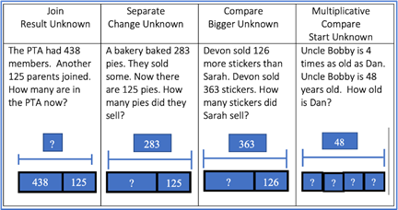

###### Skills in Practice

While the five process goals are expected to be embedded in each standard, the Skills in Practice highlight the most prevalent process goals in relation to the content presented.

**Mathematical Problem Solving:** Problem solving requires both an ability to correctly define a problem and find a solution to it. Model effective practices that demonstrate for students how to arrive at their solutions through estimation, exactness, and justification. To unpack contextual problems, guide students through the problem-solving process by taking care to annotate *essential vocabulary* (not “key words”) related to applied operations. For example –

* + Understand the problem by reading and then re-reading the problem; imagining the problem or drawing a picture; underlining or highlighting the important information and essential vocabulary within the problem.
  + Create a plan by deciding what to do and how to solve the problem using the applicable operation(s).
  + Carry out the plan by showing all work to represent thinking (e.g., using symbols, words, concrete manipulatives, pictorial representations).
  + Check the solution by determining if the solution answers the question asked in the contextual problem. During this phase of problem solving, it is essential that students are exposed to strategies that allow them to determine the reasonableness of their responses and solutions; and to support multiple mathematically sound and accurate ways of arriving at a solution.
  + Graphic organizers such as the four-square model (Polya method) can help students to organize their thinking as they solve contextual problems –

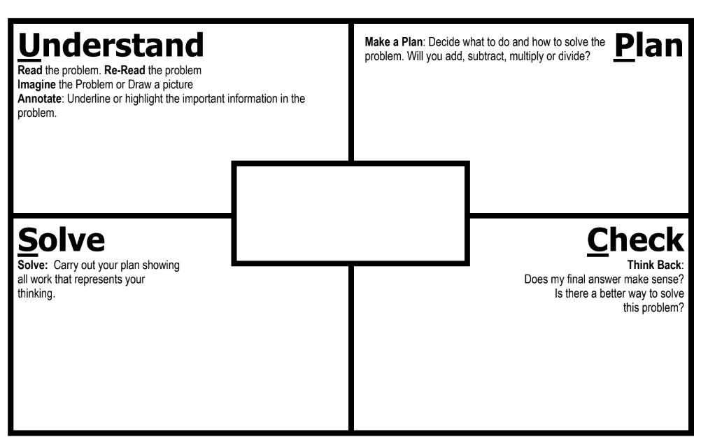

* + As students solve contextual problems, ask questions such as –
    - Are there multiple ways to solve a single problem?
    - How do you know that you have provided a reasonable answer?
    - What role does estimation play in solving contextual problems?
* As students engage in solving problems, including those in context, they should solve a variety of single-step and multistep problems using addition and subtraction. At this level, there are several common errors that students make when adding and subtracting larger numbers. Some examples of common errors are included in the chart below.

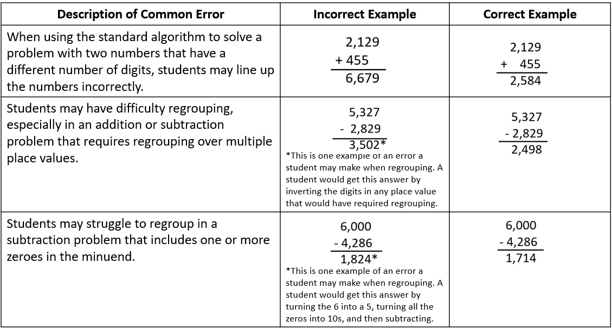

* Students who demonstrate consistent computation errors would benefit from experiences using concrete manipulatives to build conceptual understanding. In addition, opportunities to hear a variety of computation strategies shared by peers may also expose students to alternate, efficient strategies that are less reliant on regrouping. Examples of strategies that students may share are included in the chart below.

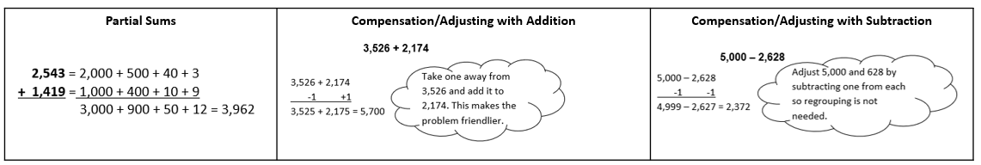

**Mathematical Reasoning:**

* Solving problems in contextual situations enhances proficiency with estimation strategies. Reasoning skills are essential for solving problems effectively and strategically. Reasoning involves analyzing information, identifying assumptions, evaluating evidence, and drawing logical conclusions. When solving problems in context, students may have difficulty understanding which operation(s) to use and may use the wrong operation(s) when solving. Students may not realize that all numbers in a contextual problem are not always needed. To help students derive the meaning of which operation to apply, ask students how thinking about the meaning of addition can help when solving word problems. Give students a chance to explain individually and share their thoughts with each other. Repeat this process for subtraction, multiplication, and division. Have students explain the action of the word to move away from a reliance on “key words.” For example –
  + Addition:
    - Finding the total quantity of separate quantities
    - Combining two or more quantities
  + Subtraction:
    - Finding how much more or how much less
    - Finding how much further
    - Finding the difference between two quantities
    - Determining a quantity when taking one amount from another
* As students engage in solving problems, including those in context, they should be encouraged to begin with estimating. There are many ways to estimate (e.g., rounding, using compatible numbers) and students would benefit from hearing peers’ estimation strategies. Class discussions about how different estimation strategies produce different estimates, whether an estimate will be greater than or less than the exact answer, and how estimates can help determine the reasonableness of an answer will help students develop a robust toolkit of estimation strategies.

**Mathematical Connections:** Students must connect fluency of facts, concepts, procedures, and mathematical language through mathematical reasoning to effectively solve contextual problems. Fluency with rational numbers at this grade level will help with improving logical reasoning skills, which will then lend themselves to solving contextual problems. In the following example, first, students must use their previous understanding of computation with whole numbers. Next, students must apply their understanding of mathematical language to determine which operation(s) to use, and with this information, design a plan to solve the solution. Lastly, students must determine the reasonableness of their solution by providing their reasoning.

###### Concepts and Connections

Concepts

The operations of addition, subtraction, multiplication, and division are used to represent and solve many different types of problems.

Connections

* *Within the grade level/course*:
  + 4.NS.1 – The student will use place value understanding to read, write, and identify the place and value of each digit in a nine-digit whole number.
  + 4.PS.1 – The student will apply the data cycle (formulate questions; collect or acquire data; organize and represent data; and analyze data and communicate results) with a focus on line graphs.
  + 4.PFA.1 – The student will identify, describe, extend, and create increasing and decreasing patterns (limited to addition, subtraction, and multiplication of whole numbers), including those in context, using various representations.
* *Vertical Progression*:
  + 3.CE.1 – The student will estimate, represent, solve, and justify solutions to single-step and multistep problems, including those in context, using addition and subtraction with whole numbers where addends and minuends do not exceed 1,000.
  + 5.CE.1 – The student will estimate, represent, solve, and justify solutions to single-step and multistep contextual problems using addition, subtraction, multiplication, and division with whole numbers.

###### Resources to Support Local Curriculum

* A list of approved textbooks and instructional materials is posted on the VDOE [website](https://www.doe.virginia.gov/teaching-learning-assessment/k-12-standards-instruction/mathematics/2024-mathematics-textbooks).
* Addition and Subtraction with Whole Numbers Exemplar Mathematics Instructional Plan ([Word](https://www.doe.virginia.gov/home/showpublisheddocument/51789/638398746514500000) | [PDF](https://www.doe.virginia.gov/home/showpublisheddocument/51791/638398746520270000))

### 4.CE.2

##### The student will estimate, represent, solve, and justify solutions to single-step and multistep problems, including those in context, using multiplication with whole numbers, and single-step problems, including those in context, using division with whole numbers; and recall with automaticity the multiplication facts through 12 × 12 and the corresponding division facts.

1. Students will demonstrate the following Knowledge and Skills:
2. Determine and justify whether an estimate or an exact answer is appropriate when solving contextual problems involving multiplication and division of whole numbers. Refine estimates by adjusting the final amount, using terms such as *closer to*, *between*, and *a little more than*.
3. Recall with automaticity the multiplication facts through 12 × 12 and the corresponding division facts.*
4. Create an equation using addition, subtraction, multiplication, and division to represent the relationship between equivalent mathematical expressions (e.g., 4 × 3 = 2 × 6; 10 + 8 = 36 ÷ 2; 12 × 4 = 60 12).
5. Identify and use the appropriate symbol to distinguish between expressions that are equal and expressions that are not equal, using addition, subtraction, multiplication, and division (e.g., 4 × 12 = 8 × 6 and 64 ÷ 8 ≠ 8 × 8).
6. Determine all factor pairs for a whole number 1 to 100, using concrete, pictorial, and numerical representations.
7. Determine common factors and the greatest common factor of no more than three numbers.
8. Apply strategies (e.g., rounding, place value, properties of multiplication and/or addition) and algorithms, including the standard algorithm, to estimate and determine the product of two whole numbers when given:
   1. a two-digit factor and a one-digit factor*
   2. a three-digit factor and a one-digit factor*
   3. a two-digit factor and a two-digit factor*
9. Estimate, represent, solve, and justify solutions to single-step and multistep contextual problems that involve multiplication with whole numbers.
10. Apply strategies (e.g., rounding, compatible numbers, place value) and algorithms, including the standard algorithm, to estimate and determine the quotient of two whole numbers, given a one-digit divisor and a two- or three-digit dividend, with and without remainders.*
11. Estimate, represent, solve, and justify solutions to single-step contextual problems involving division with whole numbers.
12. Interpret the quotient and remainder when solving a contextual problem.

* On the state assessment, items measuring this objective are assessed without the use of a calculator.

###### Understanding the Standard

* Estimation skills are valuable, time-saving tools particularly in practical situations when exact answers are not required and can be used in determining the reasonableness of the product or quotient when solving for the exact answer.
* An estimate is a number that lies within a range of the exact solution, and the estimation strategy used in a particular problem determines how close the estimate is to the exact solution. Estimates involve using friendlier numbers to mentally compute a reasonable answer before any exact computation is calculated.
* Students should explore reasons for estimation, using practical experiences, and use various estimation strategies to solve contextual problems. Estimation strategies include rounding, using compatible numbers, and front-end estimation.
* When estimating, students should consider whether it is important that the estimate is greater than or less than the exact answer. Students should be encouraged to examine the context and the demand for precision in deciding which estimation strategy to use.
* Students would benefit from hearing the estimation strategies of other classmates and from discussions about how different estimation strategies produce different answers (e.g., rounding numbers may produce an estimate closer to the actual answer than using front-end estimation).
* Rounding numbers is one estimation strategy and may be introduced with a number line. When given a number to round, use multiples of ten, hundred, or thousand as benchmarks and use the nearest benchmark value to represent the number.
* Using compatible numbers is another estimation strategy. Compatible numbers are pairs of numbers that are easy to multiply and divide mentally.
* Using front-end estimation is another estimation strategy. Front-end estimation involves truncating numbers to the highest place value to compute.
* When an exact answer is required, opportunities to explore whether the answer can be determined mentally or must involve paper and pencil, or calculators help students select the most efficient approach.
* The properties of the operations are “rules” about how numbers work and how they relate to one another. Students at this level do not need to use the formal terms for these properties but should utilize these properties to further develop flexibility and fluency in solving problems. The following properties are most appropriate for exploration at this level:
  + the identity property of multiplication states that if a given number is multiplied by one, the product is the same as the given number (e.g., 8 × 1 = 8)
  + the commutative property of multiplication states that changing the order of the factors does not affect the product (e.g., 12 × 43 = 43 × 12)
  + the associative property of multiplication states that the product stays the same when the grouping of factors is changed (e.g., 16 × (40 × 5) = (16 × 40) × 5)
  + The distributive property states that multiplying a sum by a number gives the same result as multiplying each addend by the number and then adding the products. Several examples are shown below:
    - 3(9) = 3(5 + 4) = (3 × 5) + (3 × 4) = 15 + 12 = 27
    - 5 × (3 + 7) = (5 × 3) + (5 × 7) = 15 + 35 = 50
    - (2 × 3) + (2 × 5) = 2 × (3 + 5) = 2 × 8 = 16
    - 9 × 23 = 9(20 + 3) = 180 + 27 = 207
  + The distributive property can also be demonstrated using an area model, as shown below:

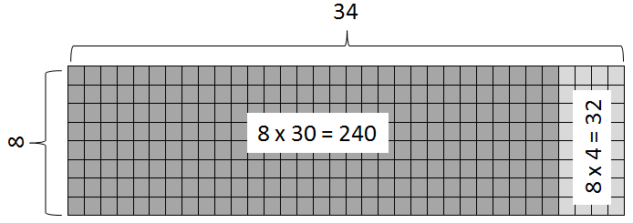

* In Grade 3, students developed an understanding of the meanings of multiplication and division of whole numbers through activities and contextual problems involving equal-sized groups, arrays, and length models. In addition, students worked to develop recall with automaticity of multiplication facts through 10 × 10 along with the corresponding division facts.
* Students develop an understanding of the meaning of multiplication and division of whole numbers through activities and contextual problems that involve equal-sets or equal-groups, arrays, and length models.
* The equal-sets or equal-groups model lends itself to sorting a variety of concrete objects into equal groups and reinforces the concept of multiplication as a way to find the total number of items in a collection of groups, with the same amount in each group, and the total number of items can be found by repeated addition or skip counting.

Image showing three groups of four circles, with an oval around each group of circles.

* The array model, consisting of rows and columns (e.g., three rows of four columns for a 3-by-4 array), helps build an understanding of the commutative property.

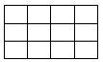

* The length model (e.g., a number line) also reinforces repeated addition or skip counting.

Number line showing three jumps of four

* Multiplication and division are inverse operations.
* Dividing by zero is undefined because it always leads to a contradiction. In the example below, there is no single defined number possibility for dividing by 0, since zero multiplied by any number is zero: If 12 ÷ 0 = r, then r · 0 = 12.
* Computational fluency is the ability to think flexibly in order to choose appropriate strategies to solve problems accurately and efficiently. The development of computational fluency relies on quick access to number facts. The patterns and relationships that exist in the facts can be used to learn and retain the facts. By studying patterns and relationships, students build a foundation for fluency with multiplication and division facts.
* In developing and using strategies to learn the multiplication facts through the twelves table, students should use concrete materials, hundreds charts, and mental mathematics. Strategies to learn the multiplication facts include an understanding of:
  + multiples
  + doubles
  + properties of zero and one as factors
  + building from foundational facts (distributive property)
  + commutative property
  + related facts
* Strategies that allow students to derive unknown multiplication facts include:
  + doubles (2s facts; double 9 is 18 so 9 × 2 = 18)
  + doubling twice (4s facts; double 6 is 12 and double 12 is 24 so 6 × 4 = 24)
  + doubling three times (8s facts; double 7 is 14 and double 14 is 28 and double 28 is 56 so 7 × 8 = 56)
  + halving (5s facts are half of ten; half of 80 is 40 so 8 × 5 = 40)
  + decomposing into known facts using the distributive property (e.g., 7 × 3 can be thought of as (5 × 3) + (2 × 3))
  + building up and building down from known facts (9 × 3 can be thought of as (10 × 3) – (1 × 3))
  + the inverse relationship between division and multiplication (5 × 3 = 15 so 15 ÷ 3 = 5)
  + halving (2s facts; half of 16 is 8 so 16 ÷ 2 = 8)
  + halving twice (4s facts; half of 28 is 14 and half of 14 is 7 so 28 ÷ 4 = 7)
  + halving three times (8s facts; half of 48 is 24, half of 24 is 12, and half of 12 is 6 so 48 ÷ 8 = 6)

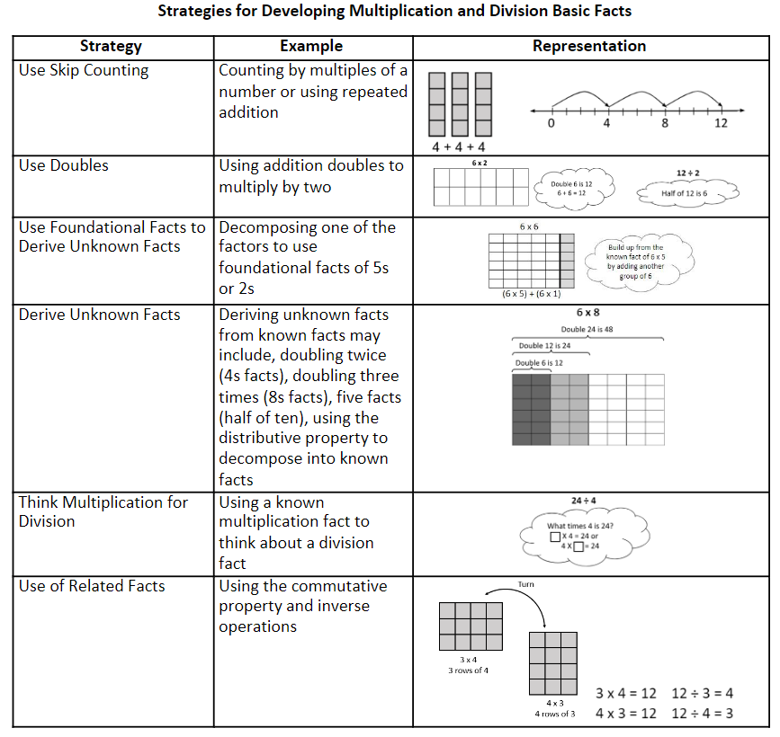

* Meaningful practice of computation strategies can be attained through hands-on activities, manipulatives, and graphic organizers.
* A certain amount of practice is necessary to develop fluency with computational strategies. The practice must be motivating and systematic if students are to develop fluency in computation.
* Automaticity of facts can be achieved through timed exercises such as flashcards and/or supplemental handouts to generate many correct responses in a short amount of time.
* An expression is a representation of a quantity. It is made up of numbers, variables, and/or computational symbols. It does not have an equal symbol (e.g., 8, 15 × 12).
* Mathematical relationships can be expressed using equations. An equation represents the relationship between two expressions of equal value (e.g., 12 × 4 = 60 − 12).
* The equal symbol (=) means that the values on either side are equivalent (balanced).
* The not equal symbol (≠) means that the values on either side are not equivalent (not balanced).
* The terms associated with multiplication are listed below:

Image showing the terms associated with multiplication. Sample problem 4 times 3 equals 12, with the word factor under the 4 and the 3, and the word product under the 12.

* A factor is a number that divides evenly into another number, leaving no remainder. In other words, if multiplying two whole number[s](https://www.splashlearn.com/math-vocabulary/number-sense/whole-numbers) gives us a product, then the numbers we are multiplying are factors of the product because the product is divisible by the factors.
* A common factor of two or more numbers is a divisor that all of the numbers share.
* The greatest common factor (GCF) of two or more numbers is the largest of the common factors that all of the numbers share.

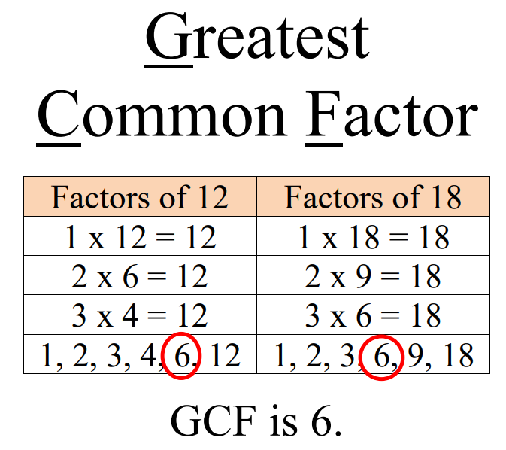

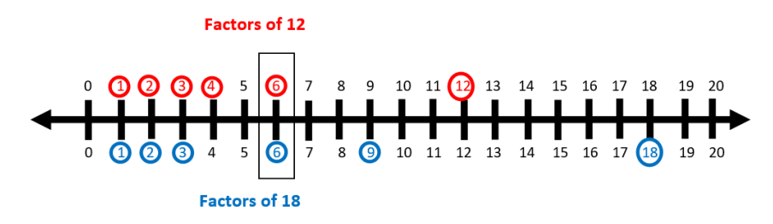

* The formats and terms associated with division are listed below:

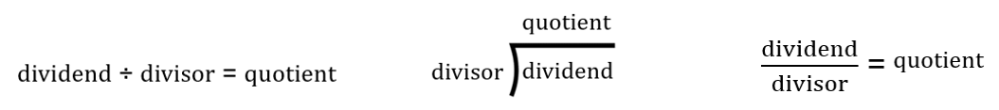

* Division is the operation of making equal groups. When the original amount and the number of groups are known, divide to determine the size of each group. When the original amount and the size of each group are known, divide to determine the number of groups. Both situations may be modeled with base 10 blocks, place value chips, or other manipulatives.

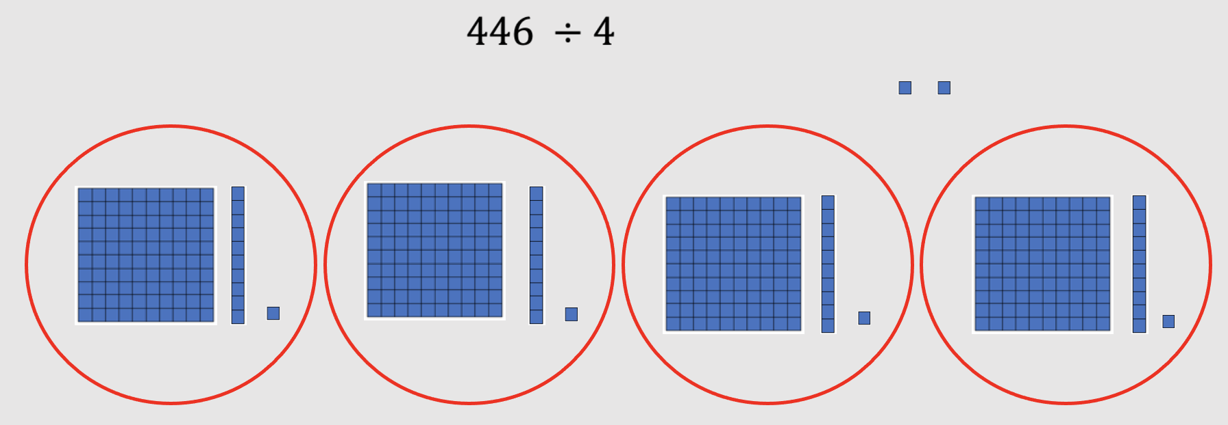 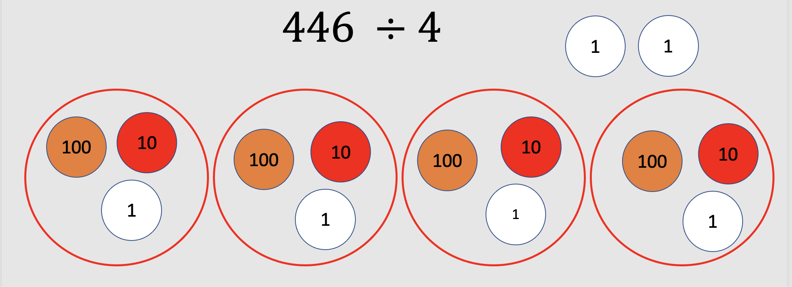

* Students benefit from experiences with various methods of division, such as repeated subtraction, partial quotients, and the standard algorithm.
* In problem solving, emphasis should be placed on thinking and reasoning rather than on key words. Focusing on key words such as *in all, altogether, difference,* etc.,encourages students to perform a particular operation rather than make sense of the context of the problem. A key-word focus prepares students to solve a limited set of problems and often leads to incorrect solutions as well as challenges in upcoming grades and courses.
* Extensive research has been undertaken over the last several decades regarding different problem types. Many of these studies have been published in professional mathematics education publications using different labels and terminology to describe the varied problem types. Some examples are included in the following chart:

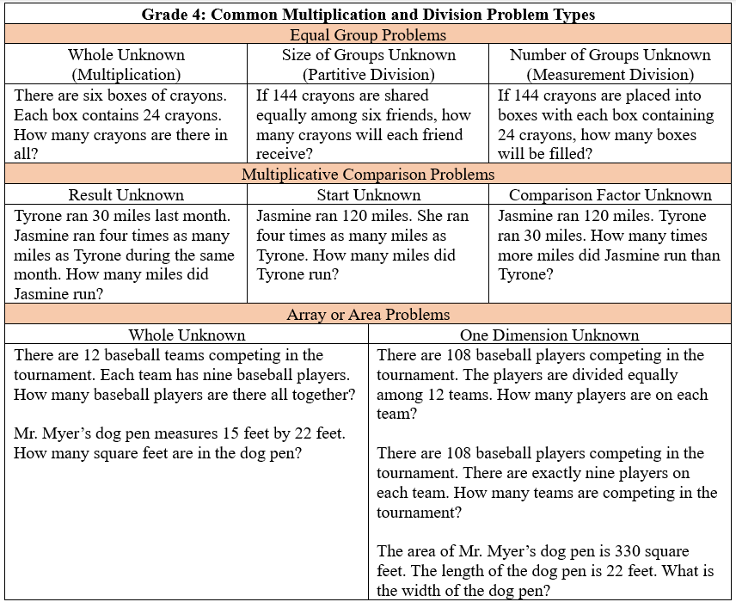

* Students need exposure to various types of contextual division problems in which they must interpret the quotient and remainder based on the context. The chart below includes an example of each type of problem.

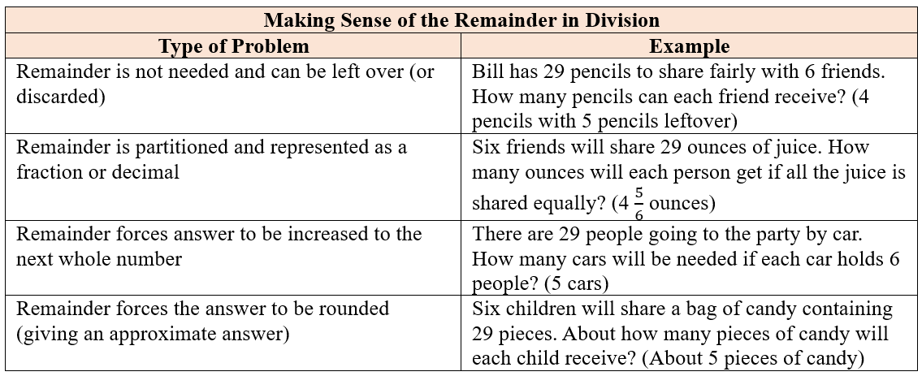

* Bar diagrams serve as a model that can provide students with ways to visualize, represent, and understand the relationship between known and unknown quantities and to solve problems.

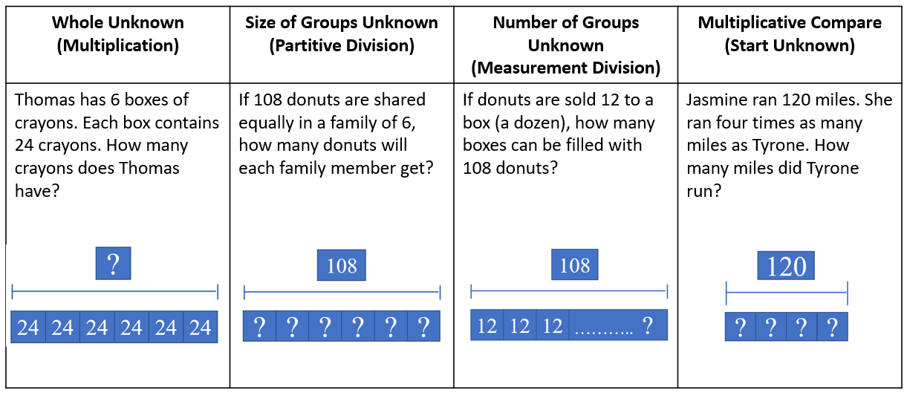

* Students will solve problems involving the division of decimals in Grade 5.

###### Skills in Practice

While the five process goals are expected to be embedded in each standard, the Skills in Practice highlight the most prevalent process goals in relation to the content presented.

**Mathematical Problem Solving:** Problem solving requires both an ability to correctly define a problem and find a solution to it. Model effective practices that demonstrate for students how to arrive at their solutions through estimation, exactness, and justification. To unpack contextual problems, guide students through the problem-solving process by taking care to annotate *essential vocabulary* (not “key words”) related to applied operations. For example –

* + Understand the problem by reading and then re-reading the problem; imagining the problem or drawing a picture; underlining or highlighting the important information and essential vocabulary within the problem.
  + Create a plan by deciding what to do and how to solve the problem using the applicable operation(s).
  + Carry out the plan by showing all work to represent thinking (e.g., using symbols, words, concrete manipulatives, pictorial representations).
  + Check the solution by determining if the solution answers the question asked in the contextual problem. During this phase of problem solving, it is essential that students are exposed to strategies that allow them to determine the reasonableness of their responses and solutions; and to support multiple mathematically sound and accurate ways of arriving at a solution.
  + Graphic organizers such as the four-square model (Polya method) can help students to organize their thinking as they solve contextual problems –



* As students solve contextual problems, ask questions such as –
  + Are there multiple ways to solve a single problem?
  + How do you know that you have provided a reasonable answer?
  + What role does estimation play in solving contextual problems?
* Automatic retrieval of facts (automaticity) allows students more mental energy to devote to relatively complex mathematical tasks and execute multistep mathematical procedures. Thus, building automatic fact retrieval in students is one (of many) important goal when engaging in problem solving.
  + Ensure that students have an efficient strategy to use as solve basic facts. When teaching basic facts, instruction should be organized related to number patterns (see list of multiplication strategies in Understanding the Standard section). For example, when solving single-step multiplication facts within 10 × 10, students should use flexible counting strategies and/or models (e.g., arrays, number lines) to develop their automaticity while also developing their conceptual understanding of multiplication and division. Students should demonstrate their understanding using words, objects, drawings, and numbers. For example, when given 3 × 4 = ___, students can create a concrete model or pictorial representation. A number line (see below) is one strategy that can be used to support students’ learning of math facts to build both automaticity and procedural fluency.

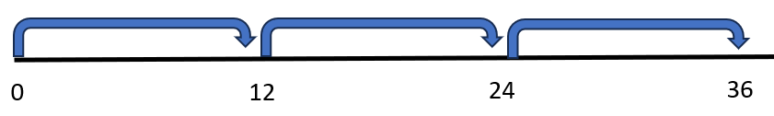

* Timed activities should be added once students have been working on developing accuracy and flexibility with such facts over many lessons. Choose the activity and materials to use in the timed activity while setting clear expectations. Timed activities can be structured for students to work together as a group or individually. If using worksheets for fluency, discuss students’ answers after time has been called and ask students to correct and explain any missed items. For group timed activities, students can work in pairs or small groups, taking turns to respond or responding all at once. For group activities or flash cards with a teacher, teachers should provide immediate feedback. If students are incorrect, teachers should allow students to self-correct and help them do so if necessary. Having students chart their individual progress over time can build motivation to set goals and encourage students to stay focused on achieving fluency and automaticity.
* Computational fluency is the ability to think flexibly in order to choose appropriate strategies to solve problems accurately and efficiently. The development of computational fluency relies on quick access to number facts. The patterns and relationships that exist in the facts can be used to learn and retain the facts. By studying patterns and relationships, students build a foundation for fluency with multiplication and division facts.
* When solving contextual problems, especially those that require multiple steps to solve, students may have difficulty approaching the problem and determining what operations are needed to solve the problem. Exposing students to a variety of problem types that require different operations to solve (see the chart “Multiplication and Division Problem Types” in Understanding the Standard) will help students become more comfortable with problem solving. In Grade 4, students begin solving contextual division problems that include a remainder. It is important for students to have experience with types of problems that require the remainder to be interpreted in different ways (see the chart “Making Sense of the Remainder in Division” in Understanding the Standard).

**Mathematical Communication:** Teach students a solution method for solving each problem type. Introduce a solution method using a worked-out example. Talk through the problem-solving process and connect the relevant problem information to the worked-out example. Say out loud the decisions that were made to solve the problem at each step. Then demonstrate how to apply the solution method by solving a similar problem with students using that method. Discuss each decision made and ask students guiding questions to engage them as problems are solved.

**Mathematical Reasoning:** Solving problems in contextual situations enhances proficiency with estimation strategies. Reasoning skills are essential for solving problems effectively and strategically. Reasoning involves analyzing information, identifying assumptions, evaluating evidence, and drawing logical conclusions. Students should apply a variety of reasoning strategies as they build the accuracy and flexibility components of fluency with multiplication and division up to 12 × 12 (e.g., skip counting, number lines, arrays).

* When solving problems in context, students may have difficulty understanding which operation(s) to use and may use the wrong operation(s) when solving. Students may not realize that all numbers in a contextual problem are not always needed. To help students derive the meaning of which operation to apply, ask students how thinking about the meaning of addition can help when solving word problems. Give students a chance to explain individually and share their thoughts with each other. Repeat this process for subtraction, multiplication, and division. *Have students explain the action of the word to move away from a reliance on “key words.”* For example –
  + Addition:
    - Finding the total quantity of separate quantities
    - Combining two or more quantities
  + Subtraction:
    - Finding how much more or how much less
    - Finding how much further
    - Finding the difference between two quantities
    - Determining a quantity when taking one amount from another
  + Multiplication:
    - Finding the quantity needed for *x* number of people or *x* number of something
    - Having equal groups and finding the total of all groups
    - Finding a part (fraction) of a whole number
    - Taking a part of a part (fraction of a fraction)
  + Division:
    - Dividing an item (or quantity) into equal sized pieces
    - Dividing a quantity into equal groups
    - Using an equal amount of something over time
    - Determining how many fractional groups can be made from a quantity
* Basic fact strategies use number relationships and benchmarks and support students, merging conceptual understanding and procedural fluency. Strategies such as “five facts plus an extra group” to determine the × 6 facts will help students build a foundation for strategies beyond basic facts. For example –

**7** × **6 = _____**

When looking at this problem, students need to determine the total of 7 groups of 6 objects. Square tiles may be used to create an array that contains 7 rows, with 6 square tiles in each row. Students would then determine how many square tiles are in the array to determine the product of 7 × 6. For example, students may recognize that 7 × 5 = 35, and that they then need to add one more group of 7, for a total of 42. To transfer from the concrete, students would draw an array with 7 rows, with each row to include 6 squares. The product (42) is how many squares are drawn in all.

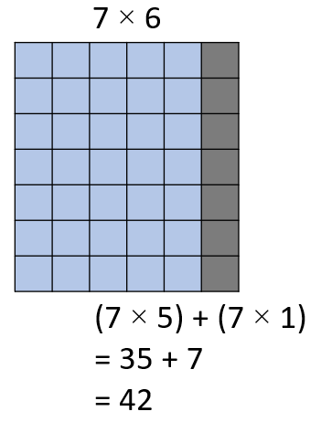

* As students begin to solve computation problems with larger numbers, estimation is an important strategy that students can use to determine an approximate answer prior to solving, and to verify the reasonableness of a solution after solving. There are many ways to estimate, and students should have experiences estimating products and quotients in multiple ways. Two ways of estimating, rounding and using compatible numbers, are demonstrated in the table below.

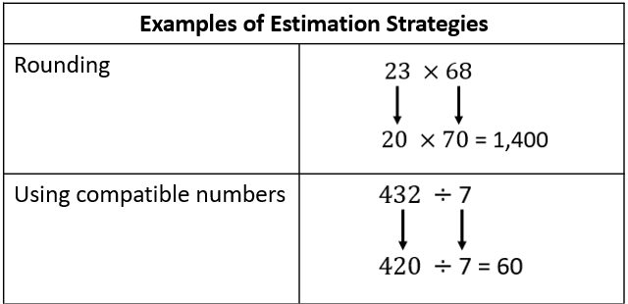

**Mathematical Connections:**

* When writing a set of related facts, students commonly struggle with writing the division facts accurately. For example, given the fact 11 × 12 = 132, students may incorrectly write 11 ÷ 12 = 132 as a related division fact. Students are often more comfortable with multiplication than division. With practice composing, decomposing, modeling, looking at relationships among fact families, and having students provide verbal explanations, students can better understand how multiplication and division are related, helping to develop their accuracy and flexibility components of computational fluency.
* Students must connect fluency of facts, concepts, procedures, and mathematical language through mathematical reasoning to effectively solve contextual problems. Fluency with rational numbers at this grade level will help with improving logical reasoning skills, which will then lend themselves to solving contextual problems. In the following example, first, students must use their previous understanding of computation with whole numbers. Next, students must apply their understanding of mathematical language to determine which operation(s) to use, and with this information, design a plan to solve the solution. Lastly, students must determine the reasonableness of their solution by providing their reasoning. An example, with common errors, is provided below.

The Corner Bakery was packing cupcakes into boxes. Each box can hold 15 cupcakes. They filled 22 boxes of cupcakes and had 10 cupcakes left over. How many total cupcakes did they bake?

A common mistake that students make is to add all of the numbers in the problem, resulting in an incorrect answer of 47. This may indicate that students are unsure of what operations are needed to solve the problem. Another common mistake is for students to correctly multiply 15 × 22 but subtract 10 instead of adding 10. This indicates that students may be relying on the use of key words (“left over”) to determine what operation to perform. Students who make these errors would benefit from additional experiences visualizing and representing the action that occurs in a contextual situation.

###### Concepts and Connections

Concepts

The operations of addition, subtraction, multiplication, and division are used to represent and solve many different types of problems.

Connections

* *Within the grade level/course*:
  + 4.CE.1 – The student will estimate, represent, solve, and justify solutions to single-step and multistep problems, including those in context, using addition and subtraction with whole numbers.
  + 4.PFA.1 – The student will identify, describe, extend, and create increasing and decreasing patterns (limited to addition, subtraction, and multiplication of whole numbers), including those in context, using various representations.
* *Vertical Progression*:
  + 3.CE.2 – The student will recall with automaticity multiplication and division facts through 10 × 10; and represent, solve, and justify solutions to single-step contextual problems using multiplication and division with whole numbers.
  + 5.CE.1 – The student will estimate, represent, solve, and justify solutions to single-step and multistep contextual problems using addition, subtraction, multiplication, and division with whole numbers.

###### Resources to Support Local Curriculum

* A list of approved textbooks and instructional materials is posted on the VDOE [website](https://www.doe.virginia.gov/teaching-learning-assessment/k-12-standards-instruction/mathematics/2024-mathematics-textbooks).
* Multiplying Two-Digit Numbers: Bridging from the Concrete to the Symbolic Exemplar Mathematics Instructional Plan   
  ([Word](https://www.doe.virginia.gov/home/showpublisheddocument/51797/638398746535130000) | [PDF](https://www.doe.virginia.gov/home/showpublisheddocument/51799/638398746540270000))

### 4.CE.3

##### The student will estimate, represent, solve, and justify solutions to single-step problems, including those in context, using addition and subtraction of fractions (proper, improper, and mixed numbers with like denominators of 2, 3, 4, 5, 6, 8, 10, and 12), with and without models; and solve single-step contextual problems involving multiplication of a whole number (12 or less) and a unit fraction, with models.

1. Students will demonstrate the following Knowledge and Skills:
2. Estimate and determine the sum or difference of two fractions (proper or improper) and/or mixed numbers, having like denominators limited to 2, 3, 4, 5, 6, 8, 10, and 12 (e.g., + , 2 + , - ) and simplify the resulting fraction. Addition and subtraction with fractions may include regrouping.*
3. Estimate, represent, solve, and justify solutions to single-step contextual problems using addition and subtraction with fractions (proper or improper) and/or mixed numbers, having like denominators limited to 2, 3, 4, 5, 6, 8, 10, and 12, and simplify the resulting fraction. Addition and subtraction with fractions may include regrouping.
4. Solve single-step contextual problems involving multiplication of a whole number, limited to 12 or less, and a unit fraction (e.g., 6 × , × 8, 2 × ), with models.*
5. Apply the inverse property of multiplication in models (e.g., use a visual fraction model to represent or 1 as the product of 4 × ).

* On the state assessment, items measuring this objective are assessed without the use of a calculator.

###### Understanding the Standard

* Students should have exposure to a variety of representations of fractions, both concrete and pictorial (e.g., fraction bars, fraction circles, length models, area models, set models).
* Reasonable estimates to problems involving addition and subtraction of fractions can be established by using benchmarks such as 0, , and 1. For example, and are both greater than , so their sum is greater than 1.
* An estimate is a number that lies within a range of the exact solution, and the estimation strategy used in a particular problem determines how close the estimate is to the exact solution. Estimates involve using friendlier numbers to mentally compute a reasonable answer before any exact computation is calculated.
* Students should explore reasons for estimation, using practical experiences, and use various estimation strategies to solve contextual problems. Estimation strategies include rounding, using compatible numbers, and front-end estimation.
* When estimating, students should consider whether it is important that the estimate is greater than or less than the exact answer. Students should be encouraged to examine the context and the demand for precision in deciding which estimation strategy to use.
* Students would benefit from hearing the estimation strategies of other classmates and from discussions about how different estimation strategies produce different answers (e.g., rounding numbers may produce an estimate closer to the actual answer than using front-end estimation).
* Students should investigate addition and subtraction with fractions using a variety of models (e.g., fraction circles, fraction strips, pattern blocks, number lines, rulers).
* Students should explore composing and decomposing fractions as a strategy for the addition and subtraction of fractions, as demonstrated in the example below.

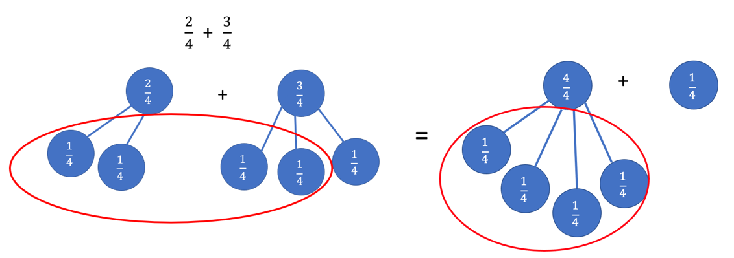

* Proper fractions, improper fractions, and mixed numbers are terms often used to describe fractions. A proper fraction is a fraction whose numerator is less than the denominator. An improper fraction is a fraction whose numerator is equal to or greater than the denominator. An improper fraction may be expressed as a mixed number. A mixed number is written with two parts: a whole number and a proper fraction (e.g., 3).
* Instruction involving addition and subtraction of fractions should include experiences with proper fractions, improper fractions, and mixed numbers as addends, minuends, subtrahends, sums, and differences.
* In Grade 4, students are expected to solve fraction addition and subtraction problems that require regrouping. Some examples of regrouping using models are shown below.
  + Addition of Proper Fractions with Regrouping and Simplifying:

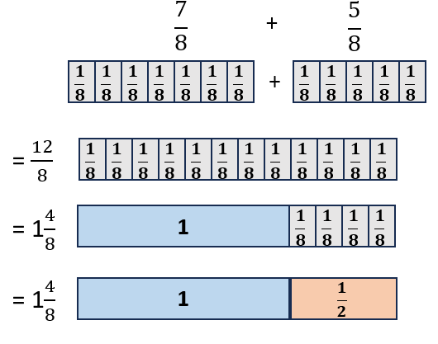

* + Addition of Mixed Numbers with Regrouping:

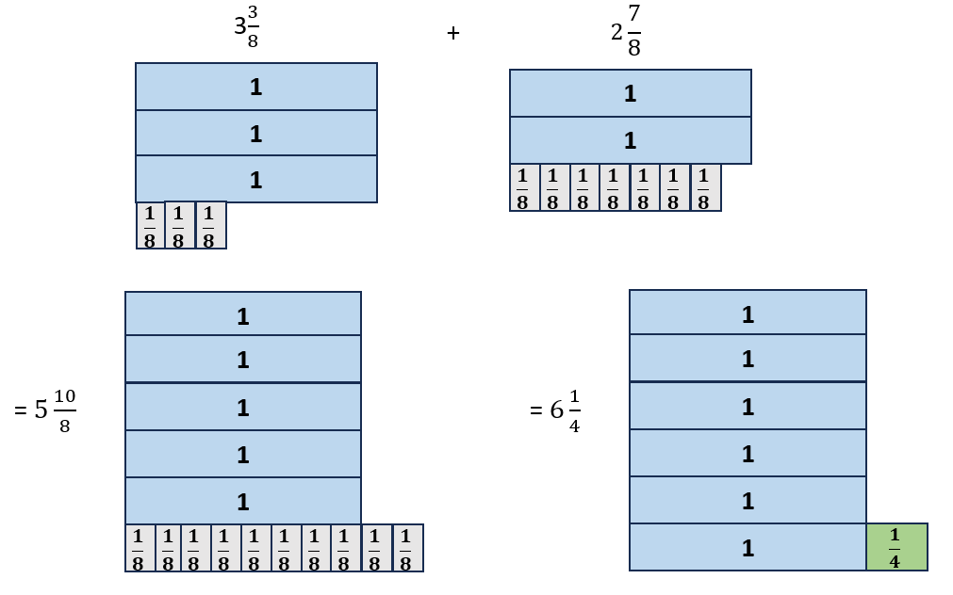

* + Subtraction of Mixed Numbers with Regrouping:

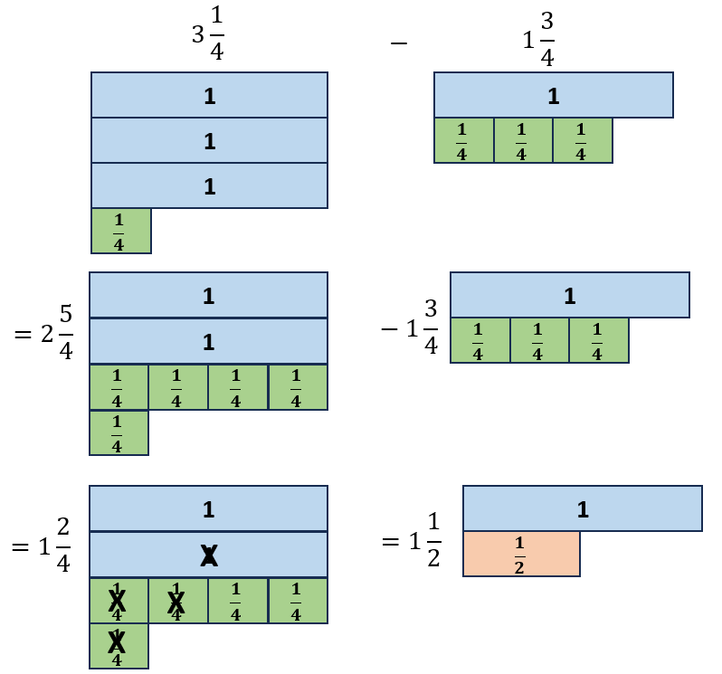

* Equivalent fractions are ways of describing the same quantity, the difference being in how the same size whole is partitioned. Simplifying fractions is finding the equivalent fraction with the fewest partitions represented in the denominator (e.g., can be simplified to because they are equivalent fractions and there are fewer partitions represented in the denominator. Each third is composed of three ninths).

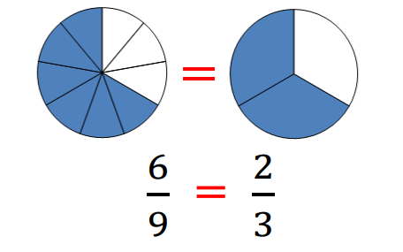

* A fraction is in simplest form when its numerator and denominator have no common factors other than one. The numerator can be greater than the denominator.
* One way to simplify a fraction is by modeling an equivalent fraction. Another way is to divide the numerator and denominator by their greatest common factor (GCF). This is the same as dividing by one whole (e.g., can be simplified to by dividing both the numerator and the denominator by 25).

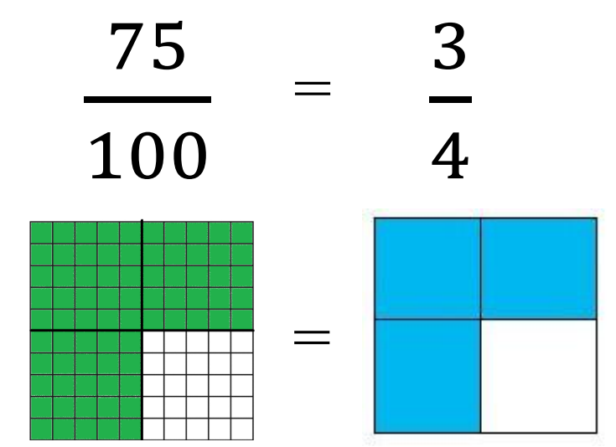

* In Grade 4, students should begin exploring multiplication with fractions by solving problems that involve a whole number and a unit fraction.
* Models for representing multiplication of fractions may include arrays, repeated addition, fraction strips or rods, and pattern blocks, paper folding, or other area models. The examples below show two ways to model 2 × using pattern blocks and a number bond.

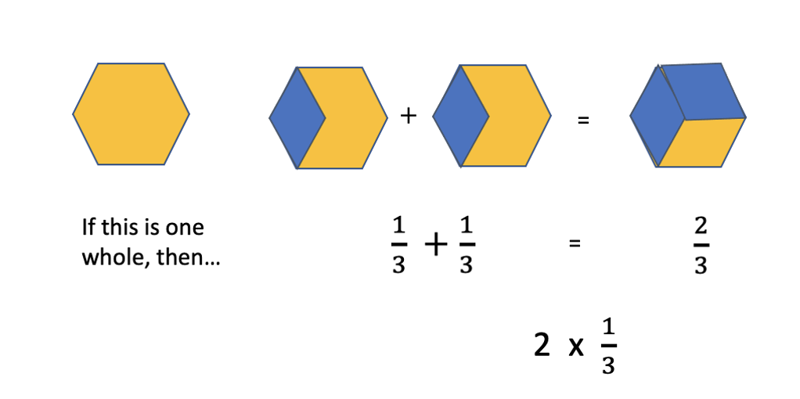 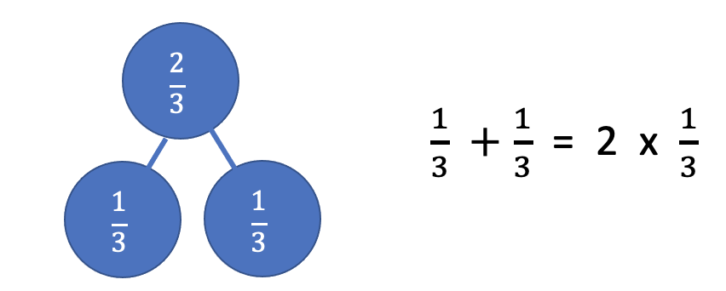

* When multiplying a whole number by a fraction such as 6 × , the meaning is the same as with multiplication of whole numbers: six groups the size of of the whole.

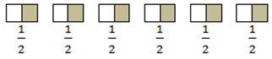 Shows the numbers six times one-half is equivalent to six-halves is equivalent to three wholes.

* When multiplying a fraction by a whole number such as × 6, we are trying to determine a part of the whole (e.g., one-half of six).

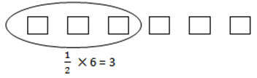

* The inverse property of multiplication states that every number has a multiplicative inverse, and the product of multiplicative inverses is 1 (e.g., 5 and are multiplicative inverses because 5 × = 1). The multiplicative inverse of a given number can be called the reciprocal of the number. Students at this level do not need to use the term for the properties of the operations.
* Examples of problems Grade 4 students should be able to solve include, but are not limited to, the following:
  + If nine children each bring cup of candy for the party, how many thirds will there be? What will be the total number of cups of candy?
  + If it takes cup of ice cream to fill an ice cream cone, how much ice cream will be needed to fill eight cones?

###### Skills in Practice

While the five process goals are expected to be embedded in each standard, the Skills in Practice highlight the most prevalent process goals in relation to the content presented.

**Mathematical Problem Solving:** Problem solving requires both an ability to correctly define a problem and find a solution to it. Model effective practices that demonstrate for students how to arrive at their solutions through estimation, exactness, and justification. To unpack contextual problems, guide students through the problem-solving process by taking care to annotate *essential vocabulary* (not “key words”) related to applied operations. For example –

* Understand the problem by reading and then re-reading the problem; imagining the problem or drawing a picture; underlining or highlighting the important information and essential vocabulary within the problem.
* Create a plan by deciding what to do and how to solve the problem using the applicable operation(s).
* Carry out the plan by showing all work to represent thinking (e.g., using symbols, words, concrete manipulatives, pictorial representations).
* Check the solution by determining if the solution answers the question asked in the contextual problem. During this phase of problem solving, it is essential that students are exposed to strategies that allow them to determine the reasonableness of their responses and solutions; and to support multiple mathematically sound and accurate ways of arriving at a solution.
* Graphic organizers such as the four-square model (Polya method) can help students to organize their thinking as they solve contextual problems –



* As students solve contextual problems, ask questions such as –
  + Are there multiple ways to solve a single problem?
  + How do you know that you have provided a reasonable answer?
  + What role does estimation play in solving contextual problems?

**Mathematical Communication:** As students begin to formalize their understanding of adding and subtracting fractions, it will be helpful to have them consider questions such as, *“What do you notice about how fractions are added and subtracted when the denominators are the same? Why do you think that happens?”* Students will begin to generalize the idea that if you start with tenths and you add or subtract tenths, your final result will be in tenths. Additionally, students would benefit from opportunities to hear their peers share problem-solving strategies, use models to represent their thinking, and demonstrate their understanding of fractional operations through mathematical discourse.

**Mathematical Reasoning:** Solving problems in contextual situations enhances proficiency with estimation strategies. Reasoning skills are essential for solving problems effectively and strategically. Reasoning involves analyzing information, identifying assumptions, evaluating evidence, and drawing logical conclusions.

* When solving problems in context, students may have difficulty understanding which operation(s) to use and may use the wrong operation(s) when solving. Students may not realize that all numbers in a contextual problem are not always needed. To help students derive the meaning of which operation to apply, ask students how thinking about the meaning of addition can help when solving word problems. Give students a chance to explain individually and share their thoughts with each other. Repeat this process for subtraction, multiplication, and division. Have students explain the action of the word to move away from a reliance on *“key words.”* For example –
  + Addition:
    - Finding the total quantity of separate quantities
    - Combining two or more quantities
  + Subtraction:
    - Finding how much more or how much less
    - Finding how much further
    - Finding the difference between two quantities
    - Determining a quantity when taking one amount from another
  + Multiplication:
    - Finding the quantity needed for *x* number of people or *x* number of something
    - Having equal groups and finding the total of all groups
    - Finding a part (fraction) of a whole number
    - Taking a part of a part (fraction of a fraction)
* Students may have difficulty as they add and subtract fractions with like denominators.
  + One of the most common mistakes that students make is to add or subtract the denominators. For example, when asked to find the sum of and , students may incorrectly state that the sum is . Similarly, when asked to determine the difference between and , students may respond that the difference is . Students who make these types of errors are applying their understanding of whole number computation to fraction computation.
  + Students may struggle to solve fraction addition or subtraction problems when they require regrouping. For example, when asked to find the difference between 1 and , students may respond with 1 (because they switched the order of the proper fractions and then subtracted) or (because they regrouped the 1 whole as but did not include the additional ).
  + If students are making these mistakes, it would be helpful for students to use concrete materials (e.g., fraction bars, fraction circles, pattern blocks) to model addition and subtraction problems, and to engage in discourse about the generalizations of fraction addition and subtraction.

**Mathematical Representations:** Students may demonstrate misconceptions when multiplying a whole number by a unit fraction. For example, consider the following contextual situation:

* Sally walked of a mile for four days in a row. Use the model below to determine how far she walked in four days.

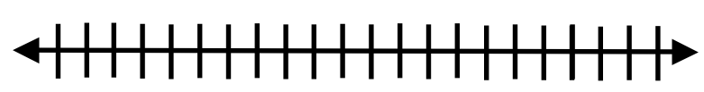

* One common misconception when multiplying a fraction by a whole number is that students may multiply both the numerator and denominator by the whole number or add the denominators through repeated addition. If students get an answer of , then these students will need additional support representing multiplication of fractions through models such as fraction strips, pattern blocks, repeated addition, or area models. Refer to the Understanding the Standard section of this document for additional models when representing multiplication of fractions.
* There are several different strategies to use when solving this problem. Some students may use the given model to solve the problem by labeling the number line in fourths and then making four separate jumps of each to represent the distance walked over four days. Other students may use repeated addition to solve this problem (e.g., . Through class discussions the strategies should be connected in order for students to apply this skill when multiplying fractions. Students should identify that when multiplying a fraction by a whole number, they are finding a part of the whole. A big idea and key understanding for students to develop is that the product of a fraction and a whole number will be smaller than the whole number.
* Which of the following problems has a product of exactly 1? Circle all correct answers.

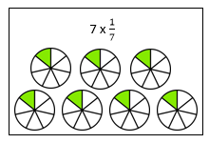 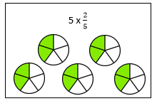 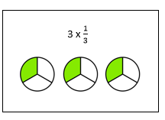

* Students should be able to apply the inverse property of multiplication by recognizing that every number has a multiplicative inverse, and that the product of the number and its multiplicative inverse is 1. If students are unable to identify the two problems that have a product of 1, then these students will need additional practice modeling multiplication of fractions with a focus on applying the inverse property of multiplication. An activity to help develop a greater understanding is to explore models such as fraction strips or fractions circles, identifying the number of unit fractions needed to equal a whole, and then connecting this model to a number sentence.

**Mathematical Connections:** Students must connect fluency of facts, concepts, procedures, and mathematical language through mathematical reasoning to effectively solve contextual problems. Fluency with rational numbers at this grade level will help with improving logical reasoning skills, which will then lend themselves to solving contextual problems. In the following example, first, students must use their previous understanding of computation with fractions. Next, students must apply their understanding of mathematical language to determine which operation(s) to use, and with this information, design a plan to solve the solution. Lastly, students must determine the reasonableness of their solution by providing their reasoning.

* An example, with common errors, is provided below:

Luca’s walk to school is of a mile. So far, he has walked of a mile. How much farther does Luca have to walk?

* One common error is for students to add the fractions instead of subtracting, resulting in an incorrect answer of or . This error indicates that students are unsure of what operation to use and would benefit from opportunities to visualize, act out, or represent (e.g., using a number line) the action that is happening in the contextual situation.
* Another common mistake is for students to realize that they need to subtract but to do so incorrectly. For example, students may subtract the denominators, resulting in an incorrect answer of . Additional practice using manipulatives (e.g., fraction circles, fraction tiles, number lines) would be helpful.

###### Concepts and Connections

Concepts

The operations of addition, subtraction, multiplication, and division are used to represent and solve many different types of problems.

Connections

* *Within the grade level/course*:
  + 4.NS.3 – The student will use mathematical reasoning and justification to represent, compare, and order fractions (proper, improper, and mixed numbers with denominators 12 or less), with and without models.
  + 4.NS.5 – The student will reason about the relationship between fractions and decimals (limited to halves, fourths, fifths, tenths, and hundredths) to identify and represent equivalencies.
* *Vertical Progression*:
  + In prior grades, there are no formal standards focused on fraction computation. However, Grade 3 students were expected to compose and decompose fractions (proper and improper) in multiple ways using models (3.NS.3d). These skills serve as a precursor to formalized fraction addition and subtraction.
  + 5.CE.2 – The student will estimate, represent, solve, and justify solutions to single-step and multistep problems, including those in context, using addition and subtraction of fractions with like and unlike denominators (with and without models), and solve single-step contextual problems involving multiplication of a whole number and a proper fraction, with models.

###### Resources to Support Local Curriculum

* A list of approved textbooks and instructional materials is posted on the VDOE [website](https://www.doe.virginia.gov/teaching-learning-assessment/k-12-standards-instruction/mathematics/2024-mathematics-textbooks).

### 4.CE.4

##### The student will estimate, represent, solve, and justify solutions to single-step and multistep problems, including those in context, using addition and subtraction of decimals through the thousandths, with and without models.

1. Students will demonstrate the following Knowledge and Skills:
2. Apply strategies (e.g., rounding to the nearest whole number, using compatible numbers) and algorithms, including the standard algorithm, to estimate and determine the sum or difference of two decimals through the thousandths, with and without models, in which:*
   1. decimals do not exceed the thousandths; and
   2. addends, subtrahends, and minuends are limited to four digits.
3. Estimate, represent, solve, and justify solutions to single-step and multistep contextual problems using addition and subtraction of decimals through the thousandths.

* On the state assessment, items measuring this objective are assessed without the use of a calculator.

###### Understanding the Standard

* Estimation skills are valuable, time-saving tools particularly in practical situations when exact answers are not required and can be used in determining the reasonableness of the sum or difference when solving for the exact answer.
* An estimate is a number that lies within a range of the exact solution, and the estimation strategy used in a particular problem determines how close the estimate is to the exact solution. Estimates involve using friendlier numbers to mentally compute a reasonable answer before any exact computation is calculated (e.g., 0.9 + 1.47, 0.9 is close to 1 and 1.47 is close to 1.5, resulting in an estimated sum of 2.5. The exact sum should be close to 2.5).
* Number lines are useful tools when developing a conceptual understanding of estimating with decimal numbers. A number line with benchmark numbers can be useful in rounding to the nearest whole number by determining which number is closer. For example, 5.824 rounded to the nearest whole number is 6.

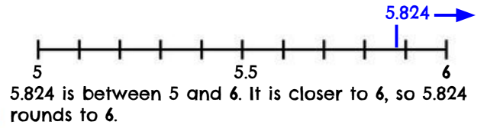

* Students should explore reasons for estimation, using practical experiences, and use various estimation strategies to solve contextual problems. Estimation strategies include rounding, using compatible numbers, and front-end estimation.
* When estimating, students should consider whether it is important that the estimate is greater than or less than the exact answer. In the following examples using the same addends, each estimation strategy results in a different sum, so students should be encouraged to examine the context and the demand for precision when deciding which estimation strategy to use.
* Students would benefit from hearing the estimation strategies of other classmates and from discussions about how different estimation strategies produce different answers (e.g., rounding numbers may produce an estimate closer to the actual answer than using front-end estimation).
* Students need a strong understanding of decimal place value to add and subtract decimal numbers accurately. They should be expected to solve a variety of problems such as 0.35 + 0.9; 1.7 – 0.55; or 0.3 + 0.637.
* Addition and subtraction of decimals may be investigated using a variety of models (e.g., 10-by-10 grids, number lines, money). The examples below show a model of decimal addition using base 10 blocks and a number line.

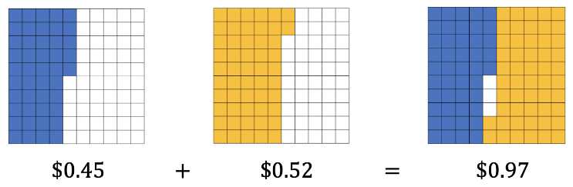

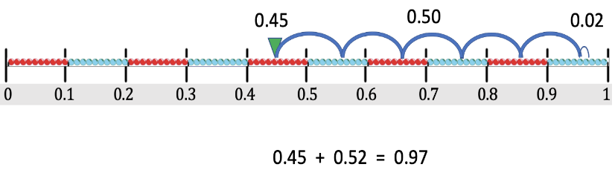

* The use of equivalent decimals may be necessary when solving addition and subtraction facts with decimals (e.g., 0.5 = 0.50 = 0.500).
* In problem solving, emphasis should be placed on thinking and reasoning rather than on key words. Focusing on key words such as *in all, altogether, difference*, etc. encourages students to perform a particular operation rather than make sense of the context of the problem. It prepares students to solve a very limited set of problems and often leads to incorrect solutions.

###### Skills in Practice

While the five process goals are expected to be embedded in each standard, the Skills in Practice highlight the most prevalent process goals in relation to the content presented.

**Mathematical Problem Solving:** Problem solving requires both an ability to correctly define a problem and find a solution to it. Model effective practices that demonstrate for students how to arrive at their solutions through estimation, exactness, and justification. To unpack contextual problems, guide students through the problem-solving process by taking care to annotate *essential vocabulary* (not “key words”) related to applied operations.

For example –

* Understand the problem by reading and then re-reading the problem; imagining the problem or drawing a picture; underlining or highlighting the important information and essential vocabulary within the problem.
* Create a plan by deciding what to do and how to solve the problem using the applicable operation(s).
* Carry out the plan by showing all work to represent thinking (e.g., using symbols, words, concrete manipulatives, pictorial representations).
* Check the solution by determining if the solution answers the question asked in the contextual problem. During this phase of problem solving, it is essential that students are exposed to strategies that allow them to determine the reasonableness of their responses and solutions; and to support multiple mathematically sound and accurate ways of arriving at a solution.
* Graphic organizers such as the four-square model (Polya method) can help students to organize their thinking as they solve contextual problems –



* As students solve contextual problems, ask questions such as –
  + Are there multiple ways to solve a single problem?
  + How do you know that you have provided a reasonable answer?
  + What role does estimation play in solving contextual problems?

**Mathematical Reasoning:** Solving problems in contextual situations enhances proficiency with estimation strategies. Reasoning skills are essential for solving problems effectively and strategically. Reasoning involves analyzing information, identifying assumptions, evaluating evidence, and drawing logical conclusions.

* When solving problems in context, students may have difficulty understanding which operation(s) to use and may use the wrong operation(s) when solving. Students may not realize that all numbers in a contextual problem are not always needed. To help students derive the meaning of which operation to apply, ask students how thinking about the meaning of addition can help when solving word problems. Give students a chance to explain individually and share their thoughts with each other. Repeat this process for subtraction, multiplication, and division. *Have students explain the action of the word to move away from a reliance on “key words.”* For example –
  + Addition:
    - Finding the total quantity of separate quantities
    - Combining two or more quantities
  + Subtraction:
    - Finding how much more or how much less
    - Finding how much further
    - Finding the difference between two quantities
    - Determining a quantity when taking one amount from another
* When adding and subtracting with decimals, students should be encouraged to estimate the sum or difference prior to solving. This will help them determine the reasonableness of their answers. For example, when asked to determine the difference of 12 and 2.803, students should be able to recognize that 2.803 is close to 3, and 12 – 3 = 9, thus the difference should be close to 9.

**Mathematical Representations:** Students may demonstrate several misconceptions as they begin to add and subtract decimal numbers.

* When adding or subtracting with a whole number and a decimal number, students are often confused about where to put the decimal point in the whole number. For example, when asked to determine the difference between 12 and 2.803, students may place the decimal point at the beginning or in the middle of the number, thus creating the number 0.12 or 1.2.
* When using the standard algorithm to add or subtract decimals with different numbers of digits, some students try to apply whole number reasoning and align the numbers starting from the right. This means that the decimal points are not lined up, which results in adding or subtracting two different place values. For example, when asked to determine the sum of 12 and 2.803, students may put the 12 under the 2.803 and align the numbers starting from the right. This would result in an incorrect sum of 2.815.
* When solving decimal subtraction problems that require regrouping, students may have difficulty regrouping over zeroes. For example, when asked to determine the difference between 12 and 2.803, students may subtract incorrectly, resulting in a difference of 10.803.
* As students are developing conceptual understanding of addition and subtraction with decimals, the use of concrete and pictorial models is helpful for many students. As students transition to the use of abstract strategies (e.g., the standard algorithm), supports such as place value charts or mats may be beneficial. The use of estimation strategies prior to solving will also help students check to see if the answers to their computation are reasonable.

**Mathematical Connections:** Students must connect fluency of facts, concepts, procedures, and mathematical language through mathematical reasoning to effectively solve contextual problems. Fluency with rational numbers at this grade level will help with improving logical reasoning skills, which will then lend themselves to solving contextual problems. In the following example, first, students must use their previous understanding of computation with decimal numbers. Next, students must apply their understanding of mathematical language to determine which operation(s) to use, and with this information, design a plan to solve the solution. Lastly, students must determine the reasonableness of their solution by providing their reasoning. An example, with common errors, is provided below.

Scarlett had a length of ribbon that was 5 feet long. She used 1.75 feet of ribbon to wrap one gift and used 1.37 feet of ribbon to wrap another gift. How much ribbon does Scarlett have left?

One common error is for students to add all the numbers in the problem, resulting in an incorrect answer of 8.12 feet of ribbon. This indicates that students are unsure of which operations are needed to solve the problem and would benefit from additional practice visualizing and representing the action in a contextual problem. Students may also provide an incorrect response of 3.12, which results when students determine the amount of ribbon that was used, rather than the amount of ribbon that is still left. Students may also have difficulty with the computation in this example, as it requires regrouping over zeroes (5.00 – 1.75 – 1.37). Additional practice using concrete manipulatives (e.g., base 10 blocks) would be helpful.

###### Concepts and Connections

Concepts

The operations of addition, subtraction, multiplication, and division are used to represent and solve many different types of problems.

Connections

* *Within the grade level/course*:
  + 4.NS.4 – The student will use mathematical reasoning and justification to represent, compare, and order decimals through thousandths, with and without models.
  + 4.NS.5 – The student will reason about the relationship between fractions and decimals (limited to halves, fourths, fifths, tenths, and hundredths) to identify and represent equivalencies.
* *Vertical Progression*:
  + While there are no formal standards that address decimal computation in previous grade levels, students may have had experience with adding and subtracting money amounts to solve contextual problems (3.NS.4).
  + 5.CE.3 – The student will estimate, represent, solve, and justify solutions to single-step and multistep problems, including those in context, using addition, subtraction, multiplication, and division with decimal numbers.

###### Resources to Support Local Curriculum

* A list of approved textbooks and instructional materials is posted on the VDOE [website](https://www.doe.virginia.gov/teaching-learning-assessment/k-12-standards-instruction/mathematics/2024-mathematics-textbooks).
* Shopping for Thanksgiving Lunch: Computation Exemplar Mathematics Instructional Plan ([Word](https://www.doe.virginia.gov/home/showpublisheddocument/51793/638519726549570000) | [PDF](https://www.doe.virginia.gov/home/showpublisheddocument/51795/638519726965900000))

## Measurement and Geometry

In K-12 mathematics, measurement and geometry allow students to gain understanding of the attributes of shapes as well as develop an understanding of standard units of measurement. Measurement and geometry are imperative as students develop a spatial understanding of the world around them. The standards in the measurement and geometry strand aim to develop students’ special reasoning, visualization, and ability to apply geometric and measurement concepts in real-world situations.

In Grade 4, students analyze and describe geometric objects, the relationships and structures among them, and the space they occupy to classify, quantify, measure, or count one or more attributes. At this grade level, students will solve problems that involve length, weight, and liquid volume using U.S. Customary and metric units; solve problems to determine equivalent measures of length, weight, and liquid volume within the U.S. Customary system; solve single-step contextual problems involving elapsed time (limited to hours and minutes within a 12-hour period); solve problems involving area and perimeter of rectangles and squares; identify, describe, and draw points, rays, line segments, angles, and lines, including intersecting, parallel, and perpendicular lines; classify and describe quadrilaterals (parallelograms, rectangles, squares, rhombi, and/or trapezoids); and identify, describe, compare, and contrast plane and solid figures.

### 4.MG.1

##### The student will reason mathematically to solve problems, including those in context, that involve length, weight/mass, and liquid volume using U.S. Customary and metric units.

1. Students will demonstrate the following Knowledge and Skills:
2. Determine an appropriate unit of measure to use when measuring:
   1. length in both U.S. Customary (inch, foot, yard, mile) and metric units (millimeter, centimeter, meter);
   2. weight/mass in both U.S. Customary (ounce, pound) and metric units (gram, kilogram); and
   3. liquid volume in both U.S. Customary (cup, pint, quart, gallon) and metric units (milliliter, liter).
3. Estimate and measure:
   1. length of an object to the nearest U.S. Customary unit ( inch, inch, inch, foot, yard) and nearest metric unit (millimeter, centimeter, or meter);
   2. weight/mass of an object to the nearest U.S. Customary unit (ounce, pound) and nearest metric unit (gram, kilogram); and
   3. liquid volume to the nearest U.S. Customary unit (cup, pint, quart, gallon) and nearest metric unit (milliliter, liter).
4. Compare estimates of length, weight/mass, or liquid volume with the actual measurements.
5. Given the equivalent measure of one unit, solve problems, including those in context, by determining the equivalent measures within the U.S. Customary system for:
   1. length (inches and feet, feet and yards, inches and yards);
   2. weight/mass (ounces and pounds); and
   3. liquid volume (cups, pints, quarts, and gallons).

###### Understanding the Standard

* The concept of a standard measurement unit is one of the major ideas in understanding measurement. Familiarity with standard units is developed through hands-on experiences of comparing, estimating, and measuring. Students benefit from opportunities to evaluate their estimates for reasonableness and refine their estimates in order to increase accuracy of future measurements.
* One unit of measure may be more appropriate than another to use when measuring an object, depending on the size of the object and the degree of accuracy desired. Real life experiences comparing the size of different units in order to select the most appropriate unit (e.g., measuring their desk in both inches and feet; measuring the length of the classroom in inches, feet, yards, millimeters, centimeters, and meters) help establish benchmarks and support a student’s ability to estimate length.
* The measurement of an object must include the unit of measure along with the number of iterations.
* Length is the distance between two points along a line.
* U.S. Customary units for measurement of length include inches, feet, yards, and miles. Appropriate measuring devices include rulers, yardsticks, and tape measures. Metric units for measurement of length include millimeters, centimeters, and meters. Appropriate measuring devices include centimeter rulers, meter sticks, and tape measures.
* The relationship between halves, fourths, and eighths as illustrated in length models forms a foundation for measuring fractional parts with measurement tools (Reference Understanding the Standard for 4.NS.3).
* Weight and mass are different. Mass is the amount of matter in an object. Weightis determined by the pull of gravity on the mass of an object.The mass of an object remains the same regardless of its location. The weight of an object changes depending on the gravitational pull at its location. In everyday life, most people are interested in determining an object’s mass, although they use the term *weight* (e.g., “How much does it weigh?” versus “What is its mass?”).
* Experiences measuring the weight/mass of familiar objects (e.g., foods, pencils, book bags, shoes) help to establish benchmarks and support a student’s ability to estimate weight/mass.
* There are a variety of measuring devices (e.g., balances, bathroom scales, food scales) to measure weight in U.S. Customary units (ounces, pounds) and metric units (grams, kilograms).
* Liquid volume is the amount of liquid a container can hold.
* U.S. Customary units for measurement of liquid volume include cups, pints, quarts, and gallons. Metric units for measurement of liquid volume include milliliters and liters.
* Students should measure the liquid volume of everyday objects in U.S. Customary units and metric units and record the volume including the appropriate unit of measure (e.g., 24 gallons).
* Benchmarks of common objects need to be established for each of the specified units of measure (e.g., the liquid volume of a school lunch milk carton is about one cup, the length of a piece of blank paper is about one foot, a basketball is about one pound, etc.). Practical experiences measuring familiar objects help to establish benchmarks and support a student’s ability to estimate measures.
* Students at this level will be given the equivalent measure of one unit when asked to determine equivalencies between units in the U.S. Customary system. Some examples may include, but are not limited to:
  + 12 inches = 1 foot
  + 1 yard = 3 feet
  + 16 ounces = 1 pound
  + 1 pint = 2 cups
* For example, students will be given the information that one gallon is equivalent to four quarts. Then they will apply that relationship to determine:
  + the number of quarts in five gallons
  + the number of gallons equal to 20 quarts
  + When empty, Tim’s 10-gallon container can hold how many quarts?
  + Maria has 20 quarts of lemonade. How many empty one-gallon containers will she be able to fill?

###### Skills in Practice

While the five process goals are expected to be embedded in each standard, the Skills in Practice highlight the most prevalent process goals in relation to the content presented.

**Mathematical Problem Solving:**

* Students may have difficulty accurately measuring the length of an object. They may be unsure of how to align the ruler with the edge of the object (e.g., lining the end of the ruler with the end of the object, rather than lining the end of the object to the 0-inch mark on the ruler; see the example below). Exposing students to different rulers and providing opportunities for students to measure the length of various objects will help students become more comfortable measuring length.

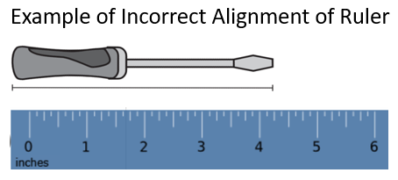

* Some students may have difficulty when solving problems involving conversions when a quantity is provided using two units. For example, given the problem below, students may struggle to determine how many inches are equivalent to 3 feet, 6 inches. The use of strategies that help students visualize the problem (see the example below) may help students understand that the problem could be solved by addition (12 + 12 + 12 + 6 = 42 inches), or by a combination of multiplication and addition (3 × 12 = 36, 36 + 6 = 42 inches).

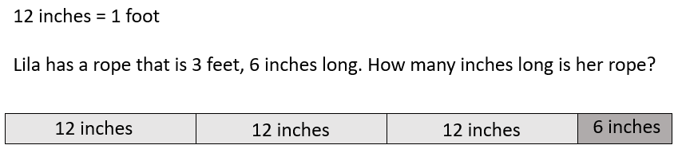

**Mathematical Reasoning:** Some students may struggle to determine an appropriate unit with which to measure a given object. For example, students may be unsure whether it is best to measure the length of a house in inches, feet, yards, or miles; or whether it is best to measure the weight of a feather using grams or kilograms. When this occurs, it may indicate that students have had limited exposure to these measures. The use of hands-on experiences, that allow students to physically measure objects and begin to develop benchmark measurements (e.g., objects that weight about pound, objects that measure about one meter) will be beneficial for students. Similarly, opportunities to compare items that are more than one of each unit (e.g., comparing 6 pounds versus 6 ounces) will help students deepen their understanding of U.S. Customary and metric units.

**Mathematical Connections:** Students may struggle to measure the length of an object to the nearest inch, inch, or inch because they have difficulty identifying the nearest fractional part. This error commonly occurs when students use rulers that include sixteenths of an inch. Teachers may wish to explicitly connect a ruler to a number line representation of fractions and to provide rulers marked with eighths before introducing rulers marked with sixteenths.

###### Concepts and Connections

Concepts

Analyzing and describing geometric objects in our world, the relationships and structures among them, or the space that they occupy can be used to classify, quantify, measure, or count one or more of their attributes.

Connections

* *Within the grade level/course*:
  + 4.NS.3 – The student will use mathematical reasoning and justification to represent, compare, and order fractions (proper, improper, and mixed numbers with denominators 12 or less), with and without models.
* *Vertical Progression*:
  + 3.MG.1 – The student will reason mathematically using standard units (U.S. Customary and metric) with appropriate tools to estimate and measure objects by length, weight/mass, and liquid volume to the nearest half or whole unit.
  + 5.MG.1 – The student will reason mathematically to solve problems, including those in context, that involve length, mass, and liquid volume using metric units.

Across Content Areas [Theme – Modeling]:

* *Science*: In Grade 4 students are expected to use models to demonstrate simple phenomena and natural processes, and to identify limitations of models.
  + 4.2a,b – The student will create a model or diagram illustrating the parts of a plan in terms of obtaining energy; explain the role of roots, stems, and leaves.
  + 4.2c – The student will create and explain a model of a flower, illustrating the parts of the flower and its reproductive processes.
  + 4.3a – The student will analyze and model how populations, communities, and ecosystems interrelate.
  + 4.3b – The student will construct a food web demonstrating the flow of energy through an ecosystem.
  + 4.3c – The student will analyze a food web and explain how changes in one part of the food web would affect other organisms.
  + 4.5a – The student will create a model that demonstrates the differences between rotation and revolution.
  + 4.5b – The student will construct and interpret a simple model to show the location and order of planets in relation to the sun in our solar system.
  + 4.6a,c – The student will create a model that demonstrates the motions of the moon, sun, and Earth and use it to describe how the main phases of the moon occur.
  + 4.7a – The student will construct a model of the ocean floor and label and describe each of the major features, including the relative depths of each.
  + 4.7c – The student will construct a model of a basic marine food web, including floating organisms, swimming organisms, and organisms living on the ocean floor.
  + 4.8a – The student will create and interpret a model of a watershed.
* *Computer Science*:
  + 4.CSY.1 – The student will model how a computing system works to accomplish a task (a) describe how computing systems perceive the world through sensors and other inputs; (b) compare and contrast how humans and computers process information from inputs; (c) explain how computing devices may be used to classify and organize input; and (d) diagram and describe a simple computing system indicating processors, inputs, and outputs.
  + 4.DA.3 – The student will create a computational model that represents attributes and behaviors associated with a concept (a) examine models of physical objects and processes; (b) create a computational model that reflects the attributes and behaviors associated with a concept; and (c) explain how a computer model illustrates a given concept.
  + 4.NI.1 – The student will identify the interrelationship between computing devices and a computing network (e) model how computing devices in a network transmit and receive information.

###### Resources to Support Local Curriculum

* A list of approved textbooks and instructional materials is posted on the VDOE [website](https://www.doe.virginia.gov/teaching-learning-assessment/k-12-standards-instruction/mathematics/2024-mathematics-textbooks).

### 4.MG.2

##### The student will solve single-step and multistep contextual problems involving elapsed time (limited to hours and minutes within a 12-hour period).

1. Students will demonstrate the following Knowledge and Skills:
2. Solve single-step and multistep contextual problems involving elapsed time in hours and minutes, within a 12-hour period (within a.m., within p.m., and across a.m. and p.m.) when given:
   1. the starting time and the ending time, determine the amount of time that has elapsed in hours and minutes;
   2. the starting time and amount of elapsed time in hours and minutes, determine the ending time; or
   3. the ending time and the amount of elapsed time in hours and minutes, determine the starting time.

###### Understanding the Standard

* Elapsed time is the amount of time that has passed between two given times.
* Elapsed time can be found by counting on from the starting time or counting back from the ending time.
* Elapsed time should be modeled and demonstrated using analog clocks, timelines, or t-charts.

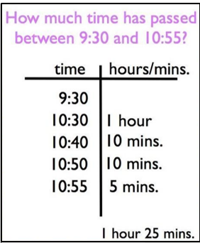 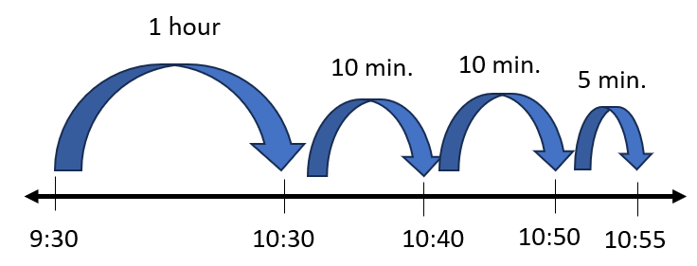

###### Skills in Practice

While the five process goals are expected to be embedded in each standard, the Skills in Practice highlight the most prevalent process goals in relation to the content presented.

**Mathematical Problem Solving:** Students may have difficulty solving elapsed time contextual problems –

* When given the starting time and the ending time of an event, students may have difficulty determining the amount of time that has elapsed. Consider the following contextual situation –
* Jaheim arrived at the park at 4:35 p.m. and left the park at 6:15 p.m. How long was Jaheim at the park? Create a number line or another model to find the answer and show your thinking.

Students may try to subtract the hours (6 – 4 = 2) and the minutes (35 – 15 = 20), resulting in a response of 2 hours, 20 minutes. Students who make this error do not understand that finding the difference between the hours and then finding the difference between the minutes does not lead to a reasonable response. These students would benefit from the use of a clock with gears that model the passing of time. Similarly, the use of a number line will allow students to model the passage of time in the contextual situation.

* When given the ending time and the elapsed time of an event, students may have difficulty determining the starting time. Consider the following contextual situation –
* Janelle went to bed at 9:12 p.m. She had been up for 11 hours and 32 minutes. What was the time when Janelle got up that morning?

Students may struggle to solve this problem because they must work backward to determine the unknown starting time. The use of a concrete or pictorial model (e.g., clock with gears, open number line, t-chart) may help students organize their work when solving elapsed time problems.

**Mathematical Representations:** Students may have difficulty solving elapsed time problems that require them to determine the time on an analog clock. Consider the following contextual situation –

* Santiago leaves for work in the morning at the time shown below. He gets home 11 hours and 6 minutes later. What time does Santiago get home? Use the number line or another model to show your thinking.

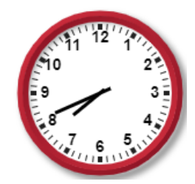

To accurately solve this problem, students must be able to determine the time on the analog clock and then determine missing end time. Additionally, some students may not recognize that this problem crosses over 12:00 p.m. (noon), and thus, the answer must be reported as p.m. These students would benefit from additional practice with problems that cross over from a.m. to p.m. and from p.m. to a.m.

**Mathematical Reasoning:** Students may struggle to solve contextual elapsed time problems involving multiple steps.

* Consider the following contextual situation in which students are given the start and end times but must determine the amount of elapsed time for a given activity –
* Kelly left her house at 3:20pm. She drove 15 minutes to the grocery store, did her grocery shopping, then drove 15 minutes home. Kelly arrived home at 4:55pm. How long did it take Kelly to do her grocery shopping?

Students may focus only on the numbers provided in the problem, adding the time it took for Kelly to get to and from the grocery store (15 + 15) and producing an incorrect answer of 30 minutes. Reasoning through the context of a problem before any computation is performed can encourage discussion about what students notice/wonder and help them become actively engaged in the problem-solving process.

Students may also misinterpret the solution they are trying to find and solve for the entire amount of time that elapsed between 3:20pm and 4:55pm. Presenting the information in stages, such as through the use of numberless word problems, can help students recognize the need for additional information and also focus their attention on questions that could be asked about the information they are given.

Representing the information provided using an open number line model can allow students to visualize what is known versus unknown, as well as organize the multiple steps needed to determine an accurate solution.

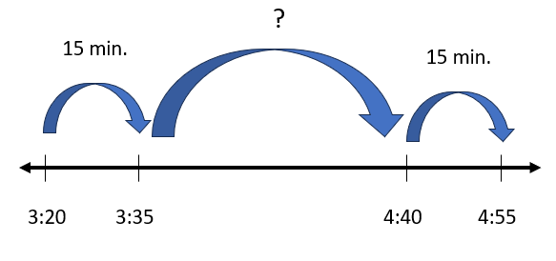

* As an example, in the contextual situation below students are given the start time and amount of elapsed time for several activities but must determine the end time –
* A family left Roanoke, Virginia at 9:35 a.m. and drove for 1 hour and 50 minutes before stopping for lunch in Charlottesville. The family stayed in Charlottesville for 45 minutes while they ate lunch, then drove for another hour and ten minutes before they arrived in Richmond. What time did the family arrive in Richmond?

Students may only consider the amount of time driving to Charlottesville and stopping for lunch. They may overlook the time that it took the family to continue driving from Charlottesville to Richmond. An open number line model can help students organize their thinking and keep track of what is happening in the problem.

###### Concepts and Connections

Concepts

Analyzing and describing geometric objects in our world, the relationships and structures among them, or the space that they occupy can be used to classify, quantify, measure, or count one or more of their attributes.

Connections

* *Within the grade level/course*:
  + 4.CE.1 – The student will estimate, represent, solve, and justify solutions to single-step and multistep problems, including those in context, using addition and subtraction with whole numbers.
* *Vertical Progression*:
  + 3.MG.3 – The student will demonstrate an understanding of the concept of time to the nearest minute and solve single-step contextual problems involving elapsed time in one-hour increments within a 12-hour period.
  + There are no additional standards about elapsed time in subsequent grade levels.

Across Content Areas

Reference 4.MG.1.

###### Resources to Support Local Curriculum

* A list of approved textbooks and instructional materials is posted on the VDOE [website](https://www.doe.virginia.gov/teaching-learning-assessment/k-12-standards-instruction/mathematics/2024-mathematics-textbooks).

### 4.MG.3

##### The student will use multiple representations to develop and use formulas to solve problems, including those in context, involving area and perimeter limited to rectangles and squares (in both U.S. Customary and metric units).

1. Students will demonstrate the following Knowledge and Skills:
2. Use concrete materials and pictorial models to develop a formula for the area and perimeter of a rectangle (including a square).
3. Determine the area and perimeter of a rectangle when given the measure of two adjacent sides (in whole number units), with and without models.
4. Determine the area and perimeter of a square when given the measure of one side (in whole number units), with and without models.
5. Use concrete materials and pictorial models to explore the relationship between area and perimeter of rectangles.
6. Identify and represent rectangles with the same perimeter and different areas or with the same area and different perimeters.
7. Solve contextual problems involving area and perimeter of rectangles and squares.

###### Understanding the Standard

* In Grade 3, students determined the area of a given polygon by counting the number of square units needed to cover the polygon and explained the usefulness of area as a measurement in a contextual situation. Students also used U.S. Customary and metric units to measure the distance around a polygon with no more than six sides to determine the perimeter and explained the usefulness of perimeter as a measurement in a contextual situation.
* Perimeter is the path or distance around any plane figure. To determine the perimeter of any polygon, determine the sum of the lengths of the sides (e.g., the perimeter of the rectangle is 14 inches).

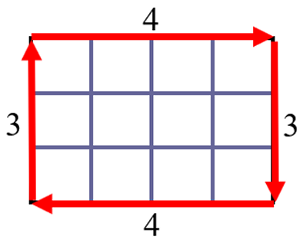

* Students should use concrete materials to investigate, develop, and use the formulas for the perimeter of a rectangle (including a square):
  + Perimeter of a square = side length + side length + side length + side length
  + Perimeter of a square = 4 × side length
  + Perimeter of rectangle = side length + side length + side length + side length
  + Perimeter of rectangle = (2 × length) + (2 × width)
* Area is the surface included within a plane figure. Area is measured by the number of square units needed to cover a surface or plane figure (e.g., the area of the rectangle is 12 square inches or 12 in.2).

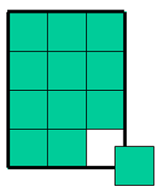

* At this level, students are not expected to represent square units using an exponent of 2 (e.g., 24 ft.2).
* Transparent grids or geoboards are useful tools for exploring the area of a figure. Connections can be made to arrays and the area model of multiplication, and can support the investigation, development, and use of the area formula.
* The formula for the area of a rectangle is one of the first that is developed and is usually given as *A = l x w*, or “area equals length times width”. Thinking ahead, an equivalent but more unifying idea is *A = b x h*, or “area equals *base* times *height*”. The base-times-height formulation can be generalized to all parallelograms (not just rectangles) and is useful in developing the area formulas for triangles and trapezoids in later grades. Therefore, base times height connects a large family of formulas that otherwise must be mastered independently.
* Any side of a figure can be called a *base*. For each base that a figure has, there is a corresponding *height*. The height is the perpendicular distance to the base. The formula *A = b x h* generates the same area through the commutative property regardless of which side is considered the base.
* Students should use concrete materials to investigate, develop, and use the formulas for the area of a rectangle (including a square):
  + Area of a square = side length × side length
  + Area of a rectangle = length × width
  + Area of a rectangle = base x height
* As rectangles and squares are explored, the idea of congruent sides should be emphasized (e.g., the perimeter of a square is 4 × side length because all four sides are congruent). The perimeter or area of a square can be determined when provided with measure of one side. The perimeter or area of a rectangle can also be determined when provided the measures of two adjacent sides. Adjacent sides are any two sides of a figure that share a common vertex.

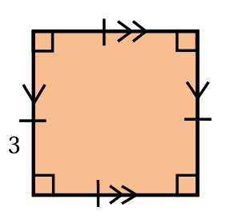 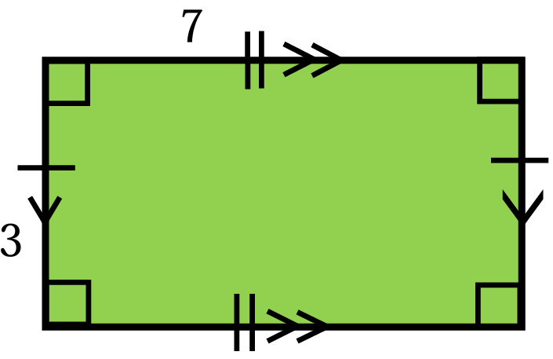

* Students should use a variety of concrete materials (e.g., color tiles, inch squares, grid paper) when creating rectangles with the same area but different perimeters and creating rectangles with the same perimeter but different areas. This is important for helping to understand the relationship between area and perimeter. See examples below.

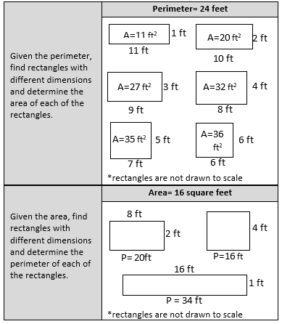

* Perimeter and area should always be labeled with the appropriate unit of measure.
* The exploration of area and perimeter lends itself to contextual problems that have multiple solutions. For example –
* If Joan has 16 feet of fencing to put around a rectangular garden, what could be the dimensions of her garden? Similarly, if Jack wanted to create a dog pen with an area of 24 square feet, how many feet of fencing would he need?

###### Skills in Practice

While the five process goals are expected to be embedded in each standard, the Skills in Practice highlight the most prevalent process goals in relation to the content presented.

**Mathematical Problem Solving:** Students often confuse the concepts of area and perimeter and may have difficulty understanding linear units versus square units. Perimeter is a length measure of the distance around a region, therefore it is additive. Students may think about area as the length of two lines (length x width), rather than the measure of a surface. It is challenging for students to think about multiplying two lengths and getting an area. Students must understand “length times width” is not a definition of area. Area is a measure of a two-dimensional space inside a region.

* Students may be given a contextual problem that does not explicitly specify whether they need to determine the area or the perimeter. In such cases, students may struggle to identify whether they need to determine the area or the perimeter. Consider the following contextual situations:
* Sandra buys a rectangular rug for her bedroom. The rug has a width of 15 ft. and a length of 24 ft. How much space does the rug cover?

Students who confuse the concepts of perimeter and area may find the perimeter of the rug, rather than the area. Similarly, students may be able to identify that they need to determine the area, but may confuse the formulas for perimeter and area, and incorrectly use the perimeter formula. Students should be encouraged to draw and label the dimensions of the rectangle before solving the problem. This visual may help students determine whether they need to find the area or the perimeter, and which formula to use to do so.

* Mario wants to put a fence around part of his yard. He wants the space inside the fence to be 48 square feet. What could be the dimension(s) of the fenced area? Draw the figure and label the dimensions.

This question requires students to understand they must work backwards from knowing the area to find the dimensions of a specified area. Students may not recognize that they need to use factor pairs of a number (i.e., factor pairs of 48 in the given problem) in order to find the dimensions of the area. Some students may also struggle with finding an answer when there is more than one correct solution. Teachers may wish to encourage students to create the figure on grid paper to assist them with finding a solution.

**Mathematical Communication:** Instruction about area and perimeter should include multiple opportunities for students to discuss real-world applications of using area and perimeter, and the different strategies that students use to determine the area and perimeter of rectangles and squares (e.g., repeated addition, formulas). When communicating about perimeter and area, students are expected to use accurate and appropriate mathematics vocabulary: units when describing perimeter (e.g., 16 inches, 36 feet), and square units when describing area (e.g., 24 square feet, 108 square inches). At this level, students are not expected to represent square units using an exponent of 2 (e.g., 24 ft.2).

**Mathematical Representations:**

* Students need multiple opportunities to “cover the surface” of two-dimensional shapes to develop an understanding of the concept of area. Students should begin to apply the concept of multiplication using arrays to the area of rectangles. This connection requires that students develop the ability to see a rectangular region as rows and columns.

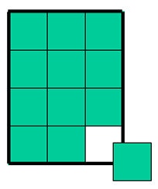 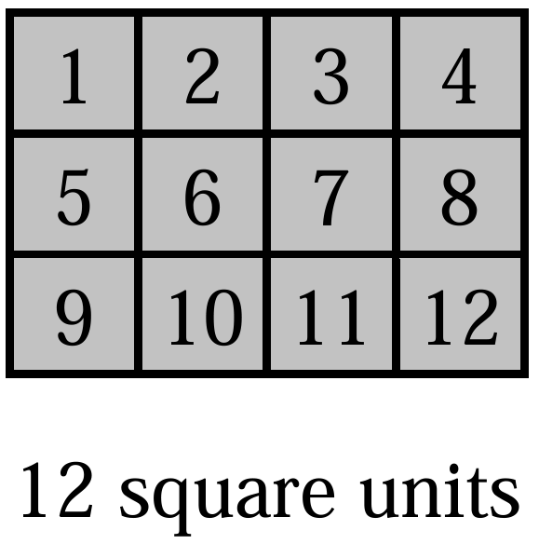 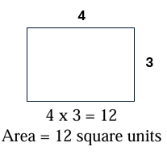

* Students should be able to determine the perimeter or area of a figure when given the measures of sides, as well as identify missing side lengths. After discussing the properties of squares and rectangles, students can use grid paper to draw the following shapes and investigate whether shapes with the same perimeter have the same area.

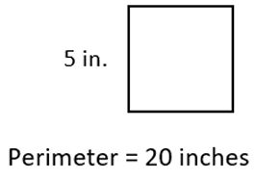 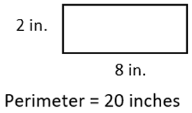

* When provided an image of a rectangle (or square) similar to the one shown below, students may have difficulty determining the area and perimeter. On the image below, the perimeter is 6 inches, and the area is 2 square inches.

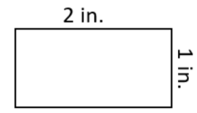

* When solving for the perimeter, students may respond that the perimeter is 3 inches (2 inches + 1 inch = 3 inches). This indicates that students did not add the side lengths of the unlabeled sides. This may further indicate that students do not have a strong understanding of the characteristics of rectangles (e.g., that opposite sides are congruent). Students should be encouraged to label each side length prior to determining the sum of all sides.
* When solving for the perimeter, students may respond that the perimeter is 2 inches (2 inches × 1 inch). This may indicate that students lack an understanding of the difference between area and perimeter. Students may need scaffolded support and to begin with rectangles and squares that show all of the squares within the figure (see 3.MG.2). Understanding that perimeter represents a length measurement and area represents a space measurement is an important concept for students to understand.
* When solving for area, students may say that the area is 6 square inches (2 inches + 1 inch + 2 inches + 1 inch). Similar to above, this may indicate that students lack an understanding of the difference between area and perimeter. Additional scaffolded support using rectangles that show all of the squares within the figure would be beneficial.
* When solving for the area, students may say that the area is 4 square inches (2 × 1 × 2 × 1). Students who multiplied the lengths of all four sides may have confused the formulas for area and perimeter and used components of each. These students would benefit from additional experiences that allow them to see the application of the area formula.

###### Concepts and Connections

Concepts

Analyzing and describing geometric objects in our world, the relationships and structures among them, or the space that they occupy can be used to classify, quantify, measure, or count one or more of their attributes.

Connections

* *Within the grade level/course*:
  + 4.CE.2 – The student will estimate, represent, solve, and justify solutions to single-step and multistep problems, including those in context, using multiplication with whole numbers, and single-step problems, including those in context, using division with whole numbers; and recall with automaticity the multiplication facts through 12 × 12 and the corresponding division facts.
  + 4.MG.5 – The student will classify and describe quadrilaterals (parallelograms, rectangles, squares, rhombi, and/or trapezoids) using specific properties and attributes.
* *Vertical Progression*:
  + 3.MG.2 – The student will use multiple representations to estimate and solve problems, including those in context, involving area and perimeter (in both U.S. Customary and metric units).
  + 5.MG.2 – The student will use multiple representations to solve problems, including those in context, involving perimeter, area, and volume.

Across Content Areas

Reference 4.MG.1.

###### Resources to Support Local Curriculum

* A list of approved textbooks and instructional materials is posted on the VDOE [website](https://www.doe.virginia.gov/teaching-learning-assessment/k-12-standards-instruction/mathematics/2024-mathematics-textbooks).
* Exploring the Relationship Between Area and Perimeter Exemplar Mathematics Instructional Plan ([Word](https://www.doe.virginia.gov/home/showpublisheddocument/51801/638398746546830000) | [PDF](https://www.doe.virginia.gov/home/showpublisheddocument/51803/638398746552770000))
* Area and Perimeter Classroom Activity ([Word](https://www.doe.virginia.gov/home/showdocument?id=61383))

### 4.MG.4

##### The student will identify, describe, and draw points, rays, line segments, angles, and lines, including intersecting, parallel, and perpendicular lines.

1. Students will demonstrate the following Knowledge and Skills:
2. Identify and describe points, lines, line segments, rays, and angles, including endpoints and vertices.
3. Describe endpoints and vertices in relation to lines, line segments, rays, and angles.
4. Draw representations of points, line segments, rays, angles, and lines, using a ruler or straightedge.
5. Identify parallel, perpendicular, and intersecting lines and line segments in plane and solid figures, including those in context.
6. Use symbolic notation to name points, lines, line segments, rays, angles, and to describe parallel and perpendicular lines.

###### Understanding the Standard

* Points, lines, line segments, rays, and angles, including endpoints and vertices, are fundamental components of noncircular geometric figures.
* A point is an exact location in a plane and in space. It has no length, width, or height. A point is usually named with a capital letter.
* A line is a collection of points extending infinitely in both directions. It has no endpoints. When a line is drawn, at least two points on it can be marked and given capital letter names. Arrows must be drawn to show that the line goes on infinitely in both directions (e.g., is read as “line AB”).
* A line segment is a part of a line. It has two endpoints and includes all the points between and including the endpoints. To name a line segment, name the endpoints (e.g., is read as “line segment AB”). The shortest distance between two points in a plane, a flat surface, is a line segment.
* A ray is a part of a line. It has one endpoint and extends infinitely in one direction. To name a ray, say the name of its endpoint first and then say the name of one other point on the ray (e.g., is read as “ray AB”).
* An angle is formed by two rays that share a common endpoint called the vertex. Angles are found wherever lines or line segments intersect.
* An angle can be named in three different ways by using:
  + three letters in order: a point on one ray, the vertex, and a point on the other ray;
  + one letter at the vertex; or
  + a number written inside the rays of the angle.
* A vertex is the point at which two lines, line segments, or rays meet to form an angle. In solid figures, a vertex is the point at which three or more edges meet.
* The table below shows examples of geometric figures.

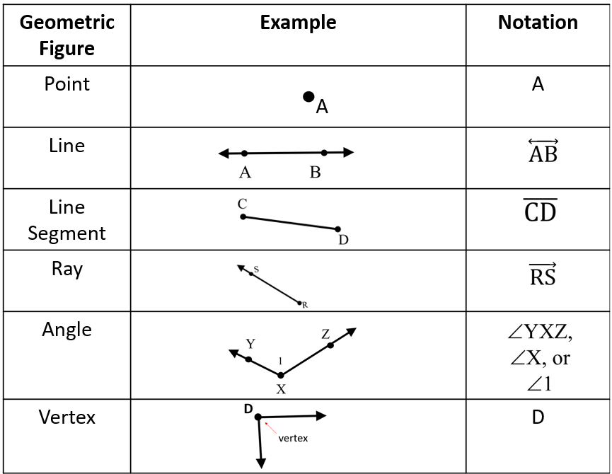

* Lines in a plane either intersect or are parallel. Intersecting lines have one point in common.

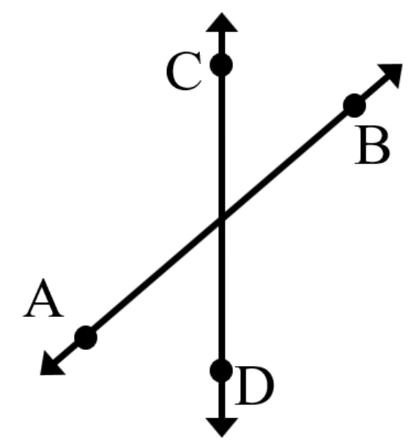

* Perpendicularity is a special case of intersection. Perpendicular lines intersect at right angles. The symbol ⊥ is used to indicate that two lines are perpendicular. For example, the notation is read as “line AB is perpendicular to line CD.”

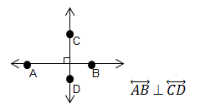

* Parallel lines lie in the same plane and never intersect. Parallel lines are always the same distance apart and do not share any points. The symbol ∥ indicates that two or more lines are parallel. For example, the notation ∥ is read as “line BC is parallel to line FG.”

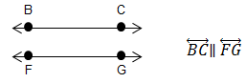

###### Skills in Practice

While the five process goals are expected to be embedded in each standard, the Skills in Practice highlight the most prevalent process goals in relation to the content presented.

**Mathematical Communication:** This standard incorporates a lot of mathematical vocabulary, and students may confuse the various terms. Students need many experiences identifying and drawing examples of *points, rays, line segments, angles,* and *lines* (*parallel, perpendicular,* and *intersecting*).They should also have opportunities to describe similarities and differences among the attributes of these terms (e.g., a line segment has two endpoints whereas a ray has one endpoint). Students are expected to use accurate vocabulary when communicating about geometry concepts (e.g., they should refer to the end of a line segment as an *endpoint,* rather than as a *dot*). In addition, students are expected to begin to use symbolic notation when drawing and name points, rays, line segments, angles, and lines. Displaying vocabulary cards or having students create a mathematics dictionary will provide a reference for students to use throughout instruction.

**Mathematical Connections:** The content is this standard is strongly connected to the content in 4.MG.5 and 4.MG.6. As students are deepening their knowledge of quadrilaterals by discussing their attributes, similarities, and differences, students are expected to accurately use the vocabulary terms addressed in 4.MG.4.

* In 4.MG.5 students classify and describe quadrilaterals based on their properties and attributes. For example, when discussing the differences between a rectangle and a rhombus, students should note that a rectangle has two sets of opposite sides (line segments) that are parallel and congruent and four right angles, whereas a rhombus has four congruent sides (line segments) and two sets of opposite angles that are congruent.

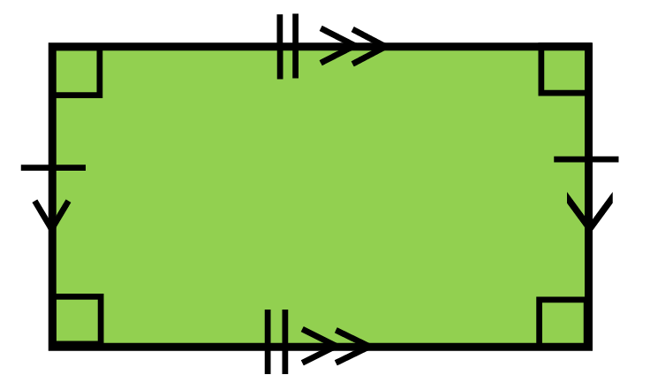 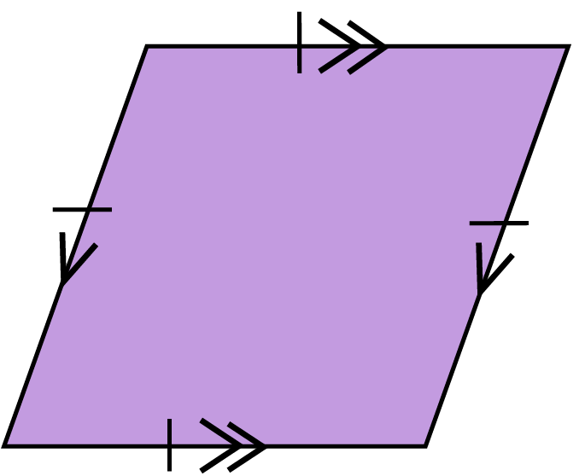

* As another example, when addressing the content in 4.MG.6 and comparing plane and solid figures, students should note that a square has four congruent sides (line segments) and four vertices, whereas a cube has 12 edges (line segments), eight vertices, and six faces.

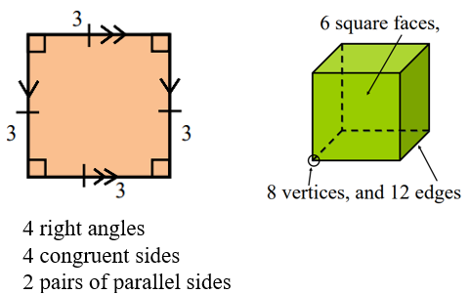

###### Concepts and Connections

Concepts

Analyzing and describing geometric objects in our world, the relationships and structures among them, or the space that they occupy can be used to classify, quantify, measure, or count one or more of their attributes.

Connections

* *Within the grade level/course*:
  + 4.MG.5 – The student will classify and describe quadrilaterals (parallelograms, rectangles, squares, rhombi, and/or trapezoids) using specific properties and attributes.
  + 4.MG.6 – The student will identify, describe, compare, and contrast plane and solid figures according to their characteristics (number of angles, vertices, edges, and the number and shape of faces), with and without models.
* *Vertical Progression*:
  + While this is the first formal standard to address points, rays, line segments, angles, and lines (parallel, perpendicular, and intersecting), students had informal experiences with this vocabulary in the previous grade as they engaged with polygons (3.MG.4). Additionally, students had formal experience with the terms *right angle* (1.MG.2e) and *vertices* (K.MG.2; 1.MG.2; and 2.MG.4).
  + 5.MG.3 – The student will classify and measure angles and triangles, and solve problems, including those in context.

Across Content Areas

Reference 4.MG.1.

###### Resources to Support Local Curriculum

* A list of approved textbooks and instructional materials is posted on the VDOE [website](https://www.doe.virginia.gov/teaching-learning-assessment/k-12-standards-instruction/mathematics/2024-mathematics-textbooks).

### 4.MG.5

##### The student will classify and describe quadrilaterals (parallelograms, rectangles, squares, rhombi, and/or trapezoids) using specific properties and attributes.

1. Students will demonstrate the following Knowledge and Skills:
2. Develop definitions for parallelograms, rectangles, squares, rhombi, and trapezoids through the exploration of properties and attributes.
3. Identify and describe points, line segments, angles, and vertices in quadrilaterals.
4. Identify and describe parallel, intersecting, perpendicular, and congruent sides in quadrilaterals.
5. Compare, contrast, and classify quadrilaterals (parallelograms, rectangles, squares, rhombi, and/or trapezoids) based on the following properties and attributes:
   1. parallel sides;
   2. perpendicular sides;
   3. congruence of sides; and
   4. number of right angles.
6. Denote properties of quadrilaterals and identify parallel sides, congruent sides, and right angles by using geometric markings.
7. Use symbolic notation to name line segments and angles in quadrilaterals.

###### Understanding the Standard

* The study of geometric figures must be active, using visual images and concrete materials (e.g., graph paper, pattern blocks, geoboards, geometric solids, computer software tools).
* The study of polygons is rich with geometry vocabulary. At this level, students are expected to accurately use the following vocabulary:
  + A polygon is a closed plane figure composed of at least three line segments that do not cross.
    - A quadrilateral is a polygon with four sides.
    - A parallelogram is a quadrilateral with both pairs of opposite sides parallel and congruent.
    - A rectangle is a quadrilateral with four right angles, and opposite sides that are parallel and congruent.
    - A rhombus is a quadrilateral with four congruent sides. Opposite sides are congruent and parallel, and opposite angles are congruent.
    - A square is a special type of rectangle that has four congruent sides in addition to four right angles. A square is also a special type of rhombus that has four right angles in addition to four congruent sides.
    - A trapezoid is a quadrilateral with exactly one pair of parallel sides.
* Examples of quadrilaterals with geometric markings to denote their properties are shown below:

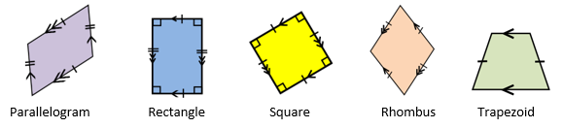

* The shortest distance between two points in a plane, a flat surface, is a line segment.
* Lines either intersect or are parallel. Intersecting lines have exactly one point in common.
* Perpendicularity is a special case of intersection. Perpendicular lines and line segments intersect at right angles. The symbol ⊥ is used to indicate that two lines or line segments are perpendicular. For example, in the image below, the notation ⊥ is read as “line segment AB is perpendicular to line segment BC.”

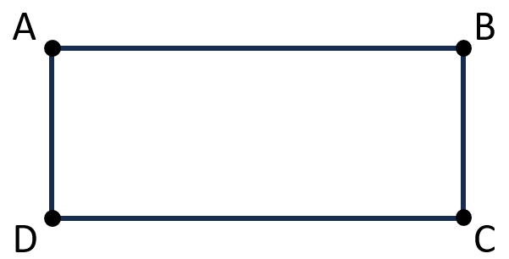

* Parallel lines lie in the same plane and never intersect. Parallel lines are always the same distance apart and do not share any points. The symbol ∥ indicates that two or more lines or line segments are parallel. For example, in the image below, the notation ∥ is read as “line segment QR is parallel to line segment TS.”

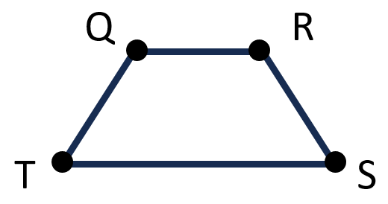

* Congruent figures have the same size and shape. Congruent sides have the same length. Congruent angles have the same measure.
* The geometric markings shown on the rectangle below indicate parallel sides with an equal number of arrows, congruent sides indicated with an equal number of hatch (hash) marks, and right angle with a square symbol. Students should have opportunities to use geometric markings in figures to indicate congruence of sides and angles and to indicate parallel sides.

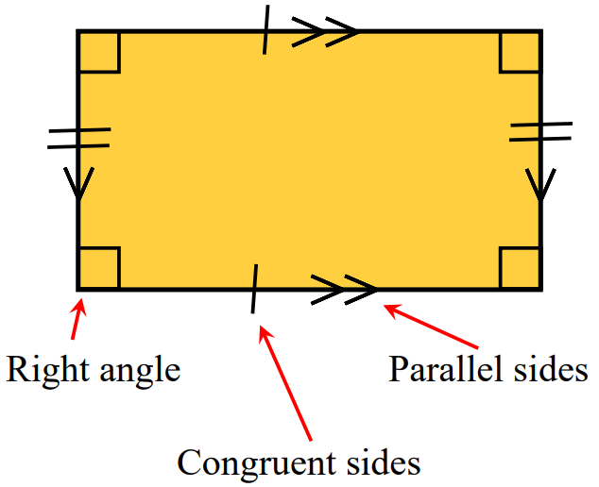

###### Skills in Practice

While the five process goals are expected to be embedded in each standard, the Skills in Practice highlight the most prevalent process goals in relation to the content presented.

**Mathematical Reasoning:**

* The use of a quadrilateral table (as shown below) can be used to provide students with an organized chart that delineates the characteristics of each quadrilateral. It can support students’ understanding as they determine similarities and differences between types of quadrilaterals and can provide a reference document for students to use during instruction.

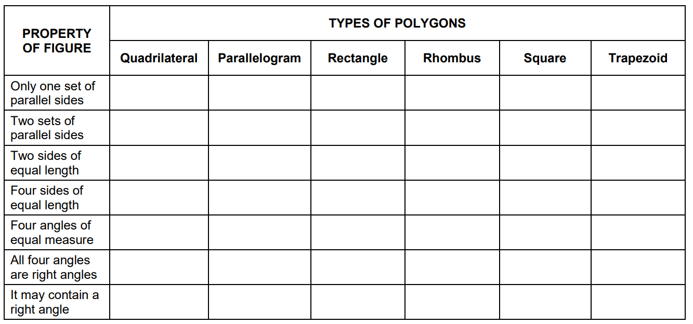

* Students may have difficulty determining and applying the hierarchy used to classify quadrilaterals. For example, given the diagram below on the left, students would be expected to complete the diagram as indicated on the right. Using the diagram, students should be able to reason that any quadrilateral can be classified as any category above it in the diagram (e.g., a square can be classified as a rectangle, rhombus, parallelogram, or quadrilateral).

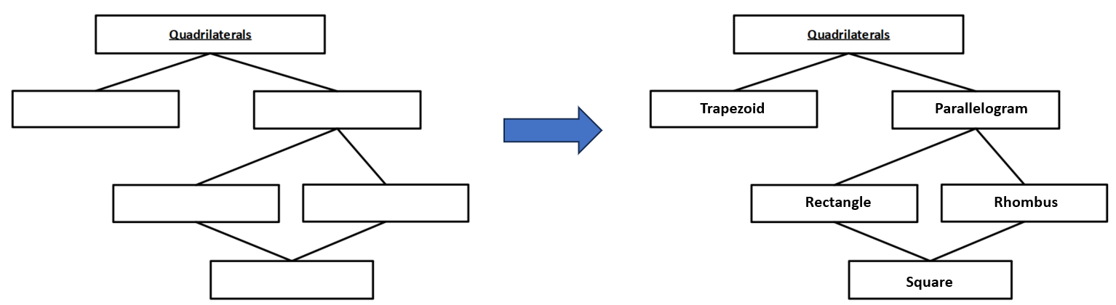

**Mathematical Connections:** Students may struggle to determine similarities and differences between two types of quadrilaterals. For example, given the two figures below, students may state that they are similar because they each have four right angles. In addition, the two figures each have opposite sides that are congruent, and they can both be classified as rectangles. Additional opportunities to review the properties that define quadrilaterals, and the use of Venn diagrams to explore similarities and differences between two figures may be beneficial.

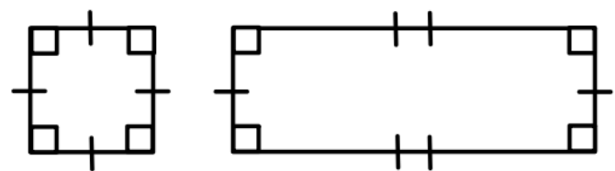

**Mathematical Representations:** Students may have difficulty classifying quadrilaterals. For example, given the figure below, a student may state that this figure is a diamond due to its orientation. Students may also have difficulty naming this figure within a hierarchy and may not understand that it can be classified as a square, rhombus, rectangle, or parallelogram. Opportunities to view quadrilaterals in different spatial orientations and activities such as sorting quadrilaterals will help students deepen their understanding of the characteristics of various quadrilaterals.

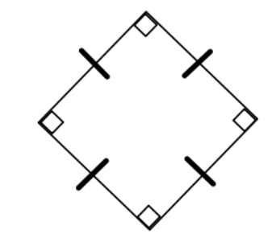

###### Concepts and Connections

Concepts

Analyzing and describing geometric objects in our world, the relationships and structures among them, or the space that they occupy can be used to classify, quantify, measure, or count one or more of their attributes.

Connections

* *Within the grade level/course*:
  + 4.MG.4 – The student will identify, describe, and draw points, rays, line segments, angles, and lines, including intersecting, parallel, and perpendicular lines.
  + 4.MG.6 – The student will identify, describe, compare, and contrast plane and solid figures according to their characteristics (number of angles, vertices, edges, and the number and shape of faces), with and without models.
* *Vertical Progression*:
  + 3.MG.4 – The student will identify, describe, classify, compare, combine, and subdivide polygons.
  + 5.MG.3 – The student will classify and measure angles and triangles, and solve problems, including those in context.

Across Content Areas

Reference 4.MG.1.

###### Resources to Support Local Curriculum

* A list of approved textbooks and instructional materials is posted on the VDOE [website](https://www.doe.virginia.gov/teaching-learning-assessment/k-12-standards-instruction/mathematics/2024-mathematics-textbooks).

### 4.MG.6

##### The student will identify, describe, compare, and contrast plane and solid figures according to their characteristics (number of angles, vertices, edges, and the number and shape of faces), with and without models.

1. Students will demonstrate the following Knowledge and Skills:
2. Identify concrete models and pictorial representations of solid figures (cube, rectangular prism, square pyramid, sphere, cone, and cylinder).
3. Identify and describe solid figures (cube, rectangular prism, square pyramid, and sphere) according to their characteristics (number of angles, vertices, edges, and by the number and shape of faces).
4. Compare and contrast plane and solid figures (limited to circles, squares, triangles, rectangles, spheres, cubes, square pyramids, and rectangular prisms) according to their characteristics (number of sides, angles, vertices, edges, and the number and shape of faces).

###### Understanding the Standard

* Students’ experiences with plane and solid figures should be hands-on and relevant to their environment.
* The study of plane and solid figures is rich with geometry vocabulary. At this level, students are expected to accurately use the following vocabulary:
* A plane figure is any closed, two-dimensional shape.
* A solid figure is three-dimensional, having length, width, and height.
* A vertex is the point at which three or more edges meet in a solid figure.
* A face is any flat surface of a solid figure.
* An edge is the line segment where two faces of a solid figure intersect.
* An angle is formed by two rays with a common endpoint called the vertex. Angles are found wherever lines and/or line segments intersect.
* A cube is a solid figure with six congruent, square faces. All edges are the same length. A cube has eight vertices and 12 edges.
* A rectangular prism is a solid figure in which all six faces are rectangles. A rectangular prism has eight vertices and 12 edges. A cube is a special case of a rectangular prism.
* A sphere is a solid figure with all its points the same distance from its center.
* A square pyramid is a solid figure with a square base and four faces that are triangles with a common vertex. A square pyramid has five vertices and eight edges.
* A cone is a solid figure formed by a face called a base that is joined to a vertex (apex) by a curved surface.
* A cylinder is a solid figure formed by two congruent parallel faces called bases joined by a curved surface.

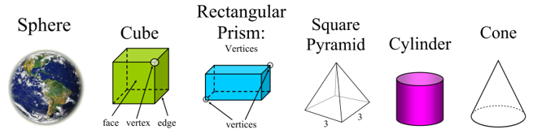

* Characteristics of solid figures included at this grade level are defined in the chart below:

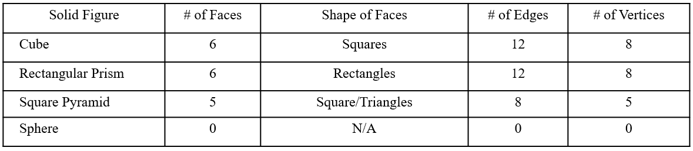

###### Skills in Practice

While the five process goals are expected to be embedded in each standard, the Skills in Practice highlight the most prevalent process goals in relation to the content presented.

**Mathematical Connections:** Students may have difficulty comparing plane and solid figures (e.g., a circle and a sphere; a square and a cube) because they confuse or are unfamiliar with the characteristics of plane and solid figures. This may further indicate that students lack an understanding of how plane and solid figures are related. Creating Venn diagrams using concrete materials will help students organize their thinking when comparing characteristics of plane and solid figures. Word banks or sentence frames may also support students as they compare plane and solid figures.

**Mathematical Representations:** Students may struggle when presented with a pictorial (two dimensional) representation of a solid (three-dimensional) figure (see examples below). This may be an indication that students have difficulty when some faces, edges, and vertices are not visible. Opportunities to explore solid figures using concrete manipulatives and real-world examples, and to compare them to pictorial representations of the same solids may be beneficial for students.

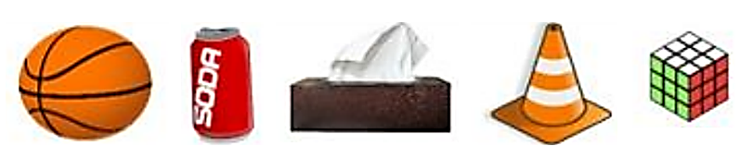

###### Concepts and Connections

Concepts

Analyzing and describing geometric objects in our world, the relationships and structures among them, or the space that they occupy can be used to classify, quantify, measure, or count one or more of their attributes.

Connections

* *Within the grade level/course*:
  + 4.MG.4 – The student will identify, describe, and draw points, rays, line segments, angles, and lines, including intersecting, parallel, and perpendicular lines.
  + 4.MG.5 – The student will classify and describe quadrilaterals (parallelograms, rectangles, squares, rhombi, and/or trapezoids) using specific properties and attributes.
* *Vertical Progression*:
  + 2.MG.4 – The student will describe, name, compare, and contrast plane and solid figures (circles/spheres, squares/cubes, and rectangles/rectangular prisms).
  + 5.MG.2 – The student will use multiple representations to solve problems, including those in context, involving perimeter, area, and volume.

Across Content Areas

Reference 4.MG.1.

###### Resources to Support Local Curriculum

* A list of approved textbooks and instructional materials is posted on the VDOE [website](https://www.doe.virginia.gov/teaching-learning-assessment/k-12-standards-instruction/mathematics/2024-mathematics-textbooks).

## Probability and Statistics

In K-12 mathematics, probability and statistics introduce students to the concepts of uncertainty and data analysis. Probability involves understanding the likelihood of events occurring, often using concepts such as experiments, outcomes, and the use of fractions and percentages. The formal study or probability begins in Grade 4. Statistics focuses on collecting, organizing, and interpreting data and includes a basic understanding of graphs and charts. Probability and statistics help students analyze and make sense of real-world data and are fundamental for developing critical thinking skills and making informed decisions using data.

In Grade 4, students deepen their understanding of how the world can be investigated through posing questions and collecting, representing, analyzing, and interpreting data to describe and predict events and real-world phenomena. At this grade level, students will apply the data cycle (formulate questions; collect or acquire data; organize and represent data; and analyze data and communicate results) with a focus on line graphs; and determine the probability of an outcome of a simple event and model, predict, and justify what might occur in the future.

### 4.PS.1

##### The student will apply the data cycle (formulate questions; collect or acquire data; organize and represent data; and analyze data and communicate results) with a focus on line graphs.

1. Students will demonstrate the following Knowledge and Skills:
2. Formulate questions that require the collection or acquisition of data.
3. Determine the data needed to answer a formulated question and collect or acquire existing data (limited to 10 or fewer data points) using various methods (e.g., observations, measurements, experiments).
4. Organize and represent a data set using line graphs with a title and labeled axes with whole number increments, with and without the use of technology tools.
5. Analyze data represented in line graphs and communicate results orally and in writing:
   1. describe the characteristics of the data represented in a line graph and the data as a whole (e.g., the time period when the temperature increased the most);
   2. identify parts of the data that have special characteristics and explain the meaning of the greatest, the least, or the same (e.g., the highest temperature shows the warmest day);
   3. make inferences about data represented in line graphs;
   4. draw conclusions about the data and make predictions based on the data to answer questions; and
   5. solve single-step and multistep addition and subtraction problems using data from line graphs.

###### Understanding the Standard

* Students should explore the entire data cycle with a question and set of data that has been collected or acquired. Student reflection should occur throughout the data cycle. The data cycle includes the following steps: formulating questions to be explored with data, collecting or acquiring data, organizing and representing data, and analyzing and communicating results.

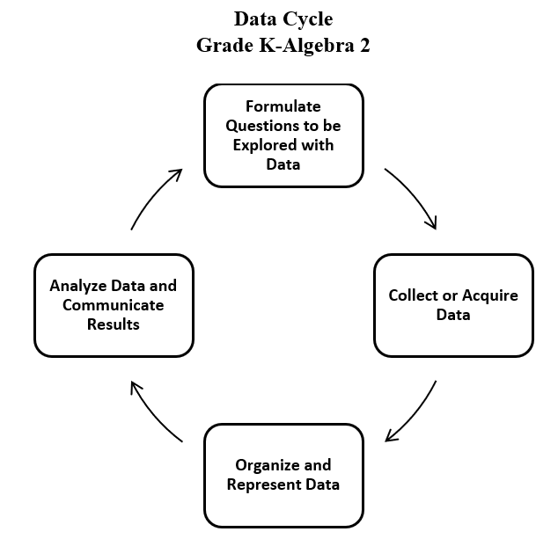

* Statistics is the science of conducting studies to collect, organize, summarize, analyze, and draw conclusions from data.
* The emphasis in all work with statistics should be on the analysis of the data and the communication of the analysis. Data analysis should include opportunities to describe the data, recognize patterns or trends, and make predictions.
* Statistical investigations should be active, with students formulating questions about something in their environment and determining ways to answer the questions.
* The following activities should be student generated at this level:
  + formulating questions about something in the student’s environment that yields data that changes over time
  + predicting answers to questions under investigation
  + collecting and representing initial data
  + determining whether the data answers the questions asked
* Data are pieces of information collected about people or things. The primary purpose of collecting data is to answer questions. The primary purpose of interpreting data is to inform decisions (e.g., which type of clothing to pack for a trip based on a weather graph or which type of lunch to serve based upon class favorites).
* Investigations involving practical data should occur frequently; data can be collected through brief class polls or through more extended experiments/projects occurring over multiple days.
* The teacher can provide data sets to students in addition to students engaging in their own data collection or acquisition. Data may be acquired from resources that are already created such as student heights over a period of time, screen time data over a period of time, weather data over several days or months (e.g., temperature, precipitation amounts), population data over a period of time, etc.
* Technology tools (e.g., graphing software, spreadsheets) can be used to collect, organize, and visualize data. These tools support progression to analysis of data in a more efficient manner.
* There are two types of data: categorical (e.g., qualitative) and numerical (e.g., quantitative). Categorical data are observations about characteristics that can be sorted into groups or categories, while numerical data are values or observations that can be measured. For example, types of fish caught would be categorical data while weights of fish caught would be numerical data. While students need to be aware of the differences, at this level, they do not have to know the terms for each type of data.
* In Grade 3, students had experiences with categorical data represented in bar graphs and pictographs.
* In Grade 4, students are expected to engage with numerical data that changes over time and is represented in line graphs.
* Line graphs are used to represent quantitative data collected about a specific subject and over a specific time interval. All the data points are plotted on a coordinate grid and the points are connected by a line. A line graph of a data set shows when change is increasing, decreasing, or staying the same over short intervals of time and over the entire period of time.
* The values along the horizontal axis of a line graph represent continuous data, usually some measure of time (e.g., time in years, months, or days). The data presented on a line graph is referred to as “continuous data,” as it represents data collected over a continuous period of time.
* The values represented on the vertical axis represent the data collected for what is being measured at each increment of time. The scale values on the vertical axis should represent equal increments of multiples of whole numbers depending upon the data being collected. Plot a point to represent the data collected for each time increment. Use line segments to connect the points in order moving left to right.
* Scales shown on the horizontal and vertical axes label increments of the graph. Students should have experience with various increments when creating line graphs limited to multiples of 1, 2, 5, 10, or 100. The scale should extend one increment above the greatest recorded piece of data.
* Each axis should be labeled, and the graph should be given a title.
* Comparing different types of representations (tables and line graphs) provides students an opportunity to learn how different representations can show different aspects of the same data.
* Tables are one way to organize the exact data collected and display numerical information. They do not show visual comparisons, which generally means it takes longer to understand or to observe trends.
* A trend is the general direction in which something is developing or changing over time. A projection is a prediction of future change. Trends and projections are usually illustrated using line graphs in which the horizontal axis represents time.
* Examining a line graph from left to right shows how one variable changes over time and reveals trends or progress of change in the data collected over time.

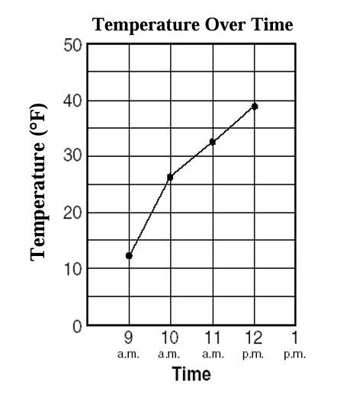

* Examples of some questions that could be explored by comparing the table to a line graph below include: In which representation do you readily see the increase or decrease of temperature over time? In which representation is it easiest to determine when the greatest rise in temperature occurred? In which representation can you draw some conclusions about what the temperature will be at the next measurement time?

|  |  |
| --- | --- |
| **Time** | **Temperature** |
| 9 a.m. | 12 |
| 10 a.m. | 26 |
| 11 a.m. | 33 |
| 12 p.m. | 39 |

* Students are interested in and notice individual data points and are able to describe parts of the data — where their own data falls on the graph, which value occurs most frequently, and which values are the largest and smallest. It is important to develop students’ understanding as they begin to think about the set of data as a whole.
* Data analysis helps describe data, recognize patterns or trends, and make predictions.
* Statements representing an analysis and interpretation of the characteristics of the data in the line graph should be included (e.g., patterns or trends of increase and/or decrease, and least and greatest data value).
* Students should interpret data by making observations from line graphs by describing the characteristics of the data and the data as a whole (e.g., the time period when the temperature increased the most, similarities and differences, the total number over a period of time, the time period during which no change occurred).
* Students would benefit from exploring previously taught graphical representations when justifying how to best represent data clearly and accurately. Comparing different types of representations (charts and graphs) provides an opportunity to learn how different graphs can show different things about the same data. Discussions around what information different graphs representing the same data provides are beneficial for determining which graphical representation best represents the data.

###### Skills in Practice

While the five process goals are expected to be embedded in each standard, the Skills in Practice highlight the most prevalent process goals in relation to the content presented.

**Mathematical Communication:** As Grade 4 students engage in the data cycle, they may struggle to formulate questions that require the collection of data, especially questions that will result in the creation and analysis of a line graph. Teacher support will be necessary to help students distinguish between questions that require categorical data to answer and questions that require numerical data that changes over time. For example, *“What is your favorite activity to do during recess?”* is a question that will result in the collection of categorical data (e.g., kickball, basketball, swings), and would be best represented on a bar graph or pictograph. Conversely, *“How much will a plant grow over a period of nine weeks?”* is an example of a question that will result in the collection of numerical data that changes over time and would be best represented on a line graph. Some other ideas of questions that will result in the collection of numerical data that changes over time include –

* What is the number of school lunches purchased over the course of a month (or year)?
* What is your height (in cm) each month over the course of the school year?
* What is the total amount of money raised during the school fundraiser (displayed daily or weekly)?
* What is the total number of books the class read over the month (or year)?
* How many books were sold at the book fair?
* What is the weight (or height) of your pet over the course of the school year?
* How many total hours have you spent on a screen this week?
* What is the average temperature over a 12-week period?
* What is the river level of a local river?
* How quickly does the water temperature increase when boiling it?
* What is the height of a plant each week?
* What was the population of the town over the past ten years?
* What was the average cost of milk over the past ten years?

**Mathematical Reasoning:** Students may have difficulty analyzing the data displayed in a line graph. For example, students may be asked to identify the greatest amount of change by finding the line segment that shows the steepest incline between two consecutive points. Similarly, students may be asked to identify the least amount of change by finding the line segment that shows little change (or no change) between two consecutive points. Students will benefit from exposure to many types of line graphs and opportunities to analyze characteristics of the line graph (e.g., the greatest/least point on the graph, the line segment of greatest/least change), and to make predictions and/or inferences based on the data in the line graph.

The graph below shows the total number of fish caught over the course of a fishing trip. A student might explain that the greatest increase in the number of fish caught occurred between 10:00 AM and 11:00 AM because the line has the steepest increase between those two times. A student might justify that there was no change in the number of fish caught occurred between 9:00 AM and 10:00 AM because the line is horizontal and shows a total number of 4 fish caught during those times.

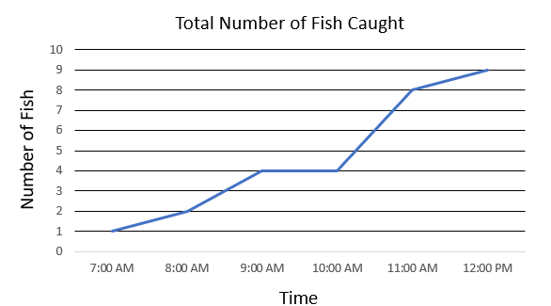

**Mathematical Representations:** The representation of numerical data that change over time and displayed on a line graph may be new to students who are familiar with categorical data that are represented in bar graphs and pictographs. Exposing students to various examples of line graphs and facilitating discussions about the components of a line graph and when the use of a line graph is appropriate will help students become more familiar with this representation. For example, students should be encouraged to notice the labels on the vertical and horizontal axes and recognize that the variable that changes over time is plotted on the horizontal axis. Teachers should help students make connections between looking at the individual points and then looking at the points connected with a line. Emphasize how the line can help students notice trends and lead to inferences about the data.

###### Concepts and Connections

Concepts

Investigating the world through posing questions, collecting data, organizing and representing data, and analyzing data and communicating results can be used to describe and predict events and real-world phenomena.

Connections

* *Within the grade level/course*:
  + 4.CE.1 – The student will estimate, represent, solve, and justify solutions to single-step and multistep problems, including those in context, using addition and subtraction with whole numbers.
* *Vertical Progression*:
  + 3.PS.1 – The student will apply the data cycle (formulate questions; collect or acquire data; organize and represent data; and analyze data and communicate results) with a focus on pictographs and bar graphs.
  + 5.PS.1 – The student will apply the data cycle (formulate questions; collect or acquire data; organize and represent data; and analyze data and communicate results) with a focus on line plots (dot plots) and stem-and-leaf plots.

Across Content Areas [Theme – Using Data]:

* *Science:* 
  + 4.4a – The student will use weather instruments (thermometer, barometer, rain gauge, anemometer) and observations of sky conditions to collect, record, and graph weather data over time; and analyze results and determine patterns that may be used to make weather predictions.
  + 4.6c – The student will analyze data from simple tide tables to determine a pattern of high and low tides, and analyze simple tide tables and the phases of the moon over time to explain the relationship between the tides and the phases of the moon.
  + 4.8a-d – The student will investigate the school yard or local ecosystem to identify questions, problems, or issues that affect a natural resource in that area and determine a possible solution to an identified problem.
* *Computer Science*:
  + 4.DA.1 – The student will identify the appropriate type of data needed to solve a problem or answer a question (a) analyze a problem to determine the appropriate type of data needed; (b) evaluate the reliability of data sources; (c) use numeric values to represent non-numeric ideas to include binary, American Standard Code for Information Interchange (ASCII), and RGB values; and (d) collect, store, clean, and organize data for analysis and to prepare visualizations.
  + 4.DA.2 – The student will create and evaluate data representations to make predictions and conclusions (a) formulate questions that require the collection or acquisition of data; (b) collect data to create charts and graphs; (c) recognize and analyze patterns and relationships within data sets; and (d) analyze visual representations to make predictions and draw conclusions.

Across Content Areas [Theme – Using Graphing]:

* *Science:* Depending on the data collected in an investigation, students may use graphs to visualize the data.
  + 4.1c – The student will organize and represent data in bar graphs and line graphs; interpret and analyze data represented in bar graphs and line graphs; and compare two different representations of the same data.
  + 4.4a – The student will use weather instruments (thermometer, barometer, rain gauge, anemometer) and observations of sky conditions to collect, record, and graph weather data over time; and analyze results and determine patterns that may be used to make weather predictions.
  + 4.6c – The student will analyze data from simple tide tables to determine a pattern of high and low tides, and analyze simple tide tables and the phases of the moon over time to explain the relationship between the tides and the phases of the moon.
* *Computer Science*:
  + 4.CSY.1 – The student will model how a computing system works to accomplish a task (a) describe how computing systems perceive the world through sensors and other inputs; (b) compare and contrast how humans and computers process information from inputs; (c) explain how computing devices may be used to classify and organize input; and (d) diagram and describe a simple computing system indicating processors, inputs, and outputs.
  + 4.DA.3 – The student will create a computational model that represents attributes and behaviors associated with a concept (a) examine models of physical objects and processes; (b) create a computational model that reflects the attributes and behaviors associated with a concept; and (c) explain how a computer model illustrates a given concept.
  + 4.NI.1 – The student will identify the interrelationship between computing devices and a computing network (e) model how computing devices in a network transmit and receive information.
* *Digital Learning Integration:*
  + 3-5 CT.B. Students select and use appropriate technologies to represent data, which will be used for interpretation and evidence-based decision making.

###### Resources to Support Local Curriculum

* A list of approved textbooks and instructional materials is posted on the VDOE [website](https://www.doe.virginia.gov/teaching-learning-assessment/k-12-standards-instruction/mathematics/2024-mathematics-textbooks).
* Data Cycle Teacher Resource ([PPT](https://www.doe.virginia.gov/home/showdocument?id=52079&t=638411641469000000) | [PDF](https://www.doe.virginia.gov/home/showdocument?id=52077&t=638411641463200000))

### 4.PS.2

##### The student will model and determine the probability of an outcome of a simple event.

1. Students will demonstrate the following Knowledge and Skills:
2. Describe probability as the degree of likelihood of an outcome occurring using terms such as *impossible, unlikely, equally likely, likely,* and *certain*.
3. Model and determine all possible outcomes of a given simple event where there are no more than 24 possible outcomes, using a variety of manipulatives (e.g., coins, two-sided counters, number cubes, spinners).
4. Write the probability of a given simple event as a fraction between 0 and 1, where there are no more than 24 possible outcomes.
5. Determine the likelihood of an event occurring and relate it to its whole number or fractional representation (e.g., impossible or zero; equally likely; certain or one).
6. Create a model or contextual problem to represent a given probability.

###### Understanding the Standard

* Probability is the measure of likelihood that an event will occur. An event is a collection of outcomes from an investigation or experiment.
* A spirit of investigation and experimentation should permeate probability instruction, where students are actively engaged in explorations and have opportunities to use manipulatives.
* For an event such as flipping a coin, the things that can happen are called *outcomes*. For example, there are two possible outcomes when flipping a coin: the coin can land heads up, or the coin can land tails up. The two possible outcomes, heads up or tails up, are equally likely which can be expressed as .
* If all outcomes of an event are equally likely, the probability of an event can be expressed as a fraction, where the numerator represents the number of favorable outcomes, and the denominator represents the total number of possible outcomes. If all the outcomes of an event are equally likely to occur, the probability of the event is equal to:
* Probability is quantified as a number between 0 and 1 and may be represented on a number line.
* An event is “impossible”if it has a probability of zero (e.g., if eight balls are in a bag, four yellow and four blue, it is impossible that a red ball could be selected).
* An event is “certain”if it has a probability of one (e.g., if ten pennies are in a bag, the probability of selecting a penny is certain).
* For another event such as spinning a spinner that is one-third red and two-thirds blue, the two outcomes, red and blue, are not equally likely.

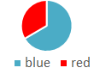

* Equally likely events can be represented with fractions of equivalent value. For example, on a spinner with eight sections of equal size, where three of the eight sections are labeled G (green) and three of the eight sections are labeled B (blue), the chances of landing on green or blue are equally likely; the probability of each of these events is the same, or .

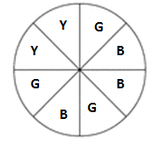

* In Grade 4, students are not expected to simplify the fraction that represents the probability of a contextual situation.
* Models or contextual problems may be created to represent a given probability. For example, if asked to create a box of marbles where the probability of selecting a black marble is , sample responses might include:

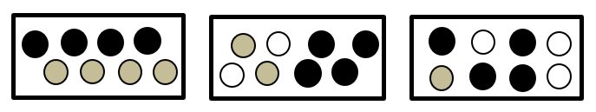

* When a probability experiment has very few trials, the results can be misleading. The more times an experiment is done, the closer the experimental probability comes to the theoretical probability (e.g., a coin lands heads up half of the time). Students should have experiences using the results of a statistical investigation to predict what might occur in the future and justify the reasoning behind the prediction. For example, when given a table showing the results of randomly pulling marbles from a bag, students predict the next color that might be pulled and justify their prediction.
* Experiences with probability that involve combinations will occur in Grade 5 (e.g., How many different outfits can be made given three shirts and two pairs of pants?).

###### Skills in Practice

While the five process goals are expected to be embedded in each standard, the Skills in Practice highlight the most prevalent process goals in relation to the content presented.

**Mathematical Problem Solving**: Students may have difficulty creating a model or a contextual problem given a probability. For example, consider the following contextual problem –

* Joe has a bag of marbles. Create a drawing of Joe’s bag of marbles in which the probability of choosing a blue marble is .

There are two common errors students may make as they create a model of this contextual situation:

* Students may draw a bag of marbles that includes six blue marbles and six marbles of another color.
* Students may draw a bag of marbles that includes only one blue marble.

These errors may indicate that students do not understand the connection between the numerator and the denominator when representing probability as a fraction or they may indicate that students do not understand how to represent a situation that is certain. Additional experiences with manipulatives and connecting the probability of a simple event to a fraction would be helpful.

**Mathematical Communication:** Students are introduced to new mathematics vocabulary with this standard (e.g., outcomes, certain, likely, unlikely, impossible). Students may confuse or misuse the meaning of the probability terms, which indicates a lack of understanding of the mathematical meaning of these terms. Students may also have difficulty understanding phrases such as “unlikely but not impossible” or “likely but not certain.” For example, given the spinner below, a student may say that the probability of a spinner landing on red is “impossible because there’s only one red.” To address errors such as this, teachers should provide students with different probability examples (e.g., marbles in a bag, spinners, flipping a coin), and engage students in discussions about the probability of various events occurring. Opportunities to hear other students’ thinking will benefit students who are struggling to use these terms and phrases accurately.

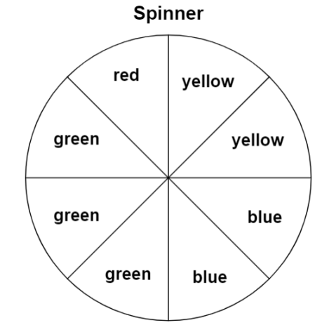

**Mathematical Representations:** When provided a number line similar to the one shown below, students may struggle to correctly label the probability terms *certain, likely, equally likely, unlikely,* and *impossible* on the number line. This may indicate that students do not understand why each term is located at the appropriate place on the number line. It could also be an indication of a lack of understanding of the vocabulary terms associated with probability.

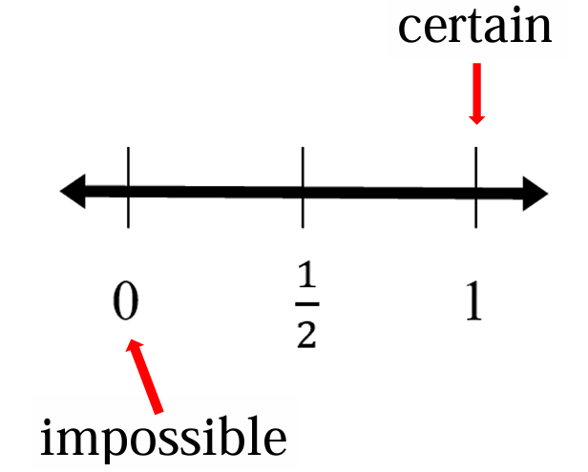

The use of concrete manipulatives (e.g., color tiles, number cubes, spinners) can be used to provide situational examples of each of the terms and help students deepen their understanding of the connections between the probability terms and the number line representation.

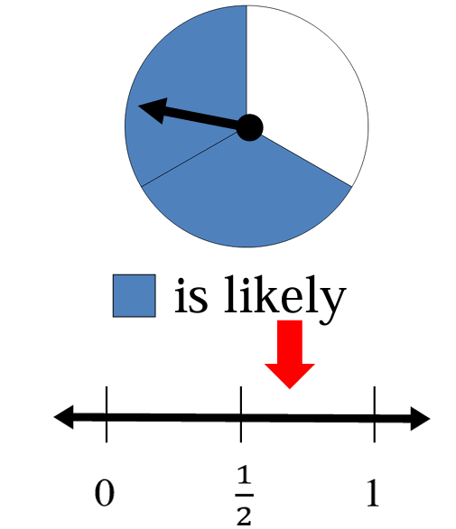 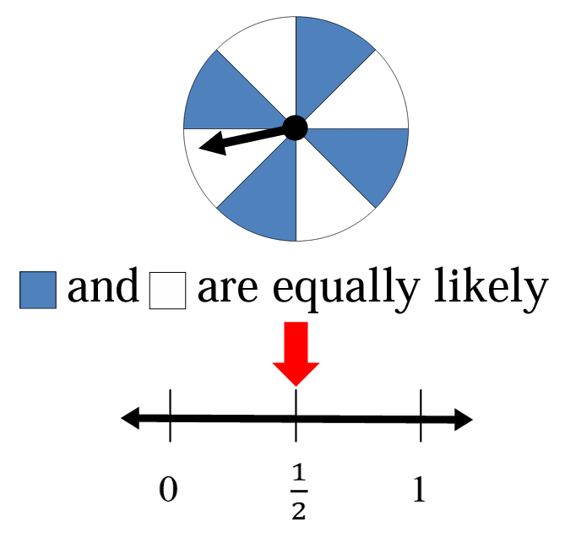 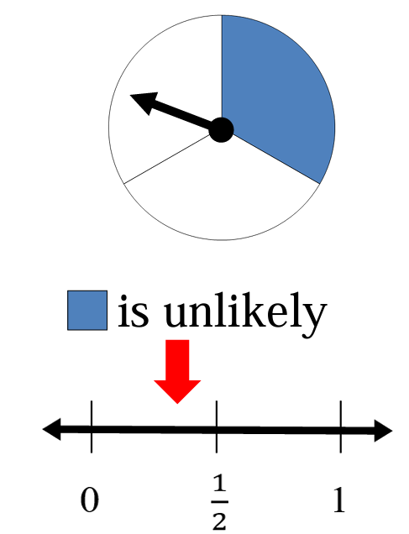

###### Concepts and Connections

Concepts

Investigating the world through posing questions, collecting data, organizing and representing data, and analyzing data and communicating results can be used to describe and predict events and real-world phenomena.

Connections

* *Within the grade level/course*:
  + 4.NS.3 – The student will use mathematical reasoning and justification to represent, compare, and order fractions (proper, improper, and mixed numbers with denominators 12 or less), with and without models.
  + 4.NS.5 – The student will reason about the relationship between fractions and decimals (limited to halves, fourths, fifths, tenths, and hundredths) to identify and represent equivalencies.
* *Vertical Progression*:
  + There are no formal standards addressing probability prior to Grade 4.
  + 5.PS.3 – The student will determine the probability of an outcome by constructing a model of a sample space and using the Fundamental (Basic) Counting Principle.

Across Content Areas [Themes – using data, graphing]

Reference 4.PS.1.

###### Resources to Support Local Curriculum

* A list of approved textbooks and instructional materials is posted on the VDOE [website](https://www.doe.virginia.gov/teaching-learning-assessment/k-12-standards-instruction/mathematics/2024-mathematics-textbooks).

## Patterns, Functions, and Algebra

In K-12 mathematics, the patterns, functions, and algebra strand focuses on the recognition, description, and analysis of patterns, functions, and algebraic concepts. Students develop an understanding of mathematical relationships and represent these using symbols, tables, graphs, and rules. In later grades, students use models as they solve equations and inequalities and develop an understanding of functions. This strand is designed to develop students’ algebraic thinking and problem-solving skills, laying the foundation for more advanced mathematical concepts.

In Grade 4, students understand that relationships can be described and generalizations can be made using patterns and relations. At this grade level, students will identify, describe, extend, and create increasing and decreasing patterns using various representations.

### 4.PFA.1

##### The student will identify, describe, extend, and create increasing and decreasing patterns (limited to addition, subtraction, and multiplication of whole numbers), including those in context, using various representations.

1. Students will demonstrate the following Knowledge and Skills:
2. Identify, describe, extend, and create increasing and decreasing patterns using various representations (e.g., objects, pictures, numbers, number lines, input/output tables, and function machines).
3. Analyze an increasing or decreasing single-operation numerical pattern found in lists, input/output tables, or function machines and generalize the change to identify the rule, extend the pattern, or identify missing terms.
4. Given a rule, create increasing and decreasing patterns using numbers and input/output tables (including function machines).
5. Solve contextual problems that involve identifying, describing, and extending increasing and decreasing patterns using single-operation input and output rules.

###### Understanding the Standard

* The ability to recognize, interpret, and generalize patterns supports understanding of many mathematical concepts. In the primary grades, students develop the knowledge and skills to recognize regularity in a sequence of numbers or shapes found in repeating patterns. In Grade 3, students worked with sequences of numbers or shapes to recognize and describe increasing and decreasing patterns. In Grade 4, students are expected to apply generalizations to extend patterns and find missing terms. The foundation of observing relationships leads to identifying rules for the relationships, which is foundational knowledge for algebra and the study of functions.
* Patterns and functions can be represented in many ways and described using words, tables, graphs, and symbols.
* Patterning activities should be introduced by making connections between concrete materials and numerical representations (e.g., number sequences, tables, description).
* In Grade 4, numerical patterns are limited to addition, subtraction, and multiplication of whole numbers.
* Opportunities to explore increasing and decreasing patterns using concrete materials and calculators are important. Calculators are valuable tools for generating and analyzing patterns. The emphasis is not on computation but on identifying and describing patterns.
* Sample increasing and decreasing patterns that can be represented as numerical (arithmetic) patterns include:
  + 2, 4, 8, 16, …
  + 8, 10, 13, 17, …
  + 325, 300, 275, 250…
  + 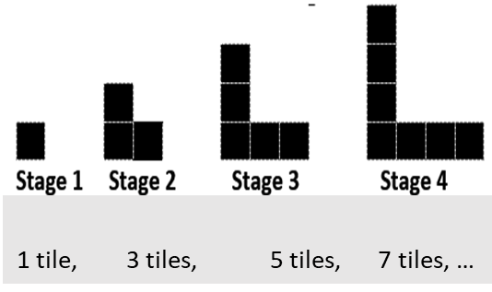
* At this level, input/output tables should be analyzed for a pattern to determine an unknown value. Experiences should include describing the rule, determining the output when given the input, and determining the input when given the output. Determining and applying rules builds the foundation for functional thinking. Sample input/output tables that require determination of the rule or missing terms can be found below:

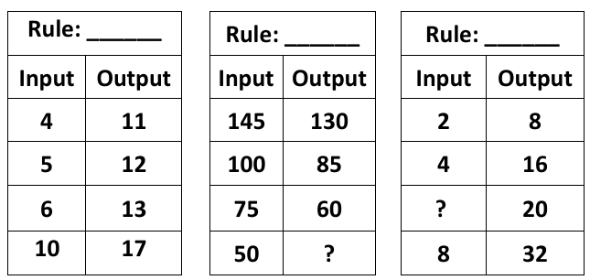

* Students will use various representations (e.g., number sequences, tables, concrete or pictorial models, verbal descriptions) for numerical patterns with whole numbers to solve contextual problems such as:
  + A group of players are coming to an end-of-season soccer celebration. One square table can seat 4 people, two square tables can seat 8 people, etc. How many people would be seated at five square tables? 13 square tables?
  + A community started a softball league for students in Grades 4 and 5. The first year there were 19 players. The second year there were 23 players. The third year there were 27 players, and the fourth year there were 31 players.
    - If this pattern continues, how many players will be in the league in the sixth year?
    - If this pattern continues, in which year will there be 55 players?

###### Skills in Practice

While the five process goals are expected to be embedded in each standard, the Skills in Practice highlight the most prevalent process goals in relation to the content presented.

**Mathematical Reasoning:** In Grade 4, students are introduced to increasing patterns that use multiplication of whole numbers, rather than addition. For example, given the pattern 1, 3, 9, 27, 81… students may identify the rule of the pattern as “plus two” because two can be added to the first term (1) to get the second term (3). However, this rule does not work beyond the first two terms (e.g., adding two to the second term (3) would result in five, not nine). Students may continue to try to use addition, stating that the rule is, *“plus two, plus six, plus 18, and plus 54.”* Students who make these errors are having difficulty transitioning from their previous experiences of patterns that included only addition and subtraction rules to a more sophisticated pattern rule that includes multiplication. Providing scaffolded support to students through questioning is important to help students make the shift. Questions may include:

* Are the numbers increasing or decreasing?
* What mathematical operation(s) would make this occur with the numbers?
* Are the numbers increasing/decreasing by the same amount each time?

In addition, exposure to a variety of patterns using different representations (including the use of concrete manipulatives to model how the pattern changes from term to term) would be beneficial for students.

**Mathematical Representations:** In Grade 4, students are introduced to input/output tables. As they begin to engage with this representation of patterns, several common mistakes may be evident. For example, given the input/output table below, students are asked to determine the input number when the output is 42.

|  |  |
| --- | --- |
| **Input** | **Output** |
| 2 | 12 |
| 5 | 30 |
| ? | 42 |
| 9 | 54 |
| 12 | 72 |

One common error is to focus on the numbers in the output column and attempt to predict the next output number. Students who make this error might add on to the last output without considering the input column. This may indicate that students are using their prior experiences with patterns, where they were often asked, *“What comes next?”* Opportunities to engage with patterns where students are asked to determine missing inputs, or terms missing in the pattern (including the first term) will provide students with more robust experiences with patterns.

Another common error is to focus on the numbers in the input column only to determine the missing input. For example, students may suggest that the missing input is 8 because going from the first input (2) to the second input (5) requires adding three, and going from the fourth input (9) to the fifth input (12) requires adding three. Thus, students may incorrectly identify the pattern as “plus three,” resulting in a missing input of eight. Students who make this error may not understand that patterns represented in input/output tables require analysis of each row (e.g., how is the input related to the output), rather than each column. Acting out the actions occurring in an input/output table or having students write out the equation for each row may help students observe the relationship between the input and output columns.

A third common error is incorrectly applying the rule for the input/output table. Students may determine that rule for the input/output table is “multiply by six.” Students who make this error would identify the missing input as 252. However, when determining a missing input, students need to use a multiplication fact with a missing factor, or they need to apply the inverse of this rule to the output (e.g., “work backwards” from the output) to determine the input. Thus, the missing input should be seven (7). Opportunities to hear other students’ strategies for solving pattern problems will help students hear multiple ways of approaching different pattern types.

###### Concepts and Connections

Concepts

Relationships are described and generalizations are made using patterns, relations, and functions.

Connections

* *Within the grade level/course*:
  + 4.CE.1 – The student will estimate, represent, solve, and justify solutions to single-step and multistep problems, including those in context, using addition and subtraction with whole numbers.
  + 4.CE.2 – The student will estimate, represent, solve, and justify solutions to single-step and multistep problems, including those in context, using multiplication with whole numbers, and single-step problems, including those in context, using division with whole numbers; and recall with automaticity the multiplication facts through 12 × 12 and the corresponding division facts.
  + 4.MG.2 – The student will solve single-step and multistep contextual problems involving elapsed time (limited to hours and minutes within a 12-hour period).
* *Vertical Progression*:
  + 3.PFA.1 – The student will identify, describe, extend, and create increasing and decreasing patterns (limited to addition and subtraction of whole numbers), including those in context, using various representations.
  + 5.PFA.1 – The student will identify, describe, extend, and create increasing and decreasing patterns with whole numbers, fractions, and decimals, including those in context, using various representations.

Across Content Areas [theme – numbers, number sense, and patterns]

* *Science:* 
  + 4.4a – The student will use weather instruments (thermometer, barometer, rain gauge, anemometer) and observations of sky conditions to collect, record, and graph weather data over time; analyze results and determine patterns that may be used to make weather predictions.
* *Computer Science*:
* 4.AP.1 – The student will apply computational thinking to identify patterns and design algorithms to compare and contrast multiple algorithms used for the same task (a) decompose an algorithm, process, or problem into a subset of smaller problems; (b) identify multiple algorithms for the same task; and (c) describe patterns within multiple algorithms.

###### Resources to Support Local Curriculum

* A list of approved textbooks and instructional materials is posted on the VDOE [website](https://www.doe.virginia.gov/teaching-learning-assessment/k-12-standards-instruction/mathematics/2024-mathematics-textbooks).